BOOK 72
PAGE 68

MONDAY, AUGUST 11, 2025 A. D.

STATE OF TENNESSEE)

COUNTY OF GRAINGER)

BE IT REMEMBERED THAT THE BOARD OF COMMISSIONERS
OF GRAINGER COUNTY, TENNESSEE, MET IN REGULAR SESSION ON MONDAY,
AUGUST 11, 2025 A.D., MIKE HOLT, GRAINGER COUNTY COMMISSION CHAIR, WAS PRESENT AND PRESIDING, AND THE FOLLOWING COUNTY COMMISSIONERS PRESENT TO-WIT:

DARELL STRATTON, SCOTT WYNN, ED MCBEE, RODNEY OVERBAY,
LUKE STRATTON, ANDY CAMERON, TINA DAVIS, DARRELL WILLIAMS, JAMES
ACUFF, JUSTIN EPPERSON, JENNIFER HOLT, ANNA BLANKEN, JESSE CLINE AND
MIKE HOLT. (14)

COUNTY COMMISSIONER’S ABSENT: WENDY NOE. (1)

OPEN BY: SHERIFF JAMES HARVILLE
PRAYER BY: RODNEY OVERBAY
PLEDGE BY: JAMES ACUFF

MIKE HOLT, COUNTY COMMISSION CHAIR, CALLED THE MEETING OF THE BOARD OF COMMISSION OF GRAINGER COUNTY TO ORDER. ANGIE J. LAMB, GRAINGER COUNTY CLERK, WAS PRESENT AND THE MINUTES OF THE MEETING WERE RECORDED TO WIT:

***************

PUBLIC COMMENTS,
NONE

***************

AGENDA, Approval of
UPON MOTION of Commissioner ANDY CAMERON, Seconded by
Commissioner JUSTIN EPPERSON, the Commission approved the agenda with addendums 14B AND
15D for the August11,2025 Meeting by Voice Vote.

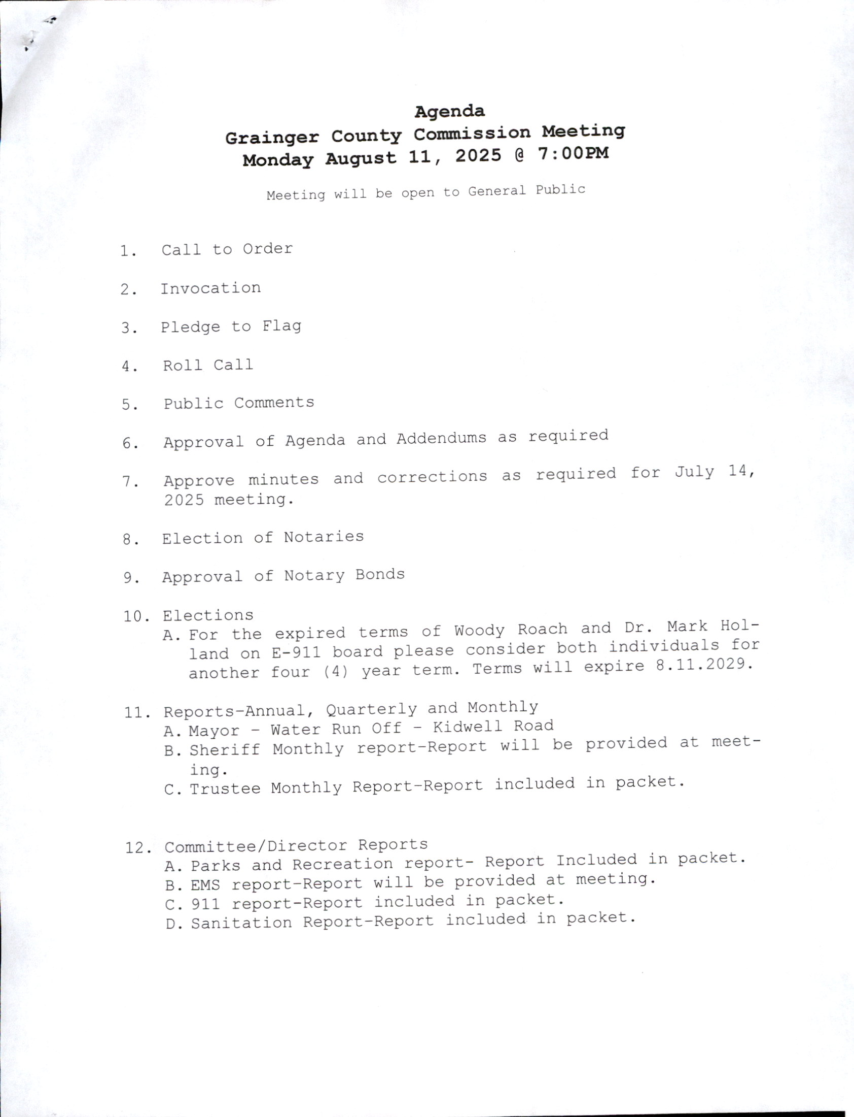

***************

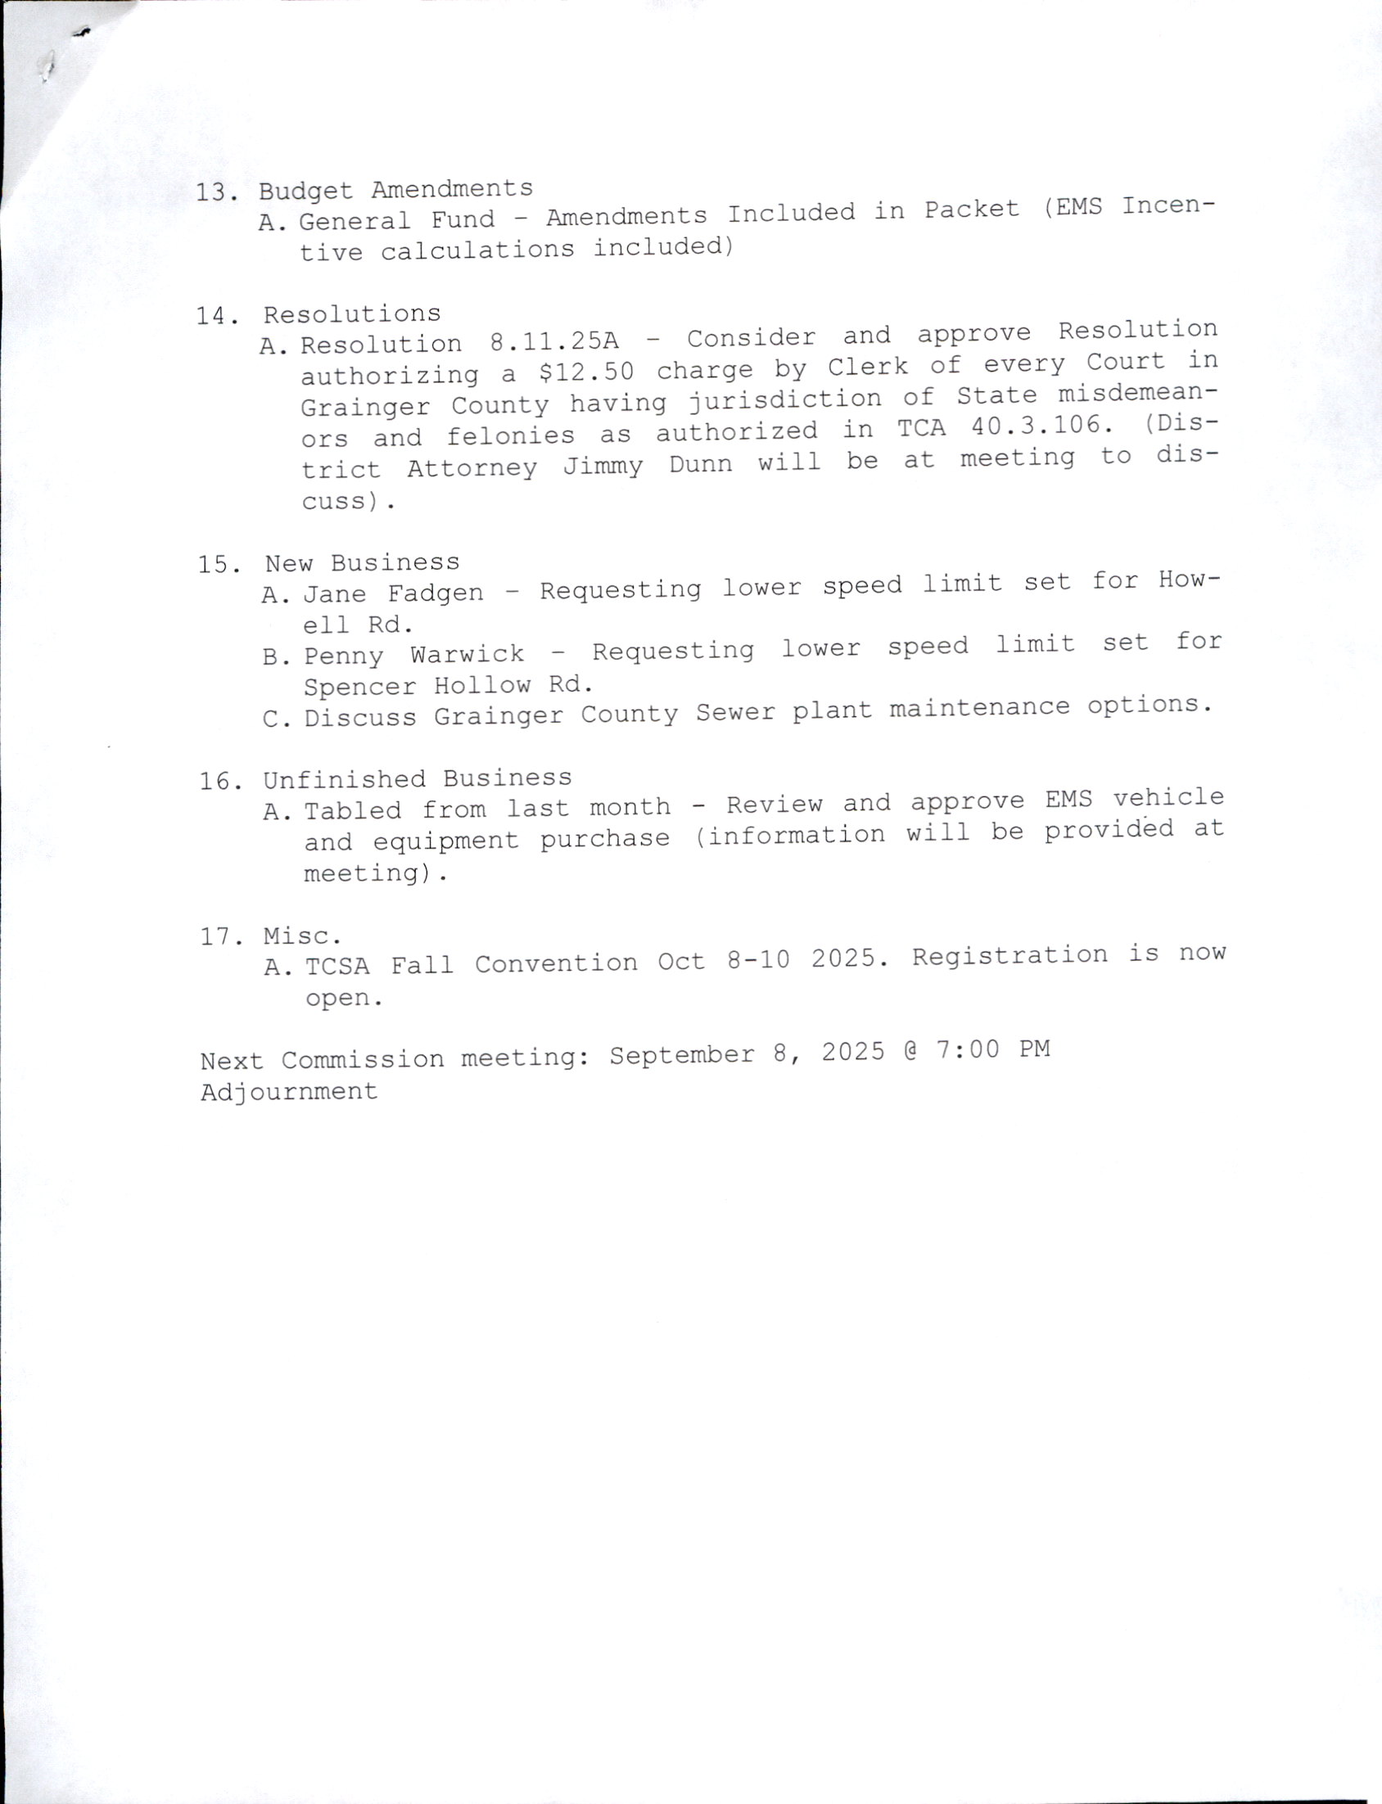

***************

***************

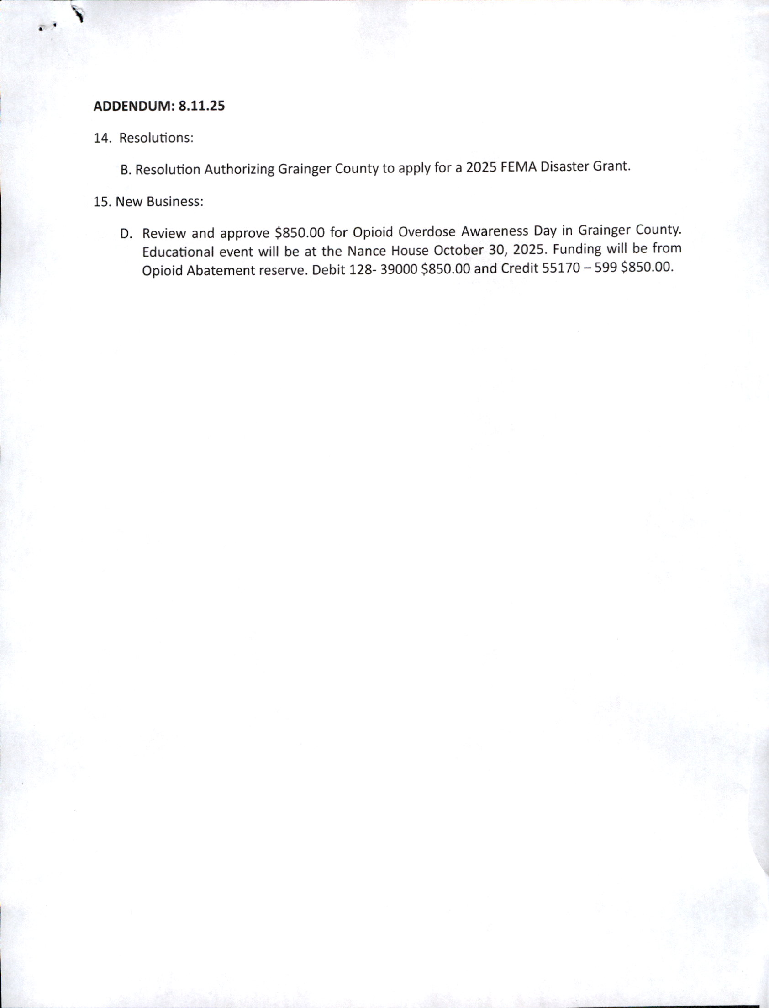

MINUTES, Approval of
UPON MOTION of Commissioner JESSE CLINE, Seconded by
Commissioner ED MCBEE, the Commission approved the minutes for the July 14, 2025
Regular County Meeting by Voice Vote.

***************

ELECTION OF NOTARIES,
UPON MOTION of Commissioner DARRELL WILLIAMS, Seconded by Commissioner TINA DAVIS, the Commission approved the following Notary Publics by Voice Vote.

1. CHARLES GALLIGHER NEW
2. LESLIE S. HAUN RENEWAL
3. BARBARA LOZANO NEW
4. DONNA SHELTON RENEWAL

***************

ELECTION OF NOTARY OF BONDS,
UPON MOTION of Commissioner JUSTIN EPPERSON, Seconded by Commissioner JENNIFER HOLT, the Commission approved the Following Notary Bonds by Voice Vote.

1. CHARLES GALLIGHER $10,000 Bond with CMA Surety Bonding Co. of America
2. LESLIE S. HAUN $10,000 Bond with National Notary Assoc.

3. BARBARA LOZANO $10,000 Bond with Travelers Casualty Ins.

4. DONNA SHELTON $10,000 Bond with Farm Bureau Ins. Co.

****************

ELECTIONS; E-911 Board
UPON MOTION of Commissioner JAMES ACUFF, Seconded by Commissioner ED MCBEE, the Commission approved the re-appointments of Woody Roach and Dr. Mark Holland to the E-911 Board with terms to expire 8.11.2029 by Voice Vote.

*************

REPORTS, MONTHLY, QUARTERLY & ANNUALLY, Mayor/Water Run Off on Kidwell Road
UPON MOTION of Commissioner SCOTT WYNN, Seconded by Commissioner ED MCBEE, the Commission requested for the County Attorney Lane Wolfenbarger to send a letter to the owner of the farm on Kidwell Road concerning the water run off on Kidwell Road by Voice Vote.

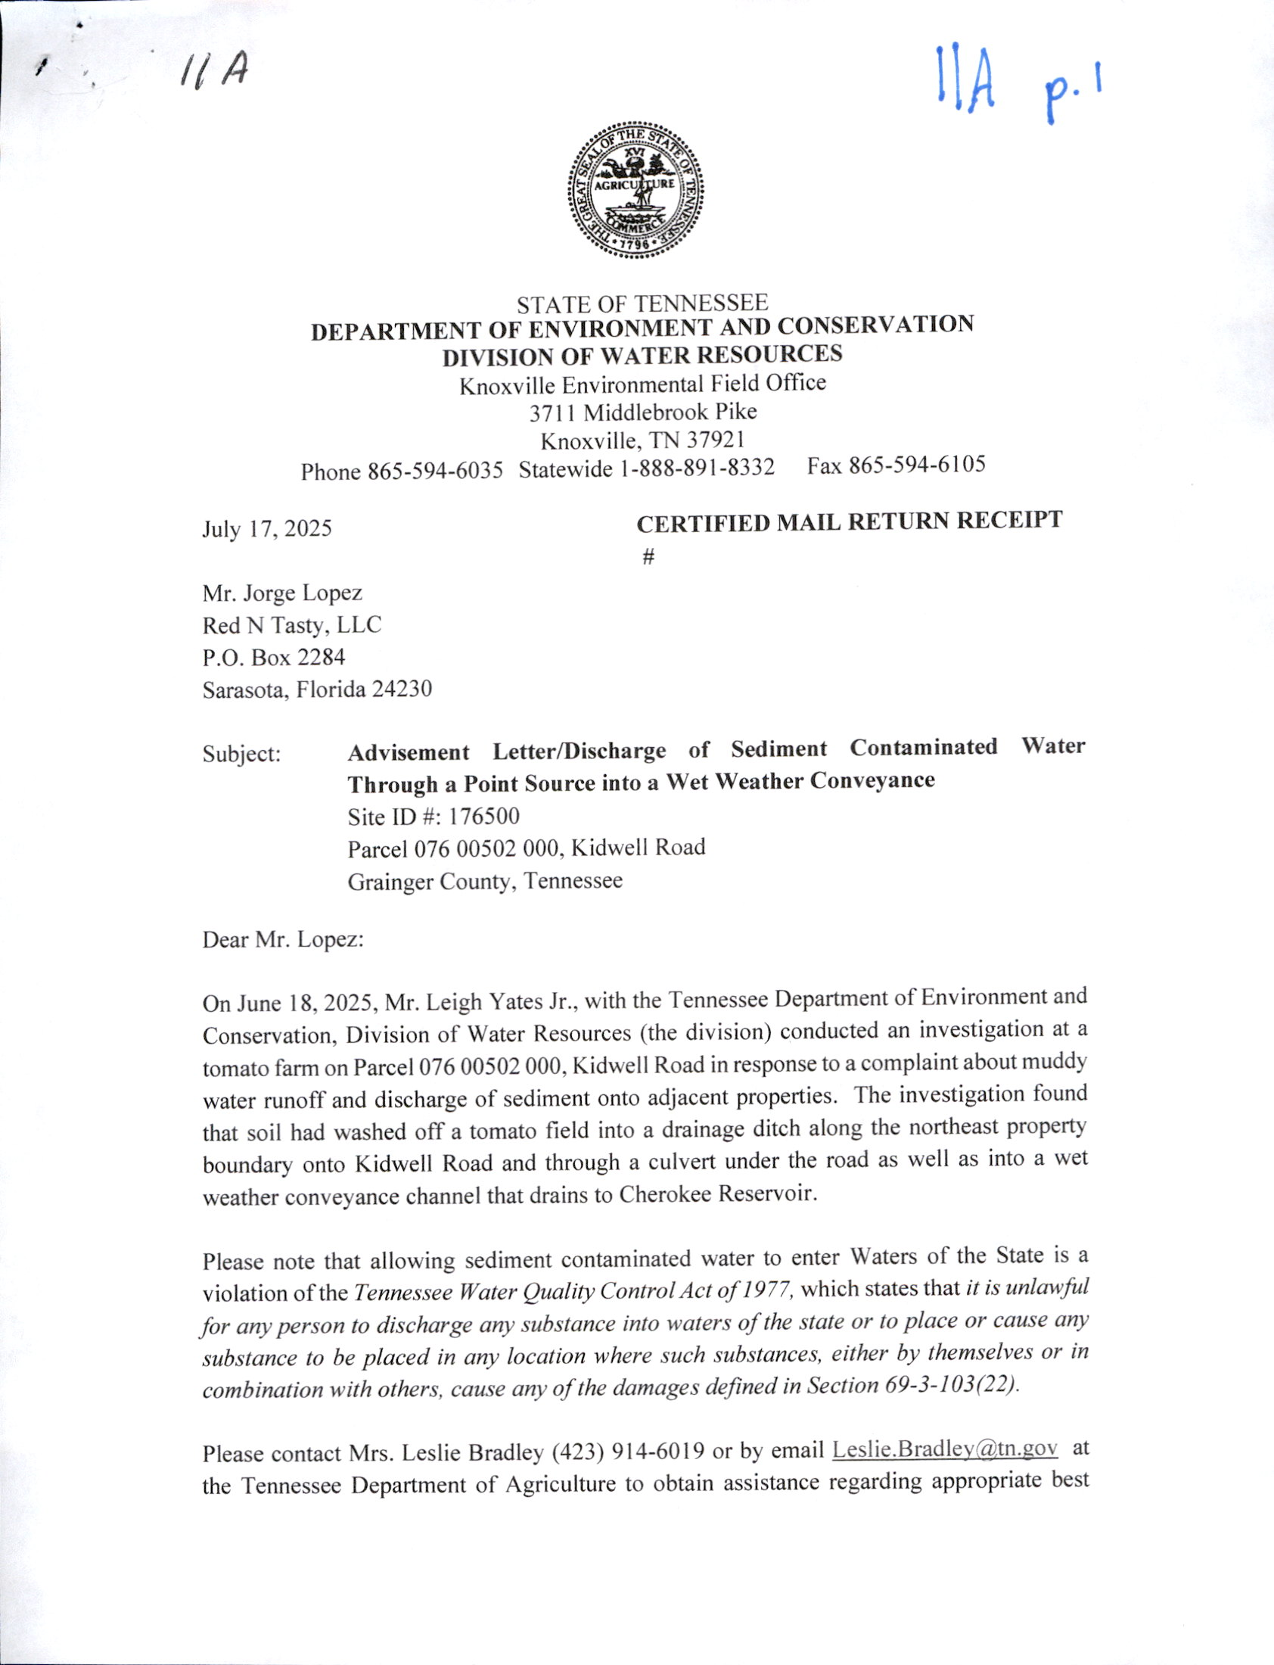
.
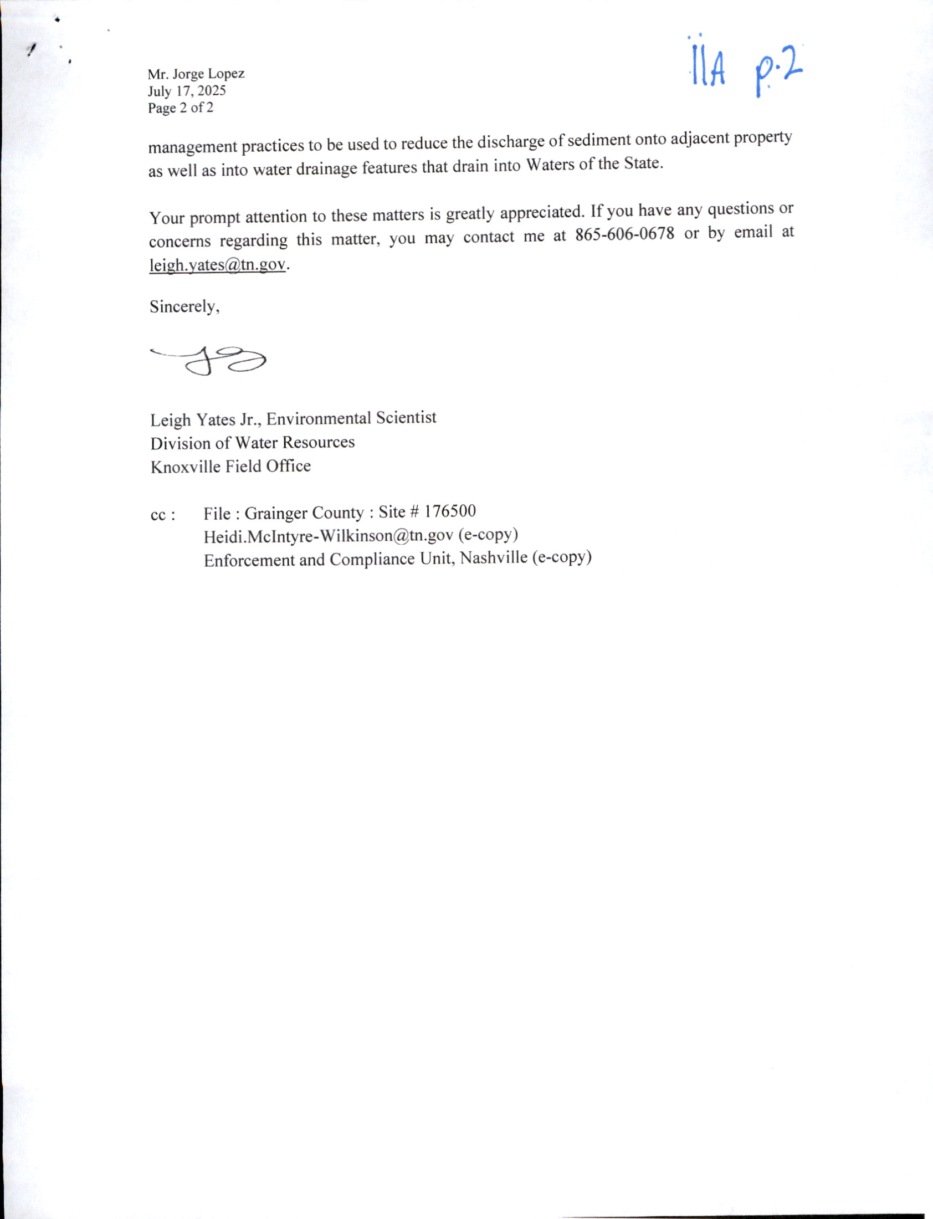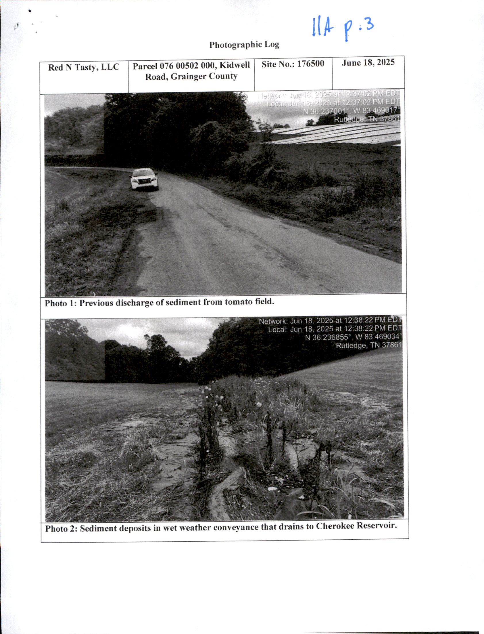
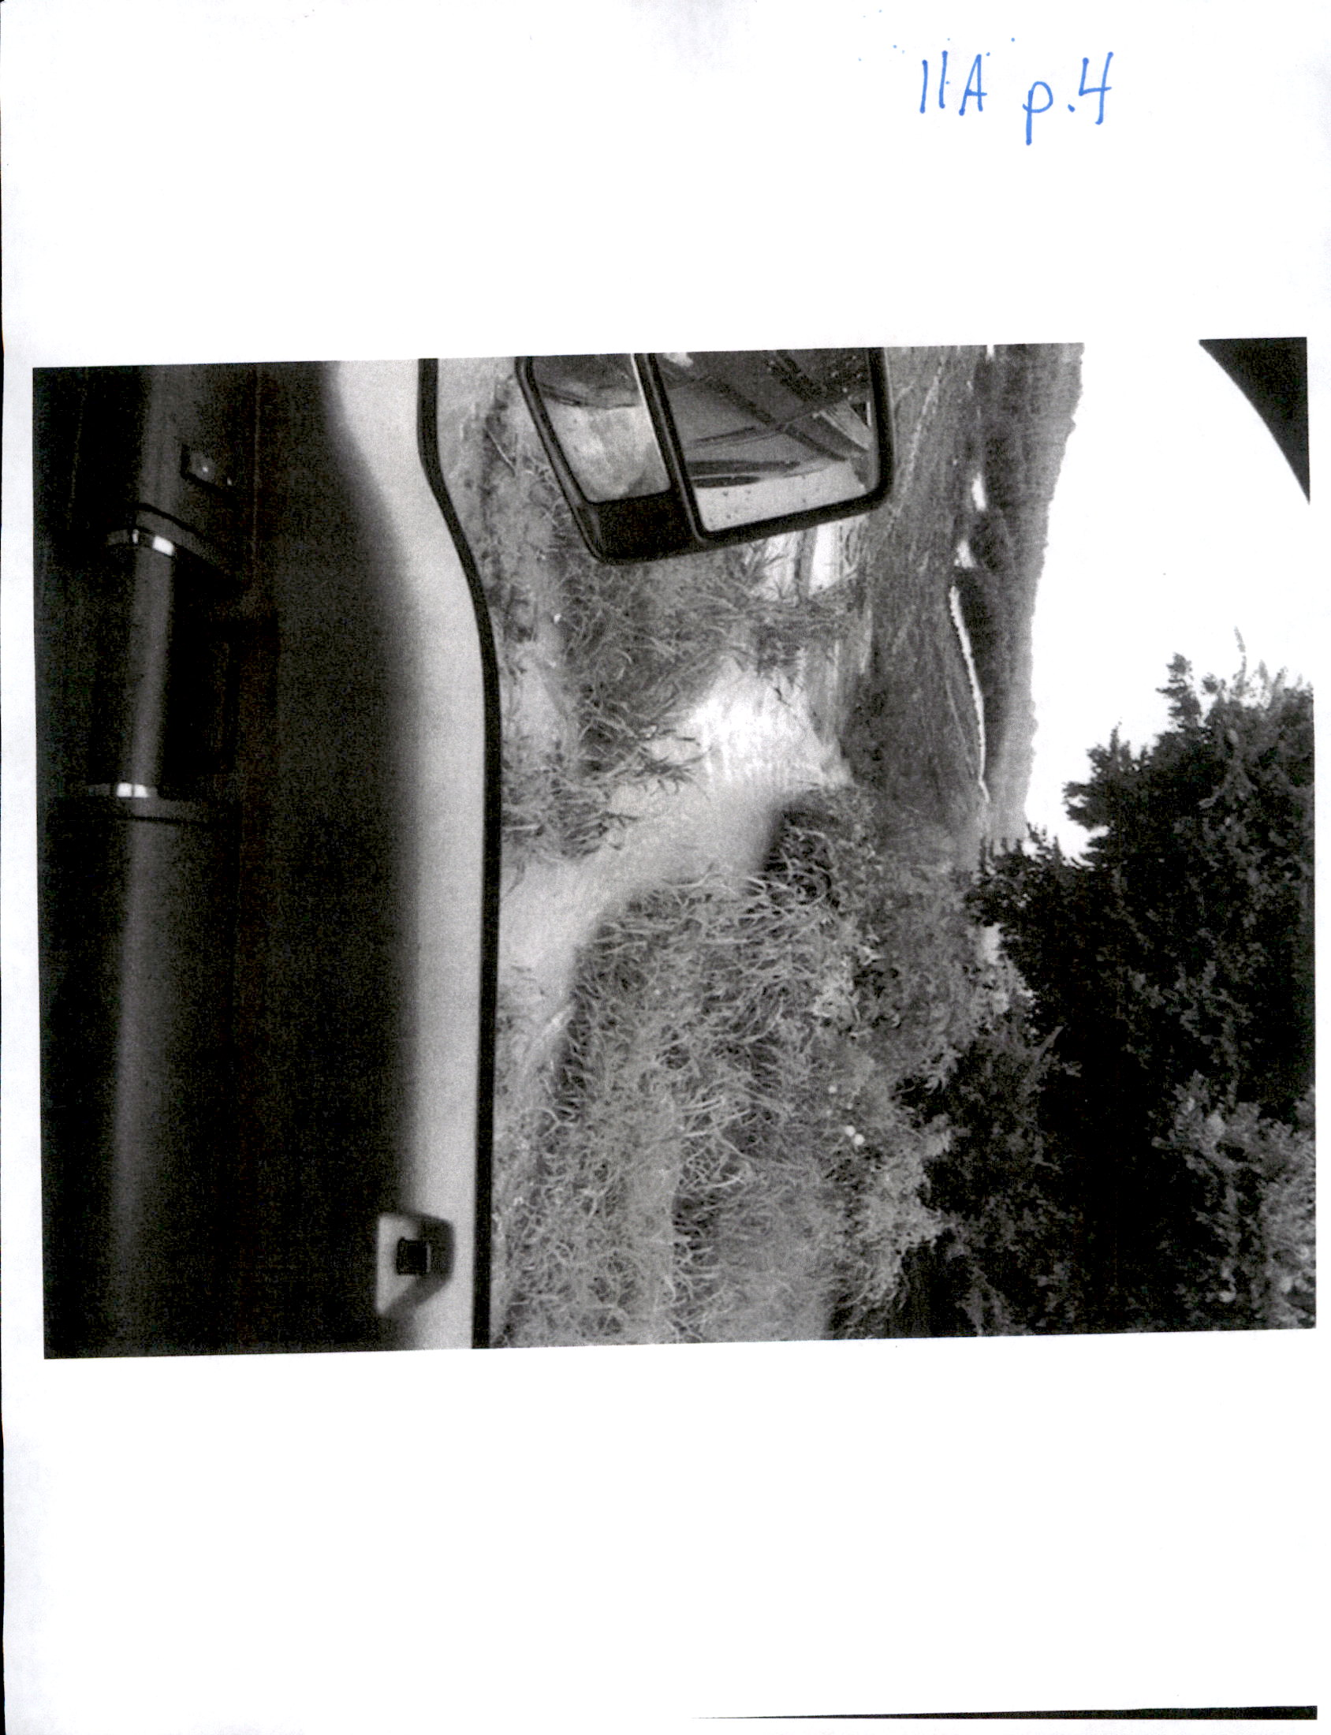

**************

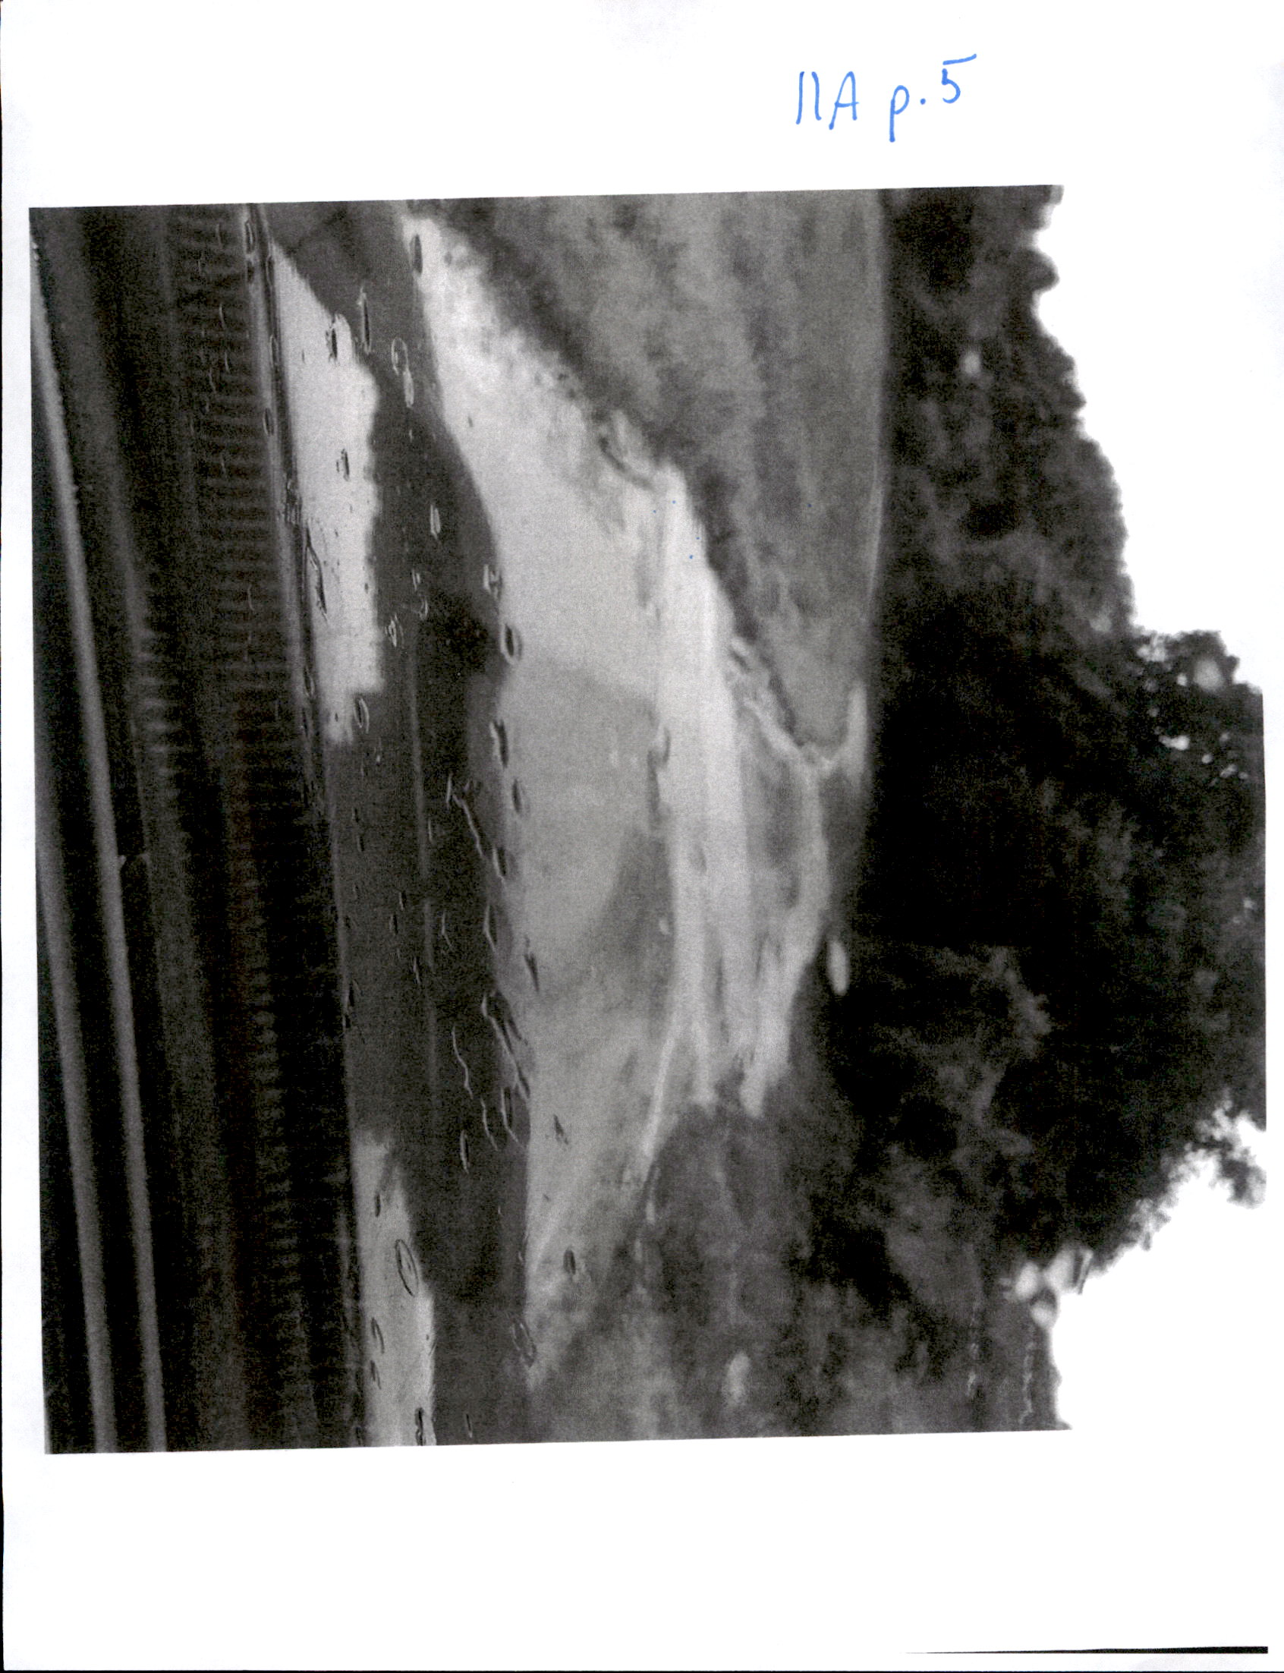

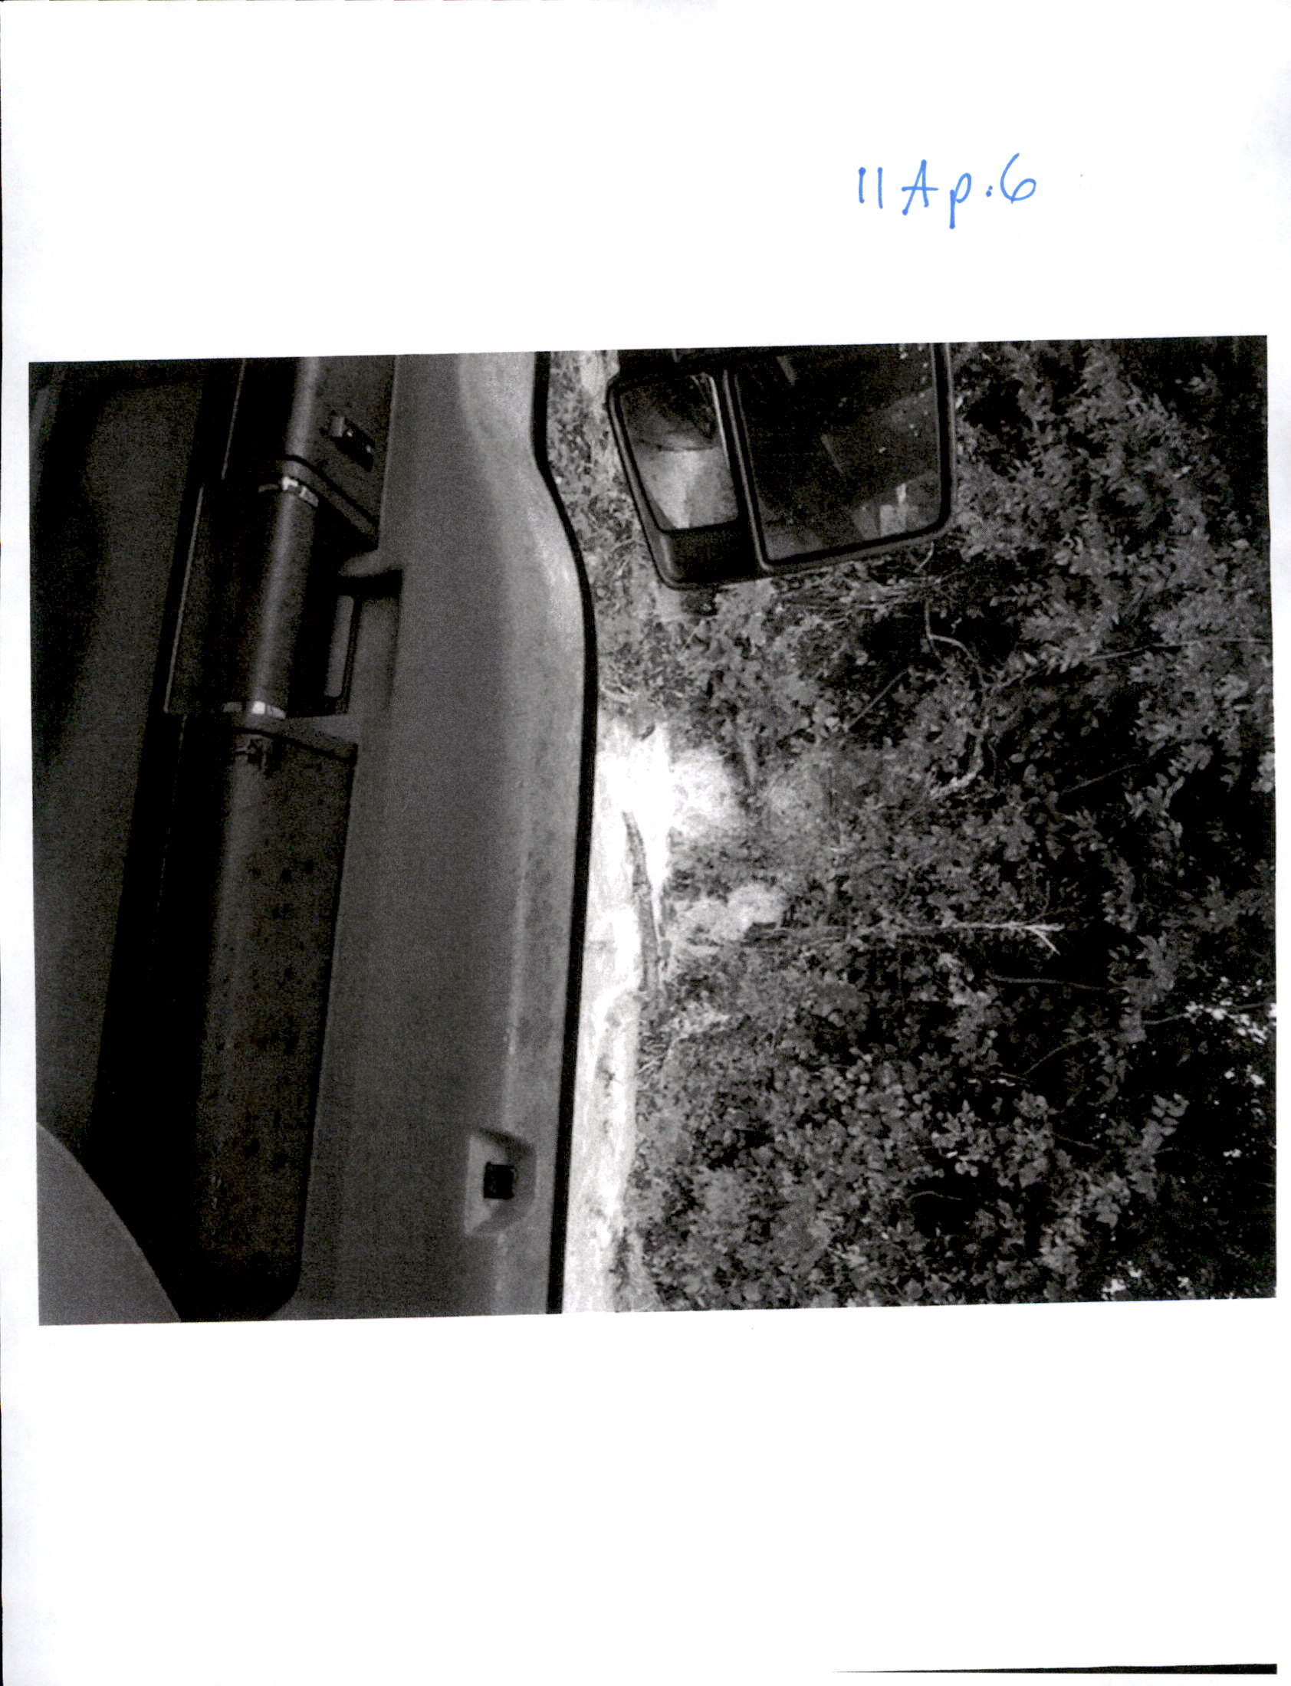

REPORTS, MONTHLY, QUARTERLY & ANNUALLY, Sheriff
Report Only
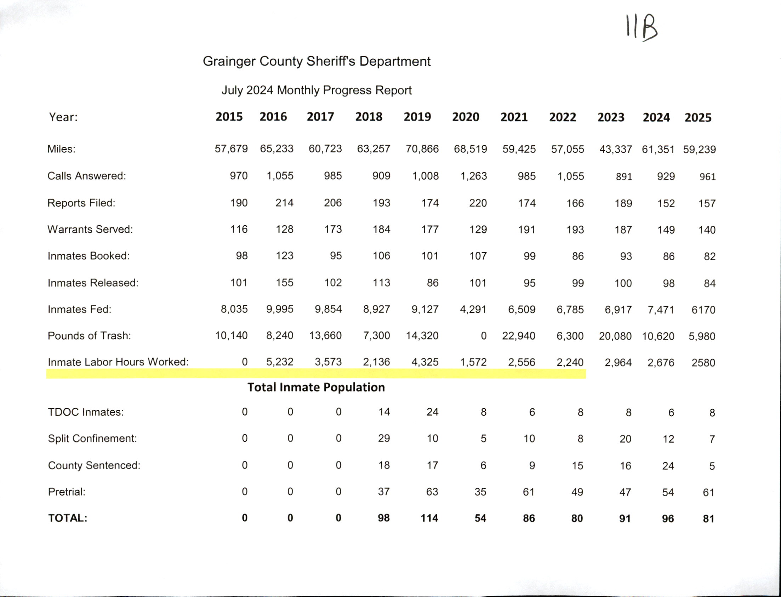

0REPORTS, MONTHLY, QUARTERLY & ANNUALLY, Trustee Monthly Report
No Motions/Report Only

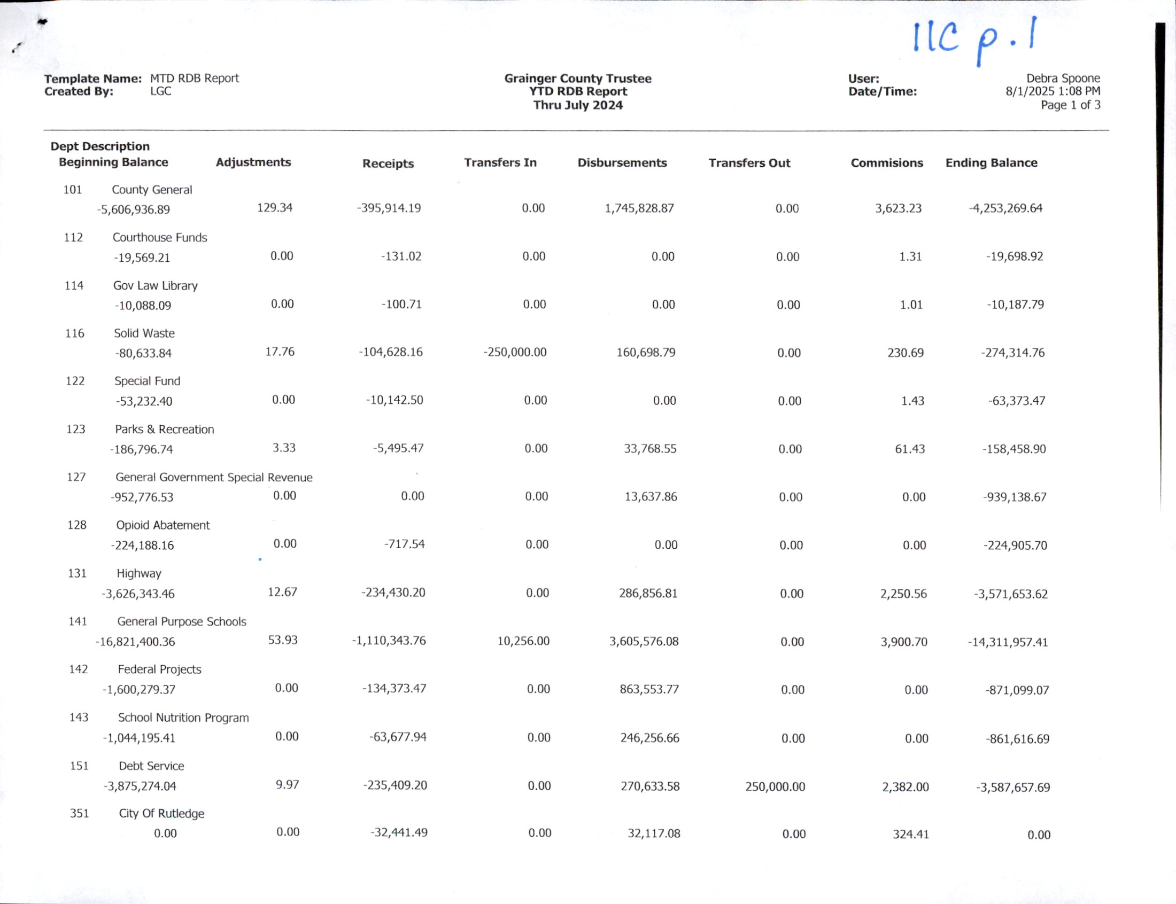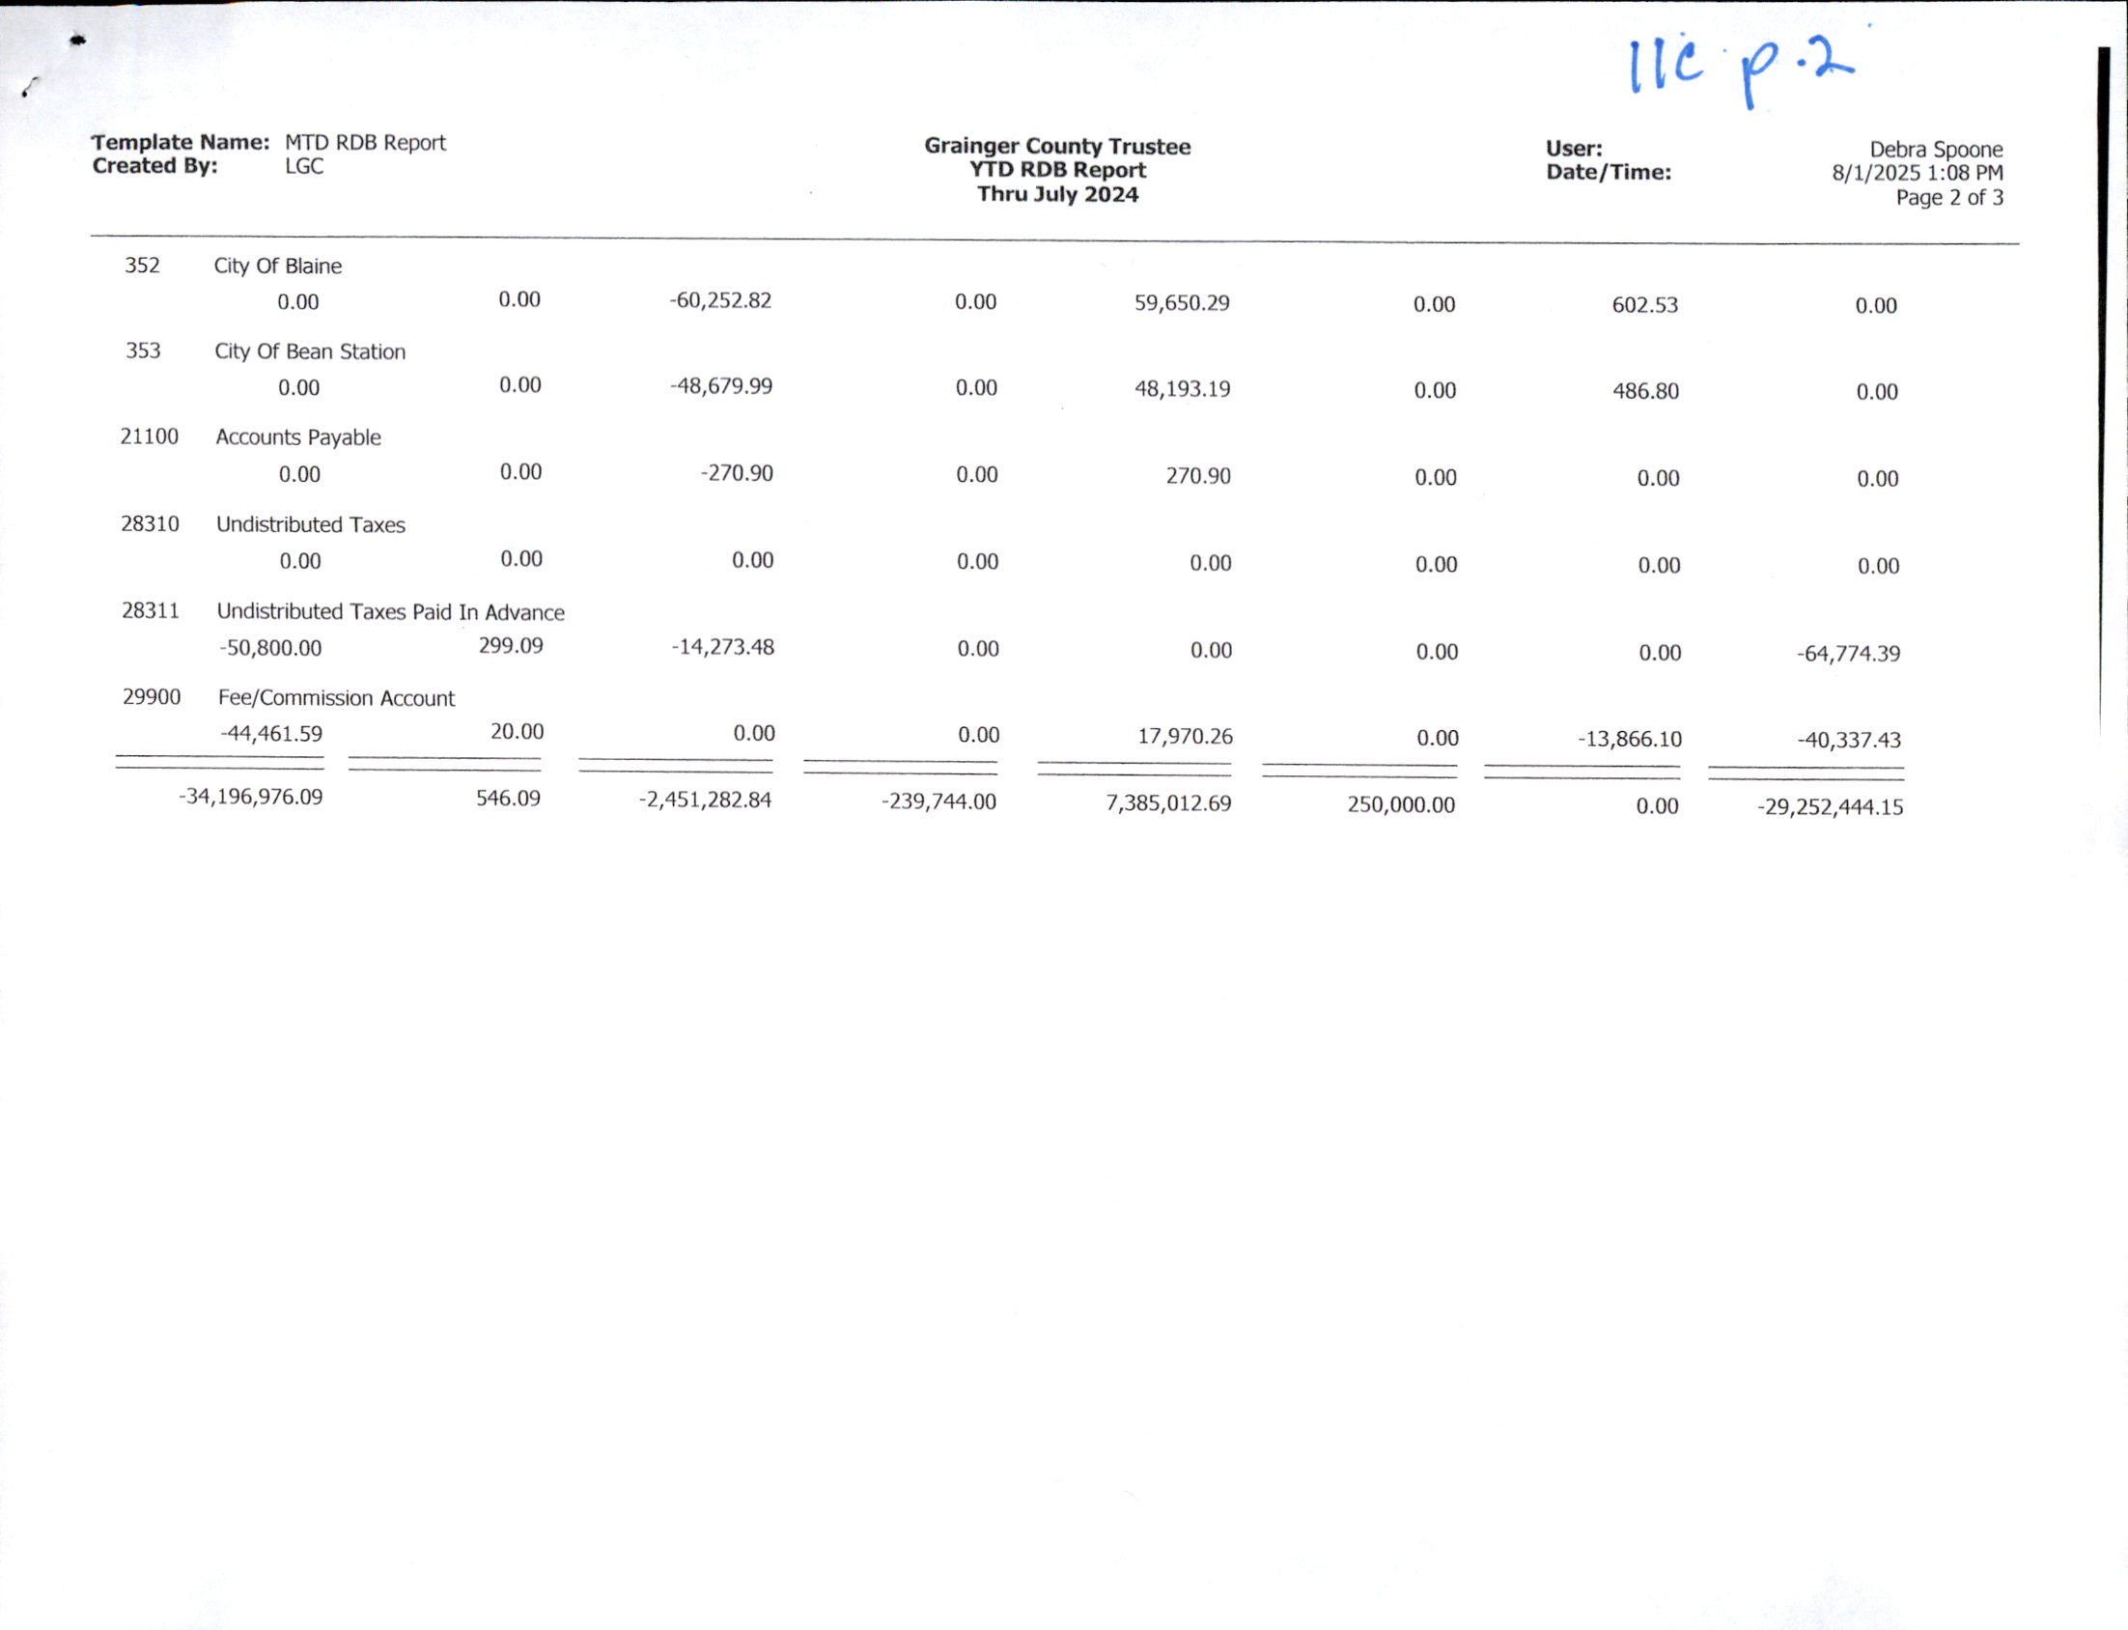

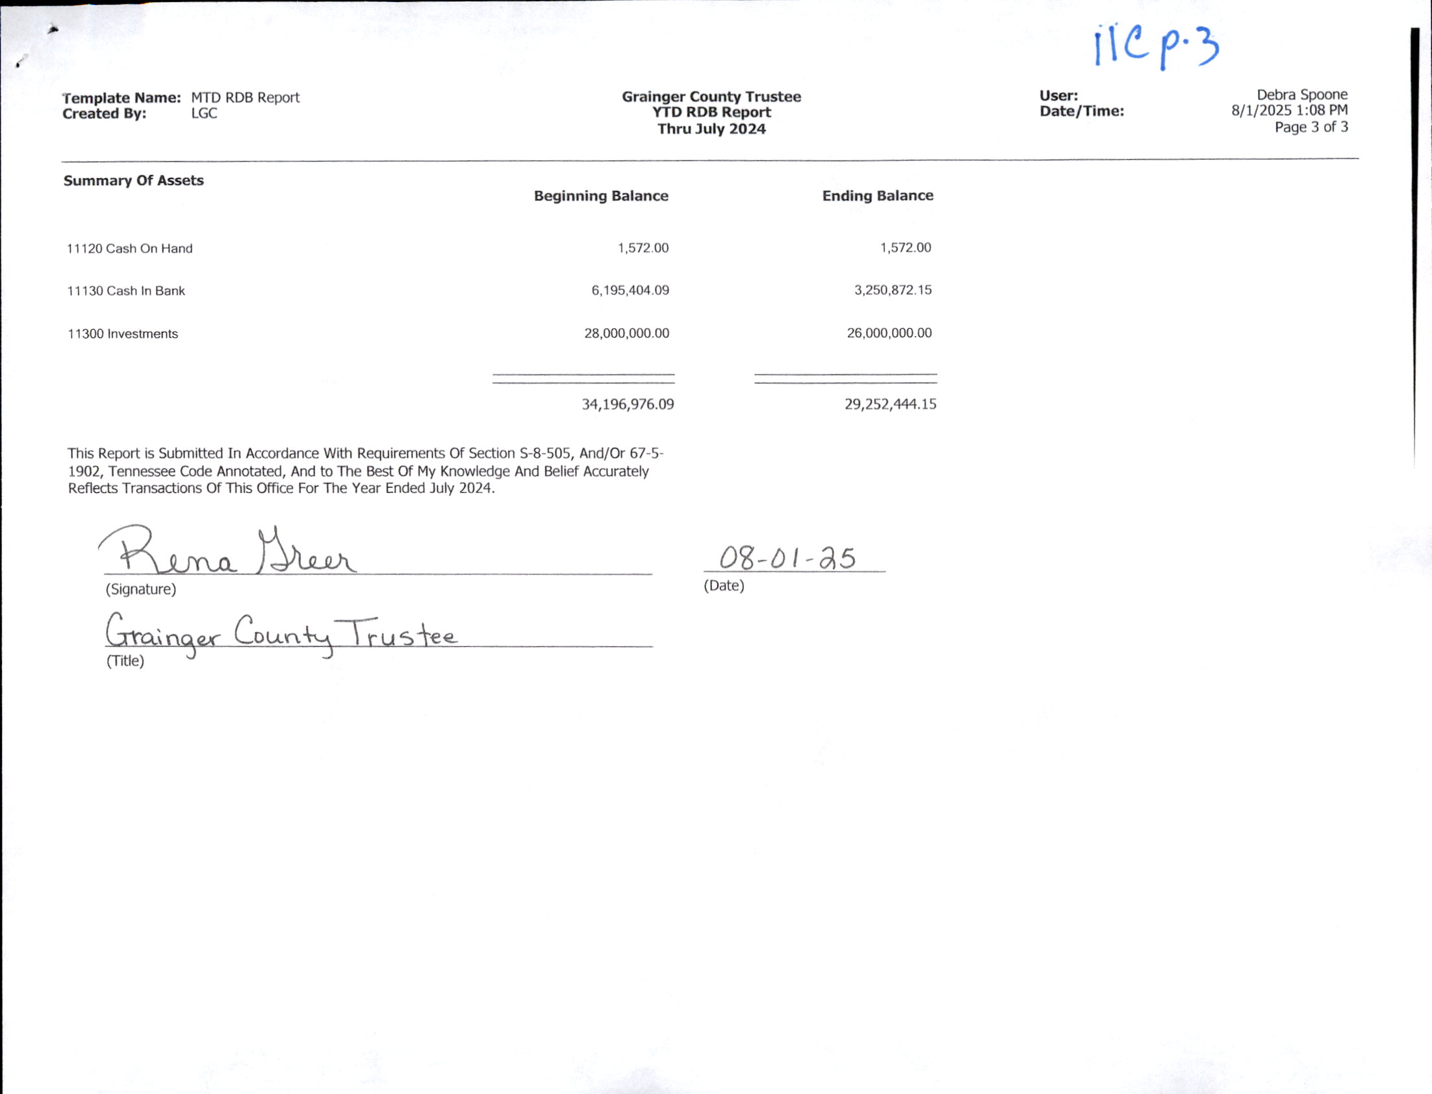

***************

***************

COMMITTEE/DIRECTOR REPORTS, Parks and Recreation
Report/No Motions

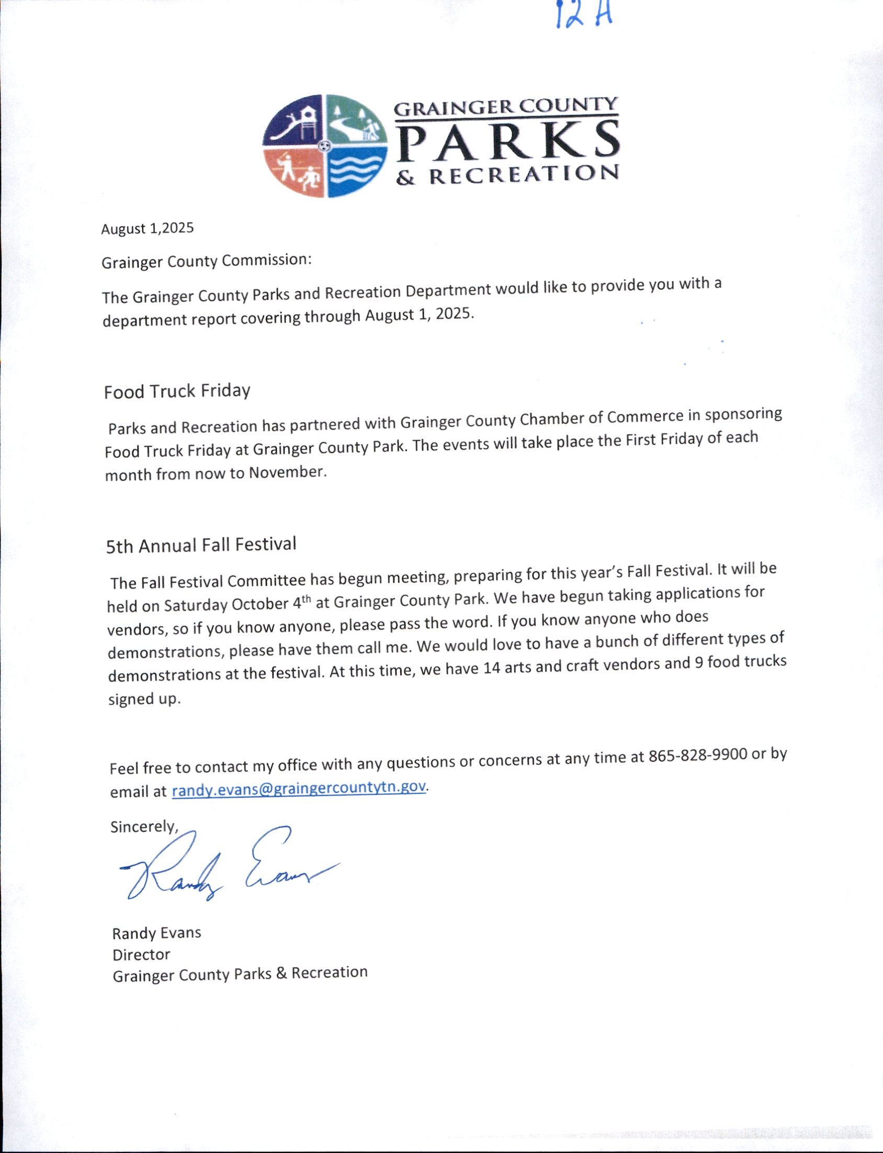

***************

COMMITTEE/DIRECTOR REPORTS, EMS
Report/No Motions

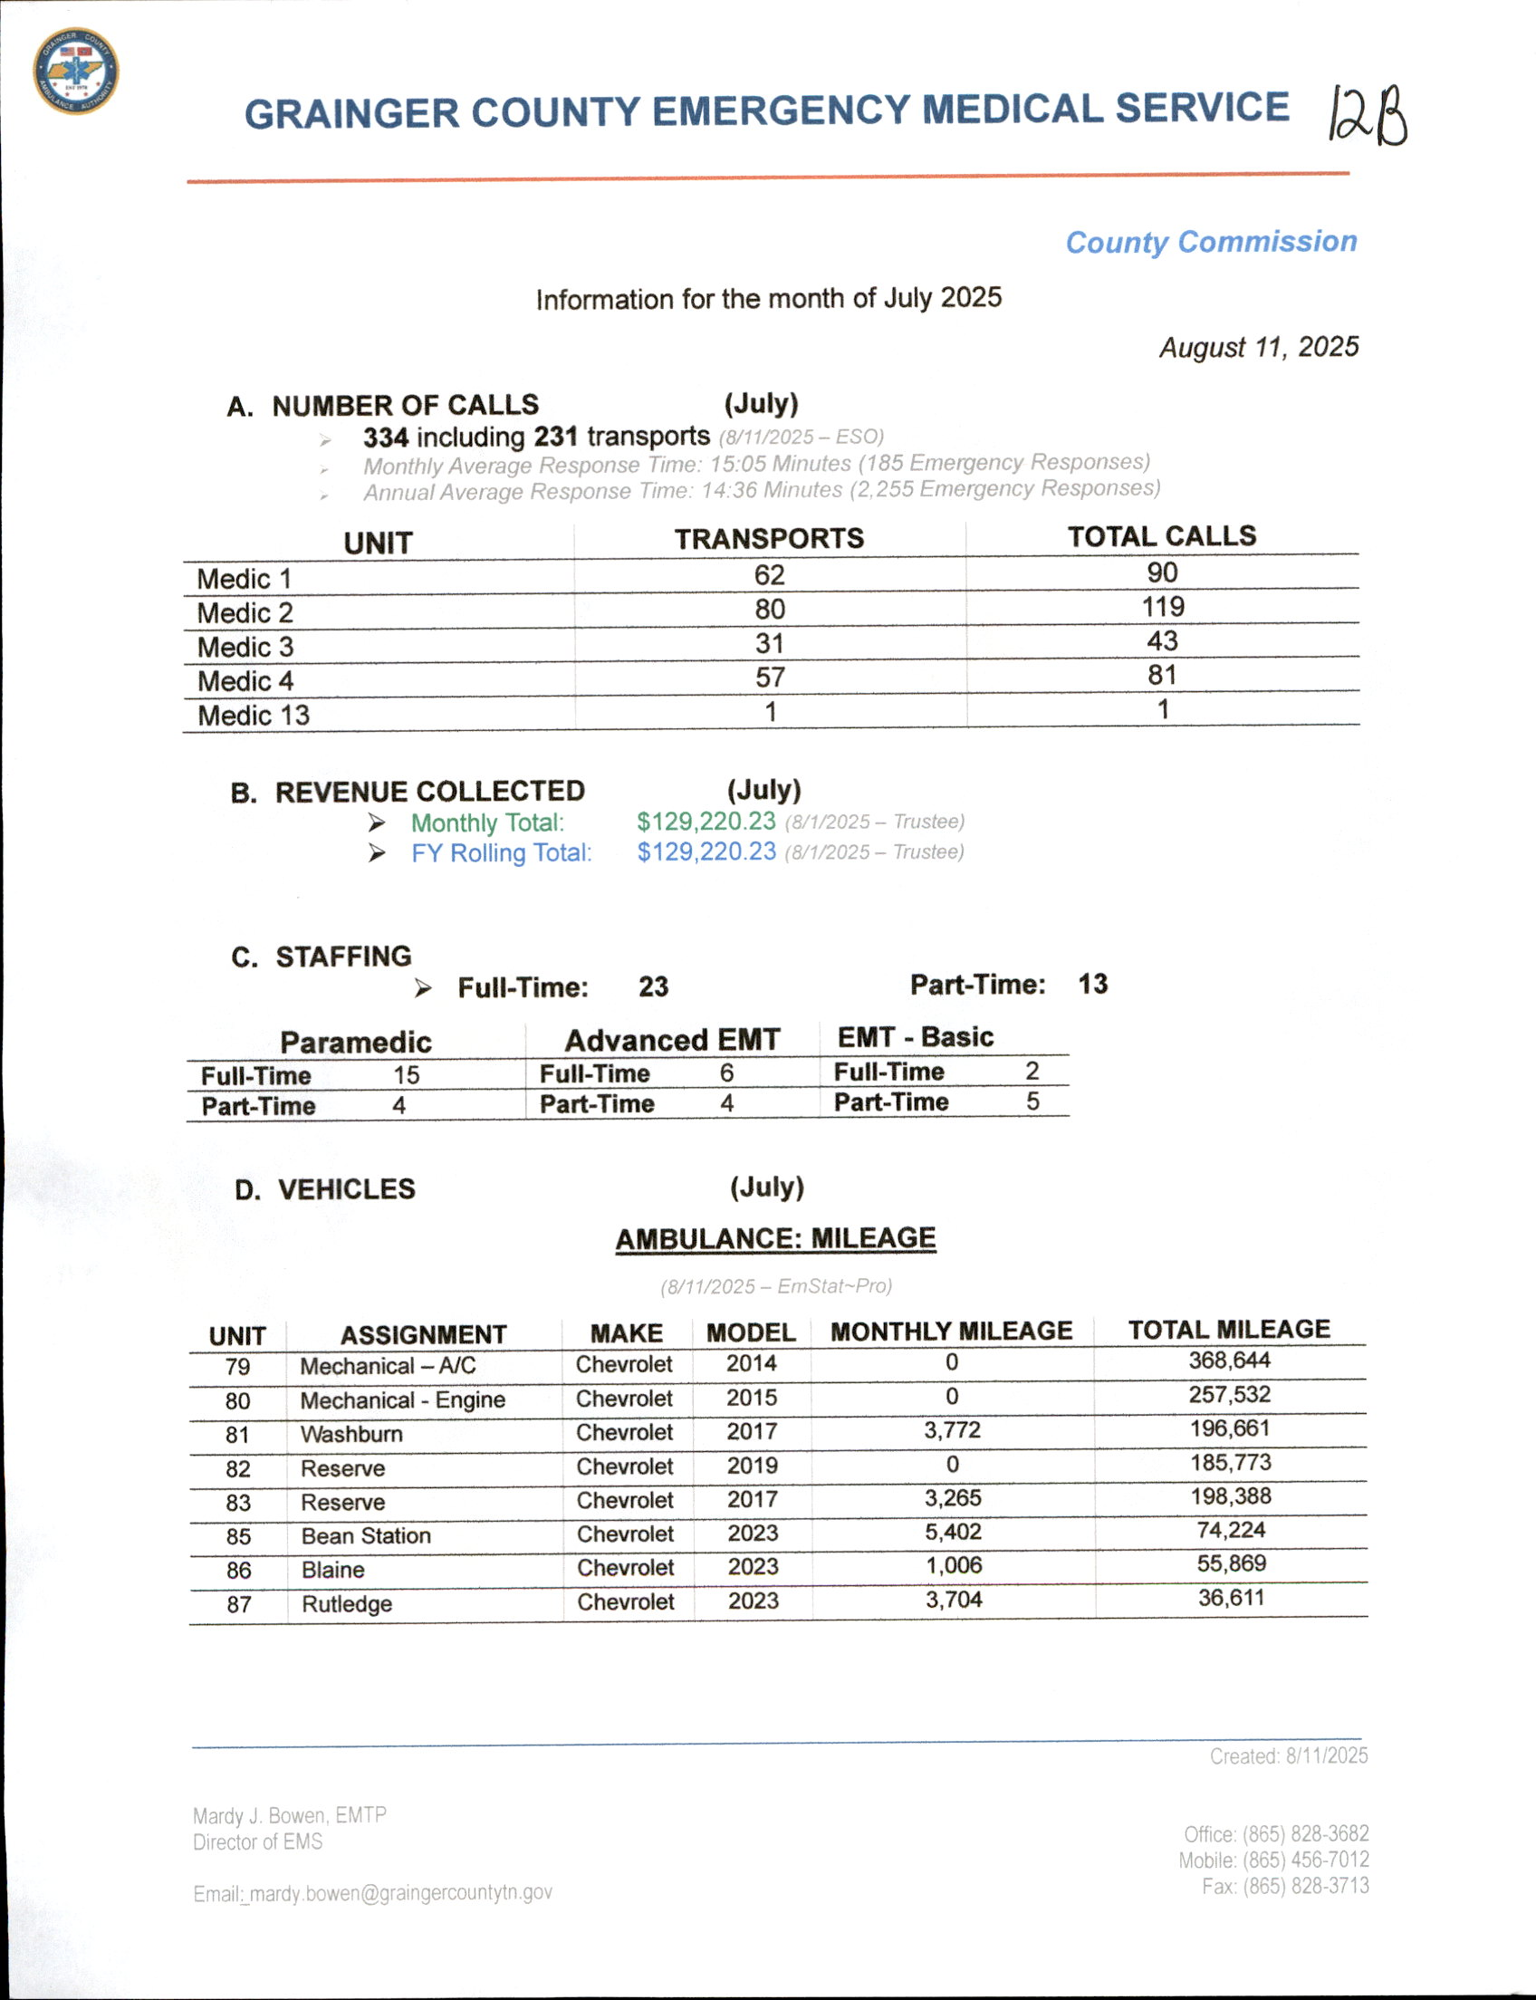

COMMITTEE/DIRECTOR REPORTS; E-911
No Motions

*************

COMMITTEE/DIRECTOR REPORTS; Sanitation
No Motions/Report

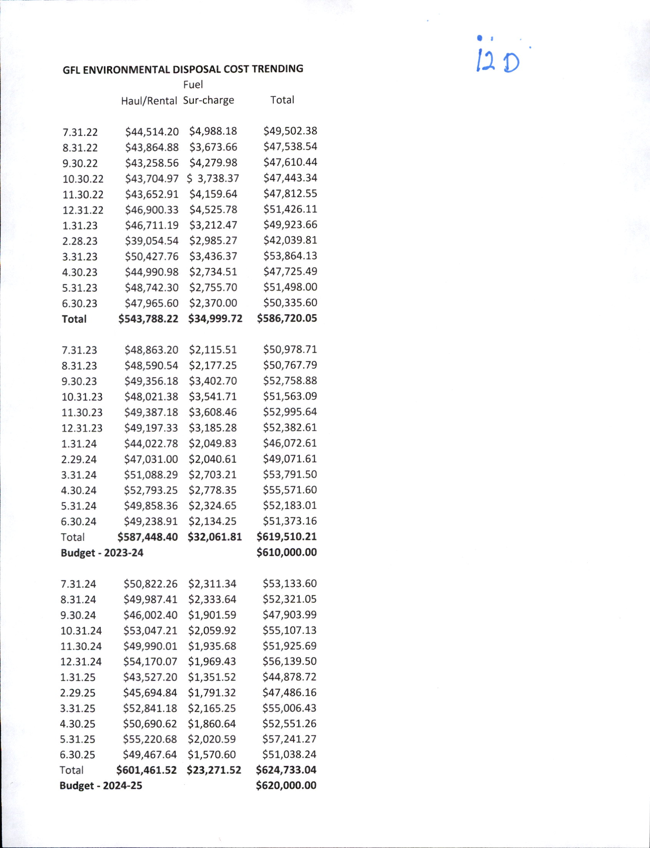

**************

BUDGET AMENMENTS;13A; Various Offices
UPON MOTION of Commissioner JENNIFER HOLT, Seconded by Commissioner ED MCBEE, the Commission approved the budget amendments for various offices from the General Fund by Roll Call Vote as Follows:

AYE: DARELL STRATTON, SCOTT WYNN, ED MCBEE, RODNEY OVERBAY, LUKE STRATTON, ANDY CAMERON, TINA DAVIS, DARRELL WILLIAMS, JAMES ACUFF, JUSTIN EPPERSON, JENNIFER HOLT, ANNA BLANKEN, JESSE CLINE AND MIKE HOLT. (14)

NAY: (0)

ABSENT: WENDY NOE. (1)
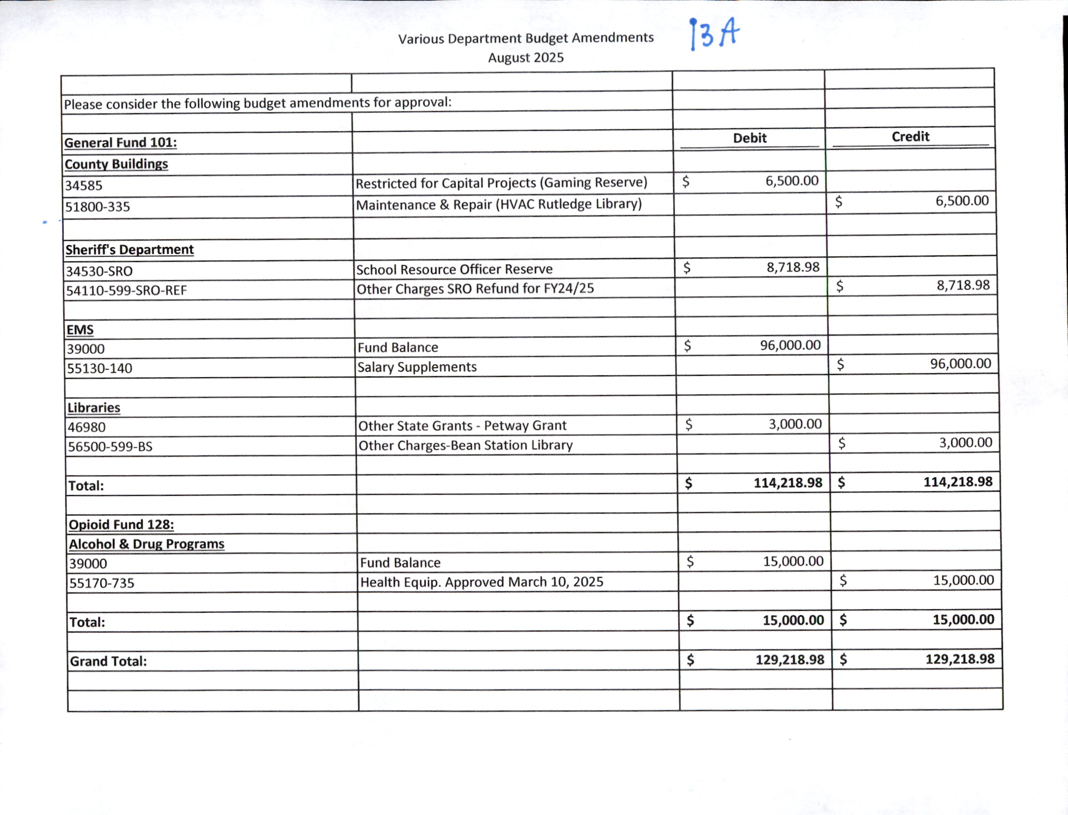

***************

***************

RESOLUTIONS;8.11.25A; $12.50 Fee Collected by Court Clerks
UPON MOTION of Commissioner LUKE STRATTON, Seconded by Commissioner JAMES ACUFF, the Commission approved Resolution 8.11.25A, authorizing a twelve dollar and fifty cent charge ( $12.50) by the clerk of every court in Grainger County having jurisdiction of state misdemeanors and felonies for the purposes authorized and set out in T.C.A. 40-3-106 by Roll Call Vote as Follows:

AYE: DARELL STRATTON, ED MCBEE, RODNEY OVERBAY, LUKE STRATTON, ANDY CAMERON, DARRELL WILLIAMS, JAMES ACUFF, JENNIFER HOLT, ANNA BLANKEN, JESSE CLINE AND MIKE HOLT. (11)

NAY: SCOTT WYNN, TINA DAVIS AND JUSTIN EPPERSON. (3)

ABSENT: WENDY NOE. (1)
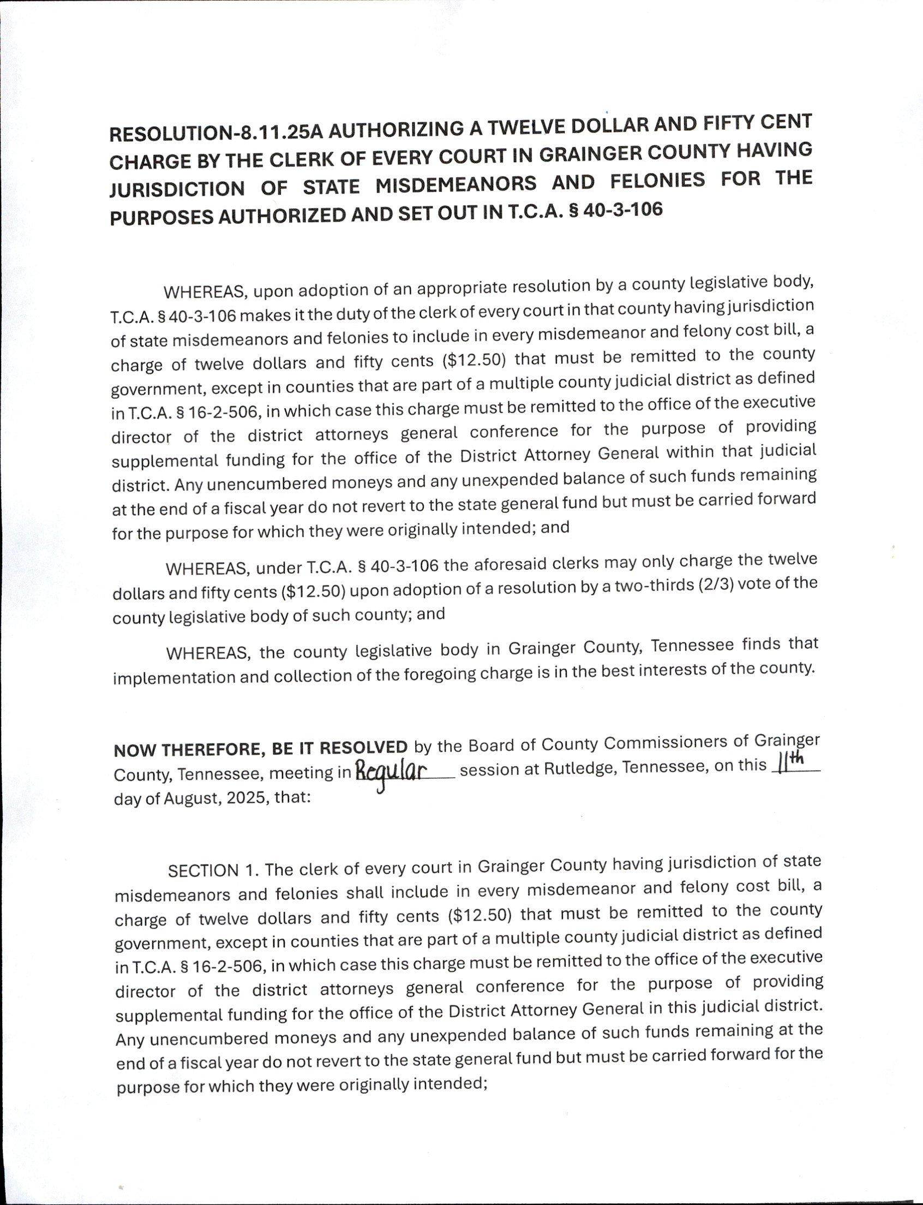

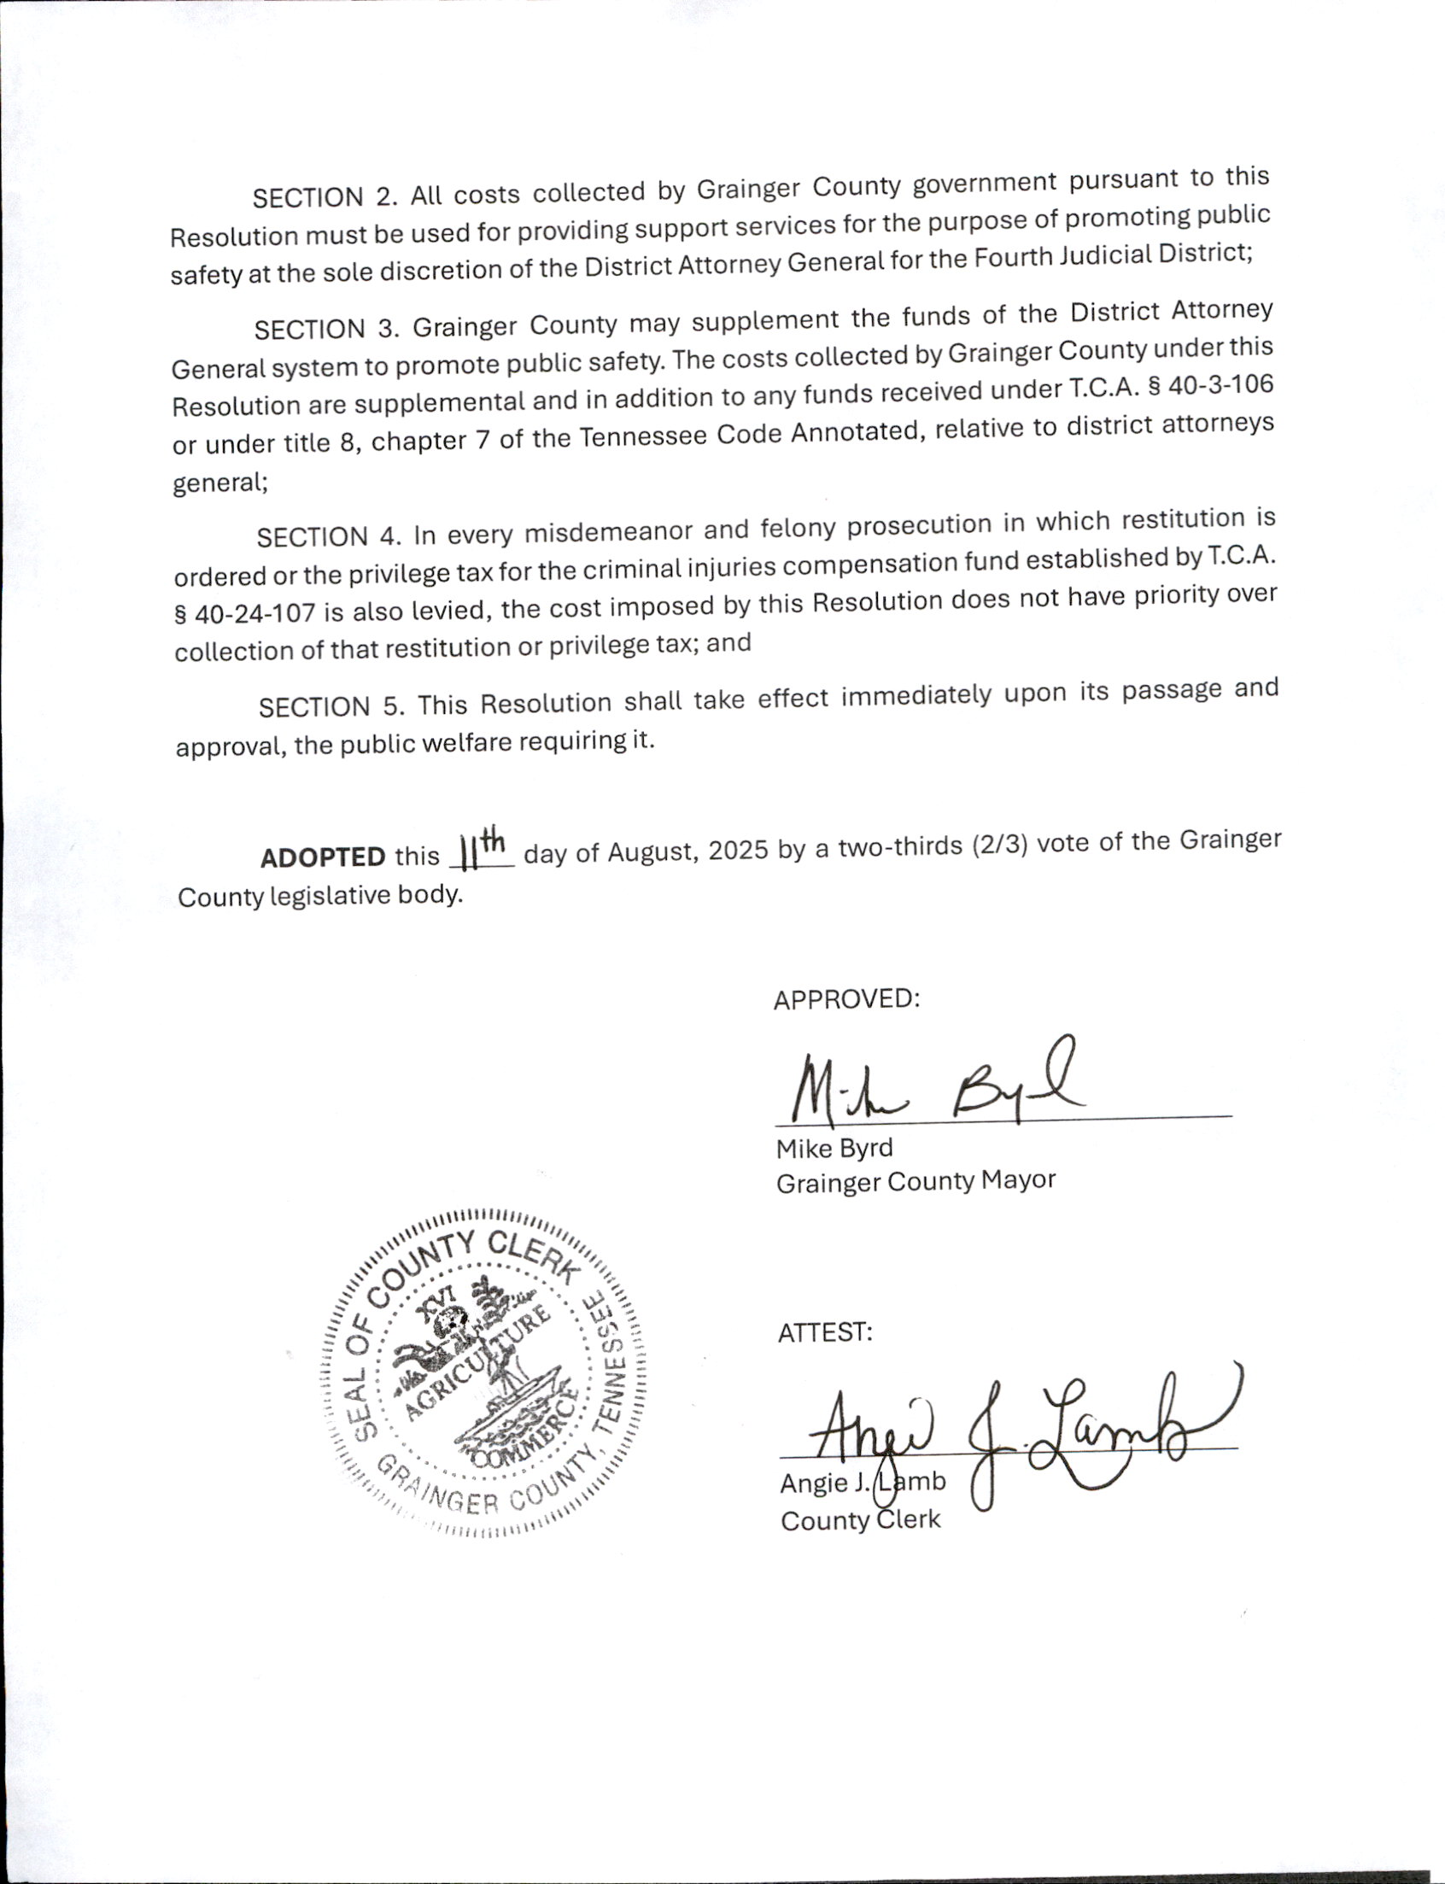

***************

RESOLUTIONS;8.11.25B; Authorizing Grainger County to apply for 2025 FEMA Disaster Grant
UPON MOTION of Commissioner JAMES ACUFF, Seconded by Commissioner JENNIFER HOLT, the Commission approved Resolution 8.11.25B, authorizing Grainger County to apply for a 2025 FEMA Disaster Grant by Roll Call Vote as Follows:

AYE: DARELL STRATTON, SCOTT WYNN, ED MCBEE, RODNEY OVERBAY, LUKE STRATTON, ANDY CAMERON, TINA DAVIS, DARRELL WILLIAMS, JAMES ACUFF, JUSTIN EPPERSON, JENNIFER HOLT, ANNA BLANKEN, JESSE CLINE AND MIKE HOLT. (14)

NAY: (0)

ABSENT: WENDY NOE. (1)

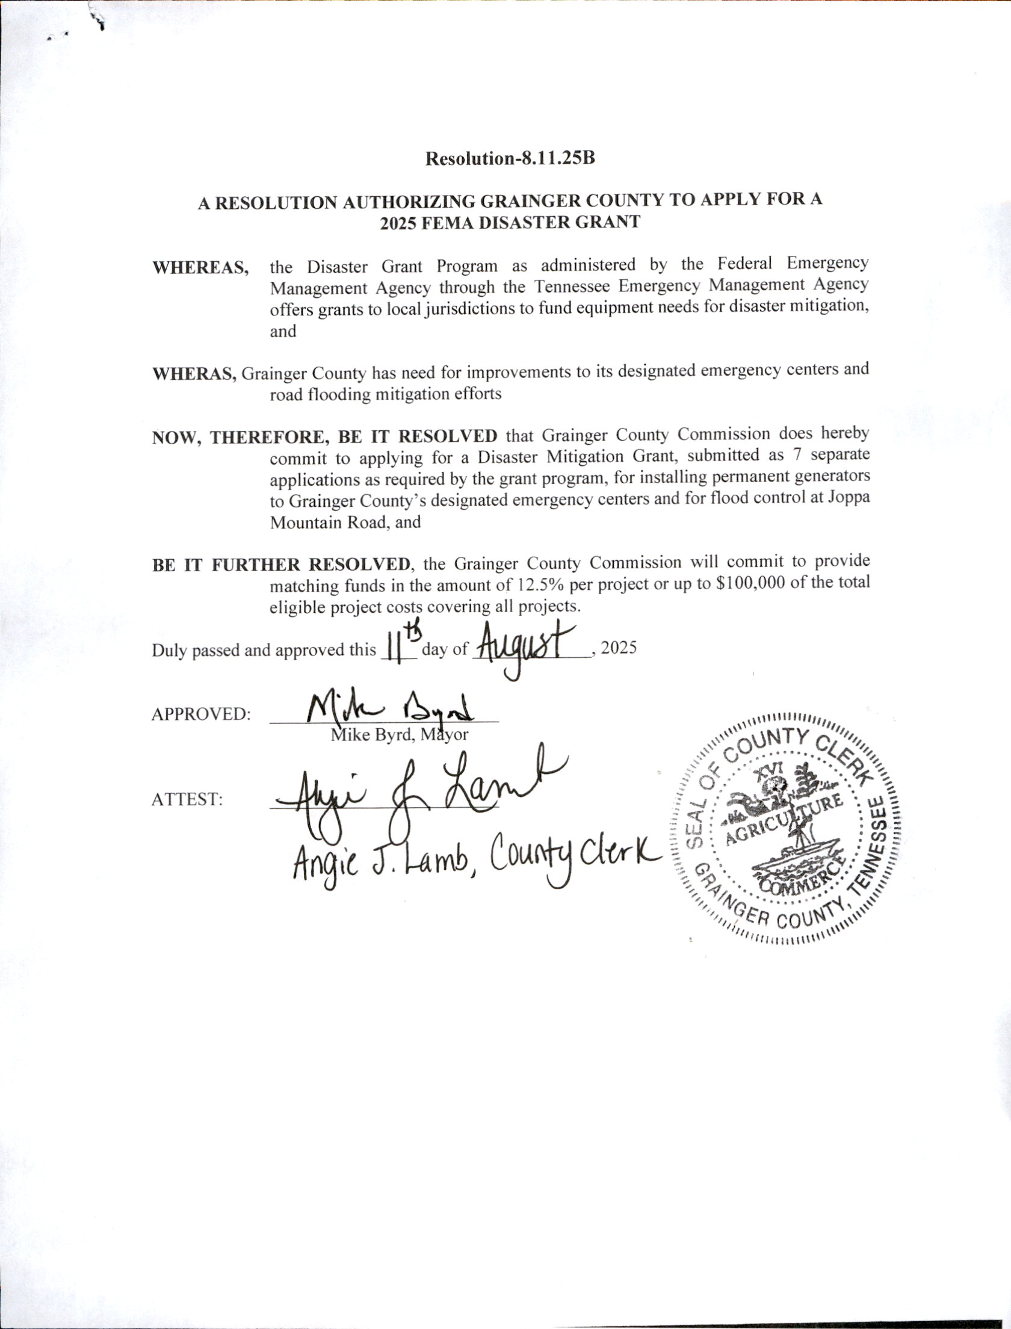

***************

NEW BUSINESS, 15A; Howell Road
UPON MOTION of Commissioner ED MCBEE, Seconded by Commissioner ANNA BLANKEN, the request to set the speed limit to 25mph on Howell Road FAILED by Roll Call Vote as Follows:

AYE: ED MCBEE, TINA DAVIS, DARRELL WILLIAMS, JENNIFER HOLT AND ANNA BLANKEN. (5)

NAY: SCOTT WYNN, DARELL STRATTON, RODNEY OVERBAY, LUKE STRATTON, ANDY CAMERON, JAMES ACUFF, JUSTIN EPPERSON, JESSE CLINE AND MIKE HOLT. (9)

ABSENT: WENDY NOE. (1)

***************

NEW BUSINESS, 15B; Spencer Hollow Road
UPON MOTION of Commissioner SCOTT WYNN, Seconded by Commissioner TINA DAVIS, the Commission tabled item 15B, Spencer Hollow Road speed limit by Voice Vote.

***************

NEW BUSINESS, 15C; Grainger County Sewer Plant Maintenance
UPON MOTION of Commissioner DARELL STRATTON, Seconded by Commissioner RODNEY OVERBAY, the Commission tabled the Grainger County Sewer Plant Maintenance by Voice Vote.

***************

NEW BUSINESS, 15D; Opioid Overdose Awareness Day in Grainger County
UPON MOTION of Commissioner JENNIFER HOLT, Seconded by Commissioner ED MCBEE, the Commission approved $850.00 for Opioid Overdose Awareness Day in Grainger County. The Educational Event will be at the Nance House October 30, 2025. Funding for the event will come from the Opioid Abatement Reserve by Roll Call Vote as Follows:

Debit 128-39000 and Credit 55170-599 $850.00

AYE: DARELL STRATTON, SCOTT WYNN, ED MCBEE, RODNEY OVERBAY, LUKE STRATTON, ANDY CAMERON, TINA DAVIS, DARRELL WILLIAMS, JAMES ACUFF, JUSTIN EPPERSON, JENNIFER HOLT, ANNA BLANKEN, JESSE CLINE AND MIKE HOLT. (14)

NAY: (0)

ABSENT: WENDY NOE. (1)

***************

UNFINISHED BUSINESS, 16A; EMS Vehicle (Ambulance)
UPON MOTION of Commissioner JAMES ACUFF, Seconded by Commissioner ANNA BLANKEN, the request to order a new ambulance for EMS, FAILED, by Roll Call Vote as Follows:

AYE: ED MCBEE, TINA DAVIS, DARRELL WILLIAMS, JAMES ACUFF, JUSTIN EPPERSON, JENNIFER HOLT AND ANNA BLANKEN. (7)

NAY: DARELL STRATTON, SCOTT WYNN, RODNEY OVERBAY, LUKE STRATTON, ANDY CAMERON, JESSE CLINE AND MIKE HOLT. (7)

ABSENT: WENDY NOE. (1)

***************

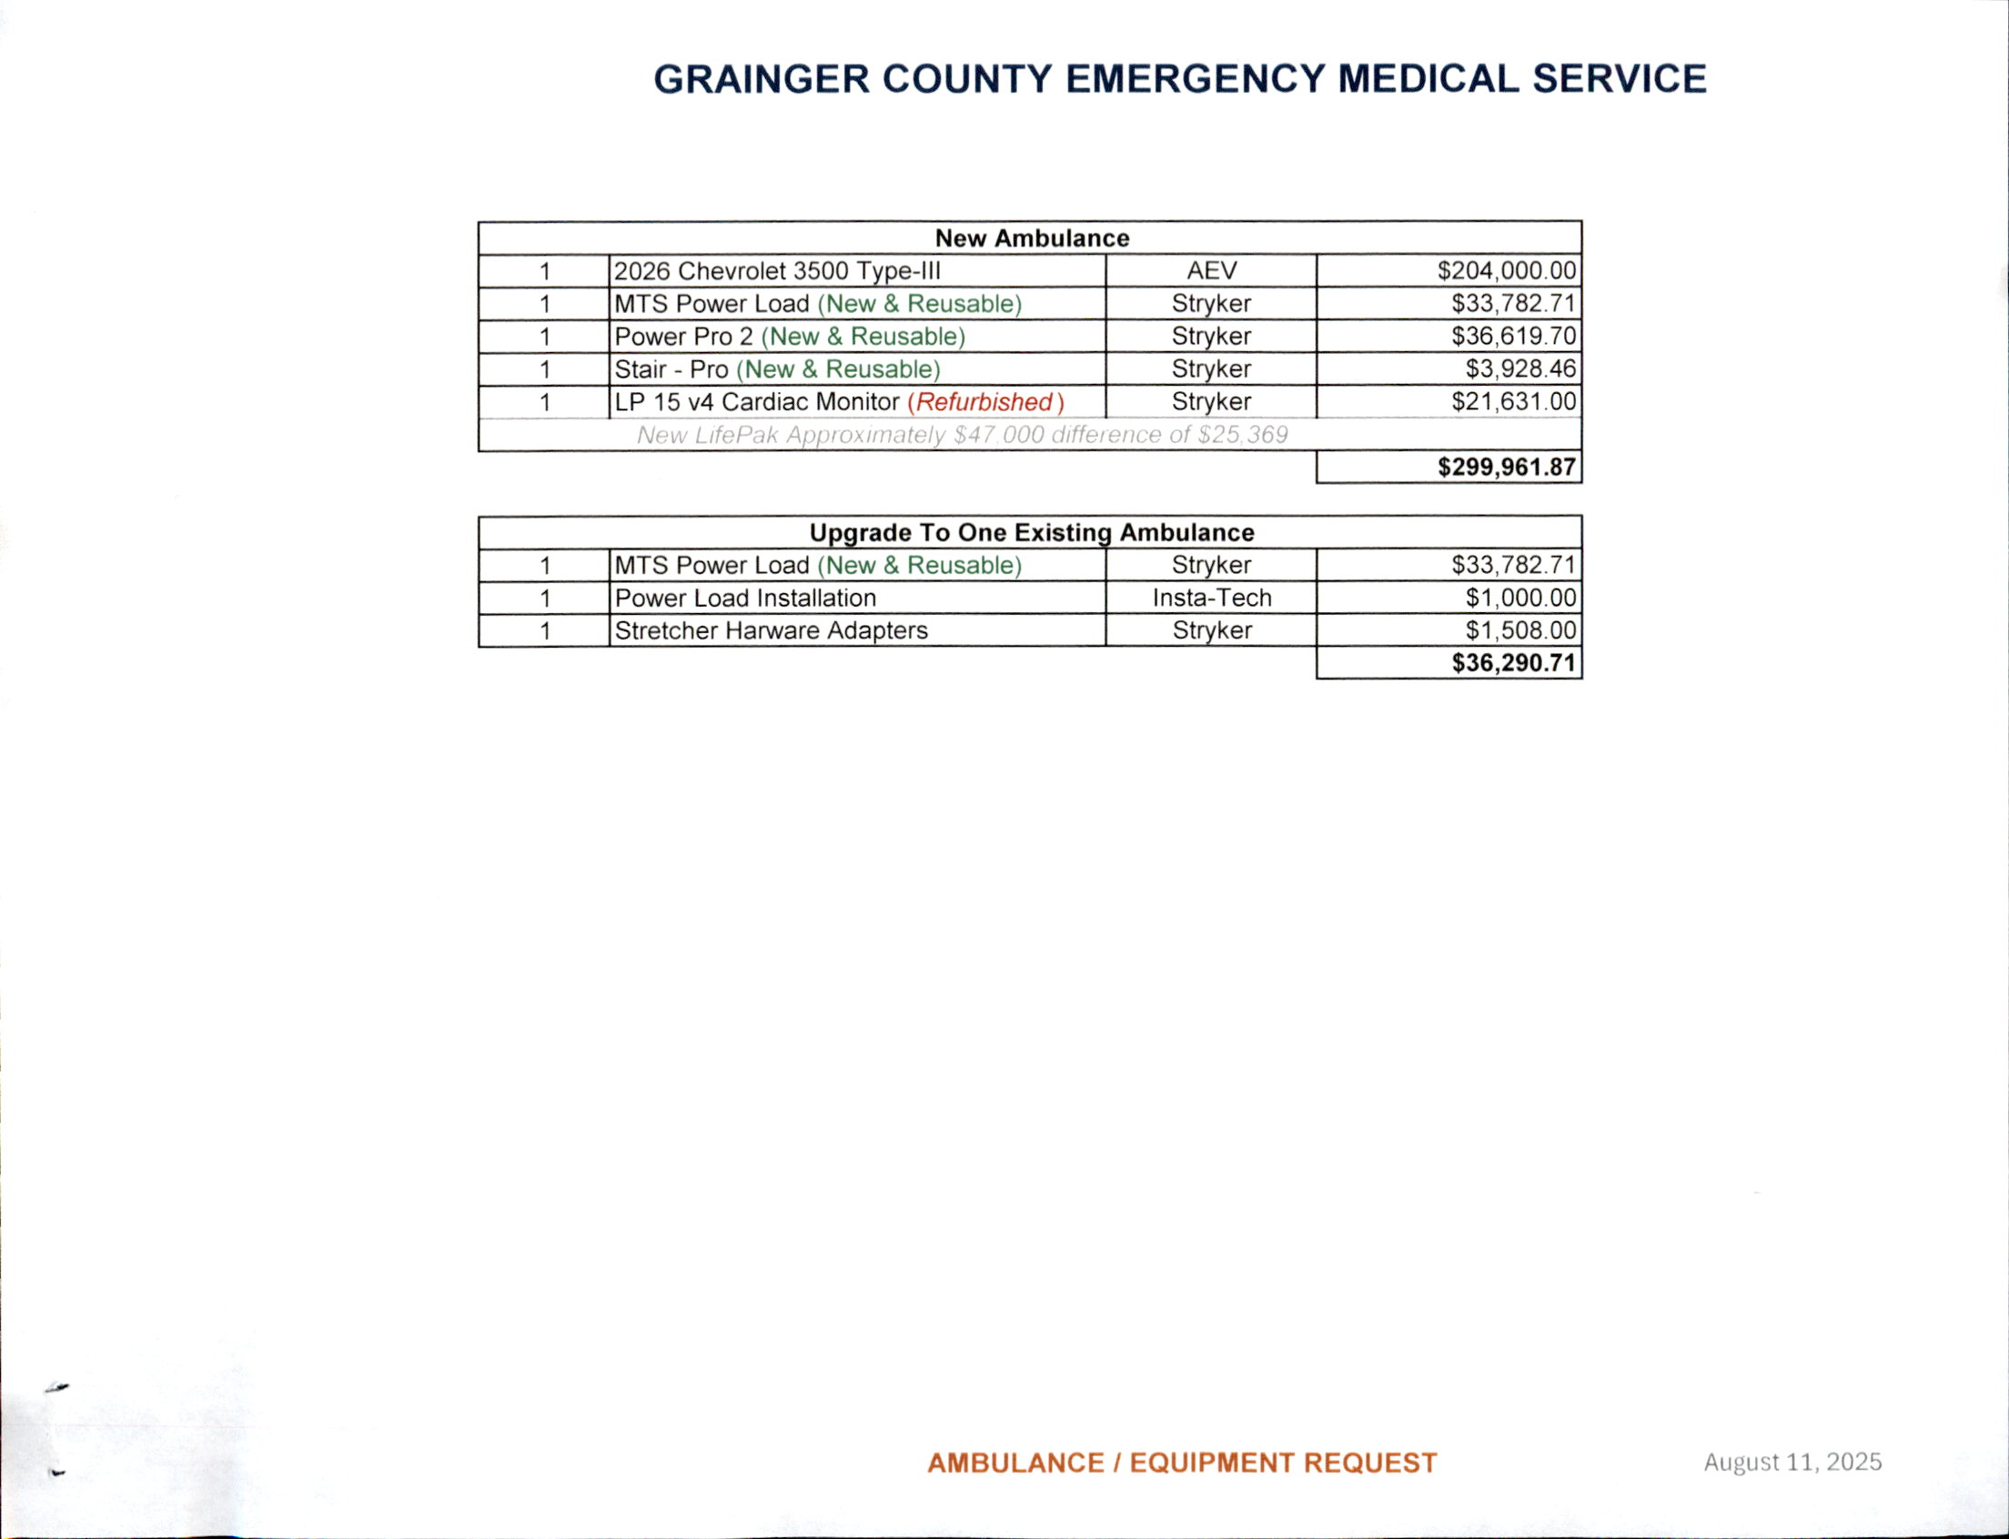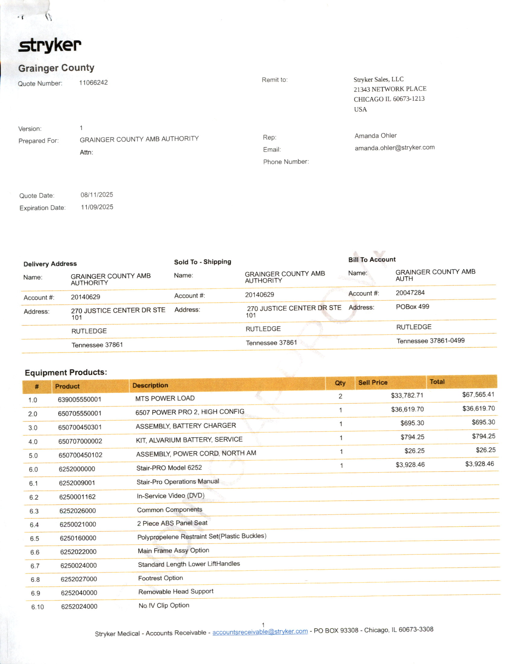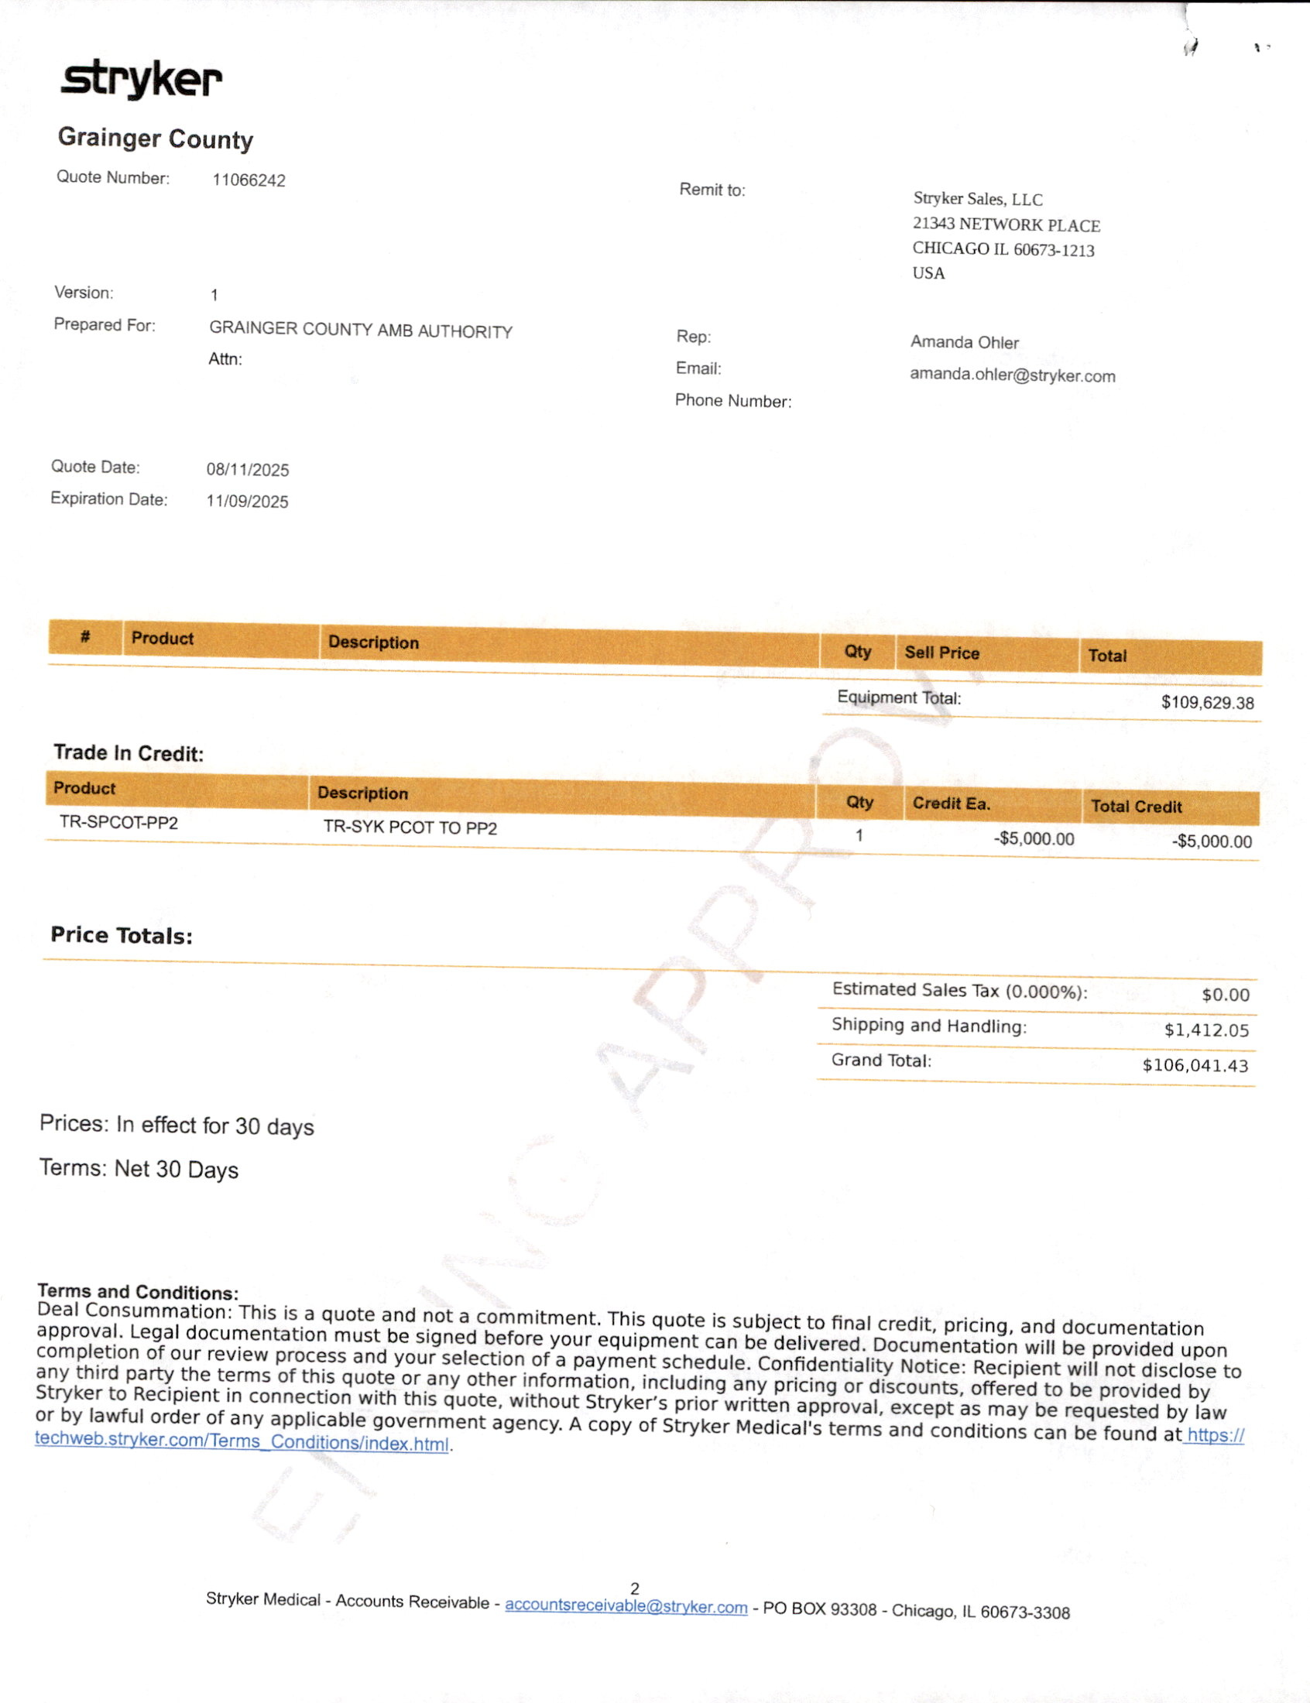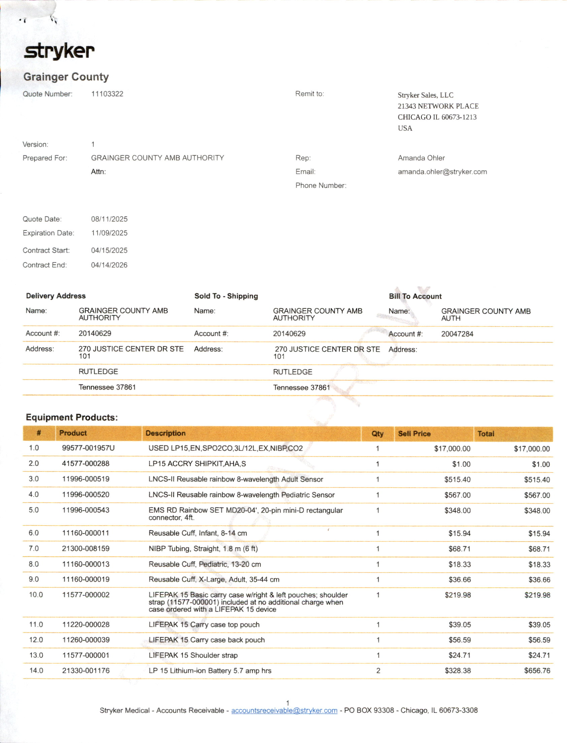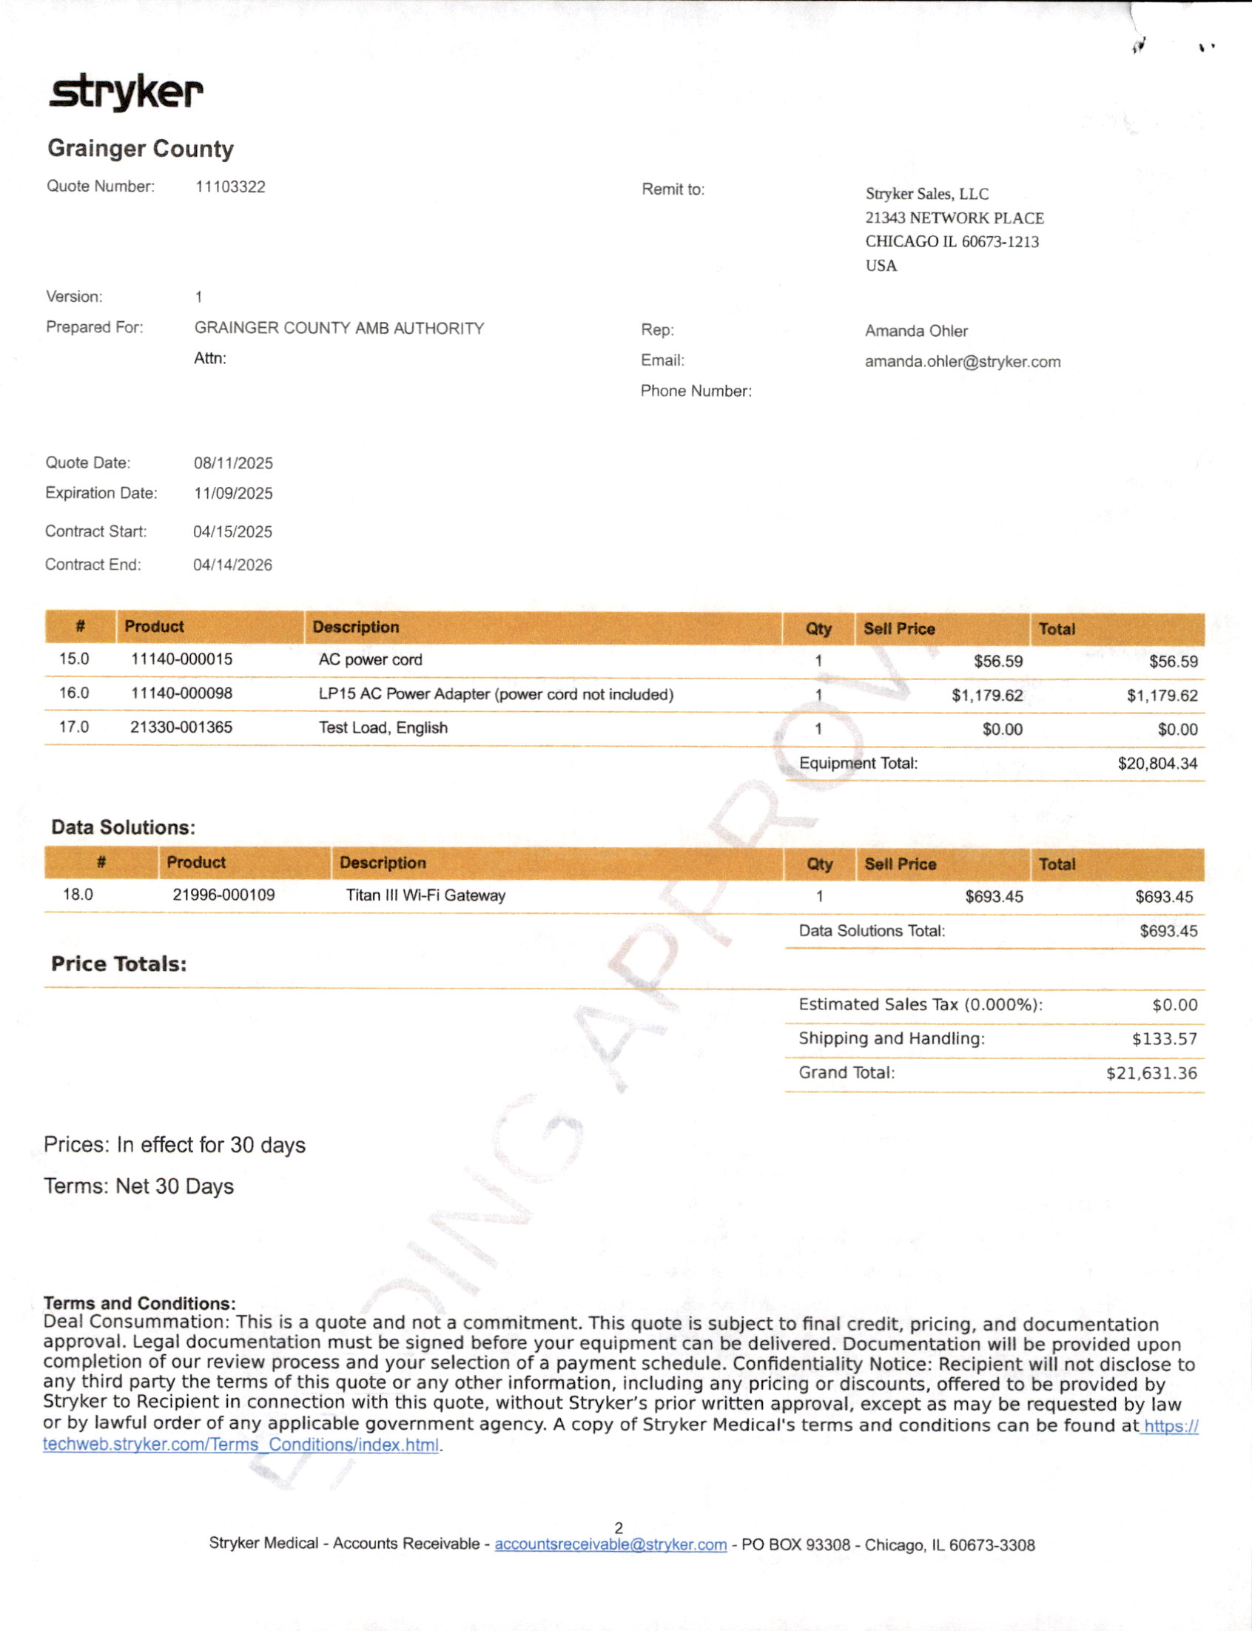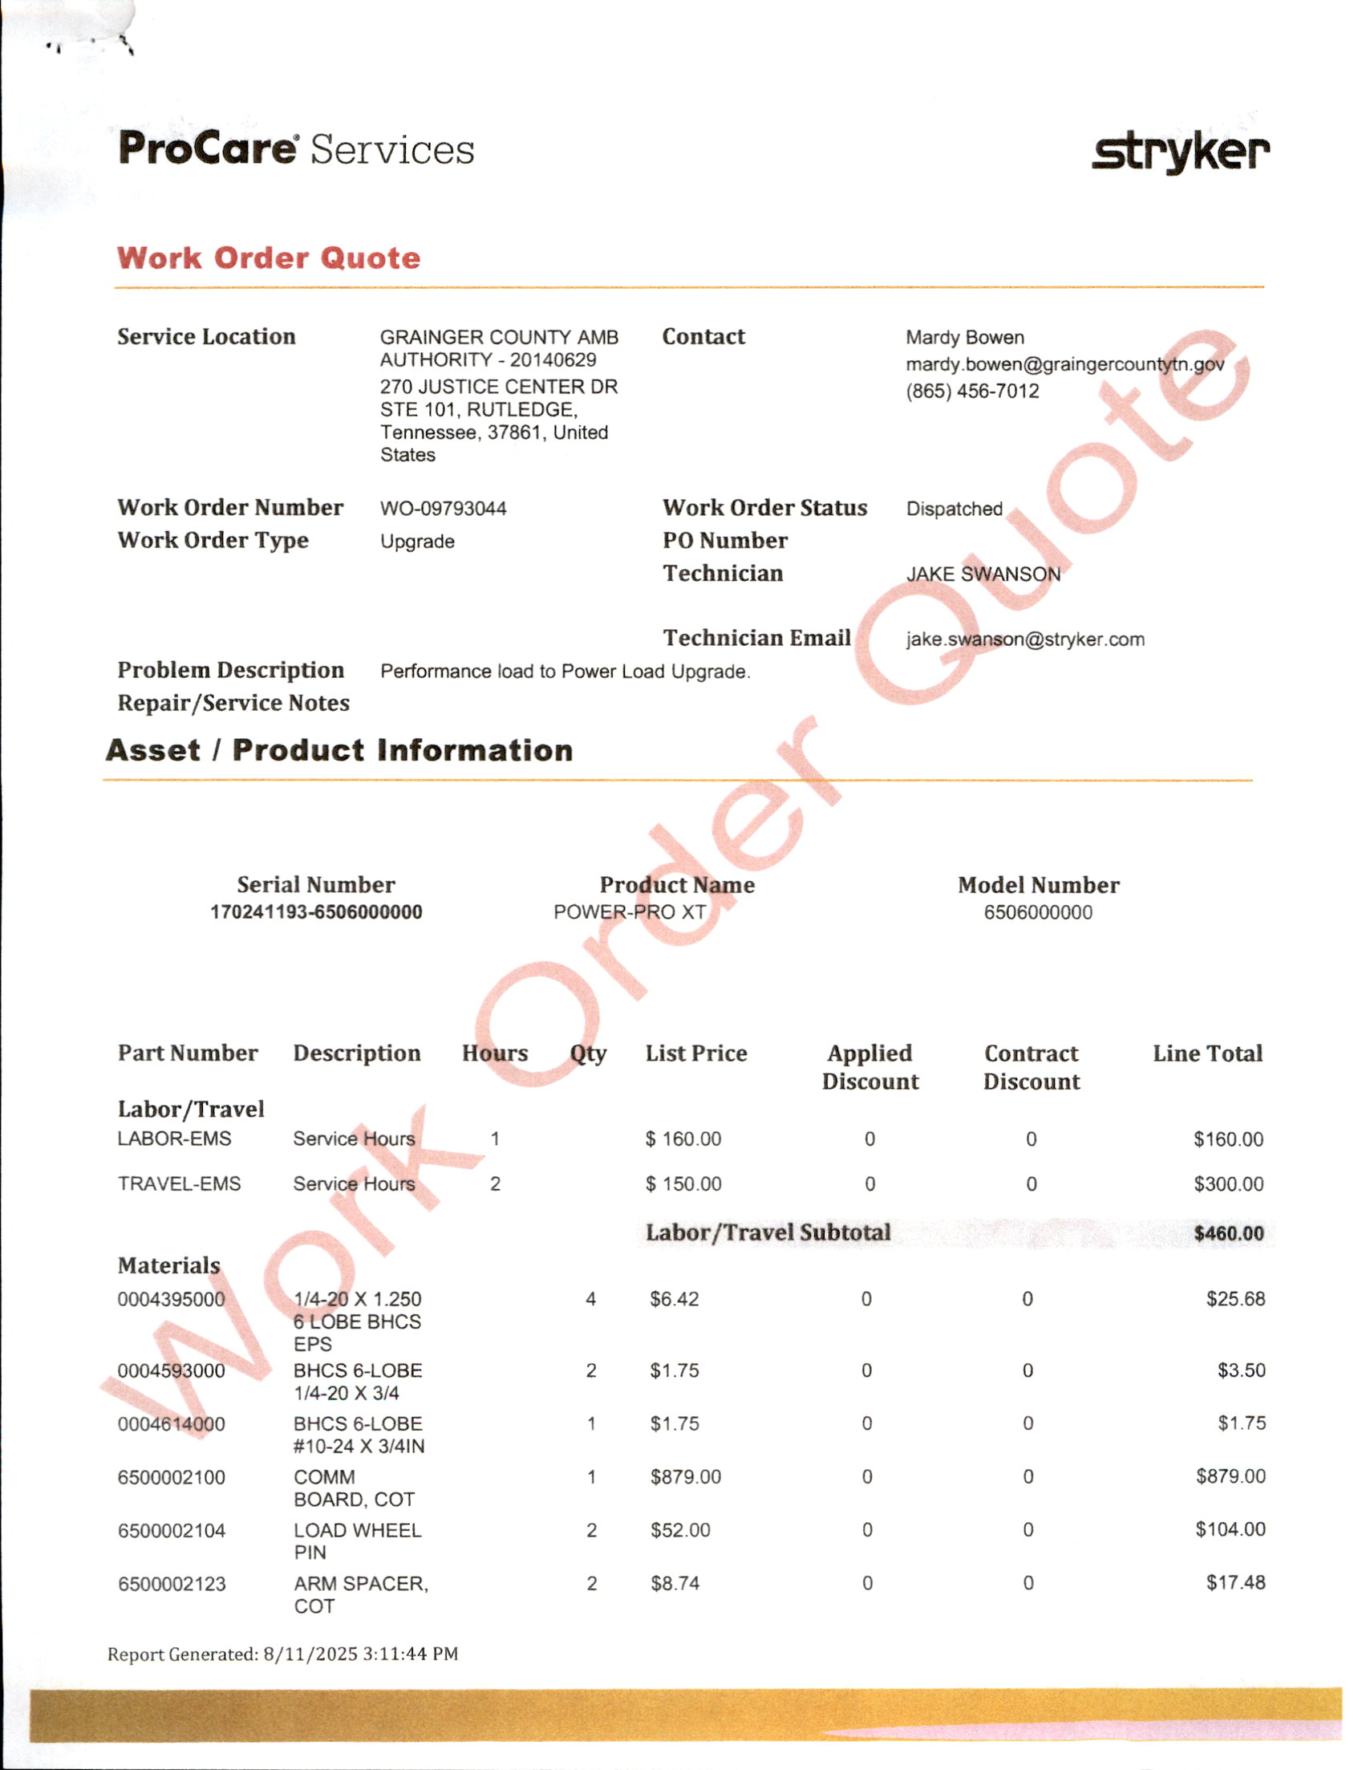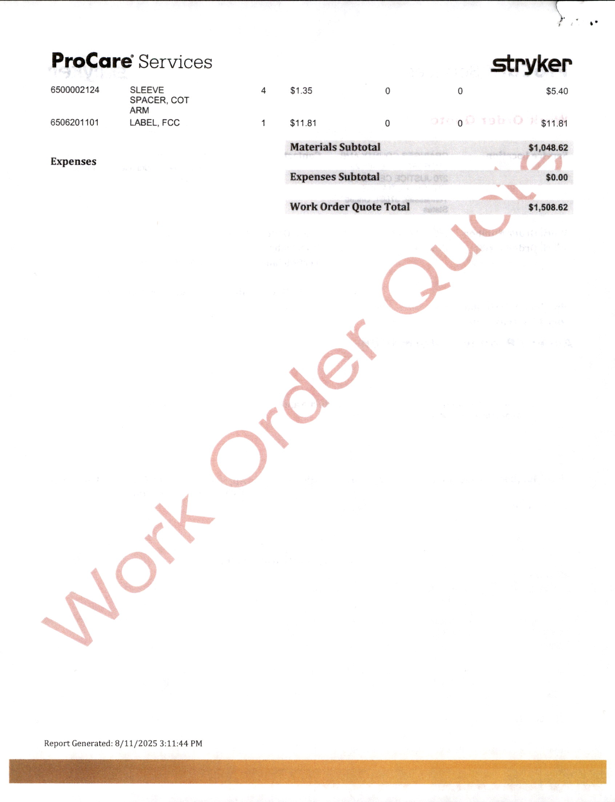

RESOLUTION, 8.11.2025A; Reconsider Resolution 8.11.2025
UPON MOTION of Commissioner ANNA BLANKEN, SECONDED BY Commissioner DARRELL WILLIAMS, the request to reconsider Resolution 8.11.2025 FAILED by Roll Call Vote as Follows:

AYE: SCOTT WYNN, ANDY CAMERON, TINA DAVIS, DARRELL WILLIAMS, JUSTIN EPPERSON AND ANNA BLANKEN. (6)

NAY: DARELL STRATTON, ED MCBEE, RODNEY OVERBAY, LUKE STRATTON, JAMES ACUFF, JENNIFER HOLT, JESSE CLINE AND MIKE HOLT. (8)

ABSENT: WENDY NOE. (1)

****************

MISC.; TCSA Fall Convention

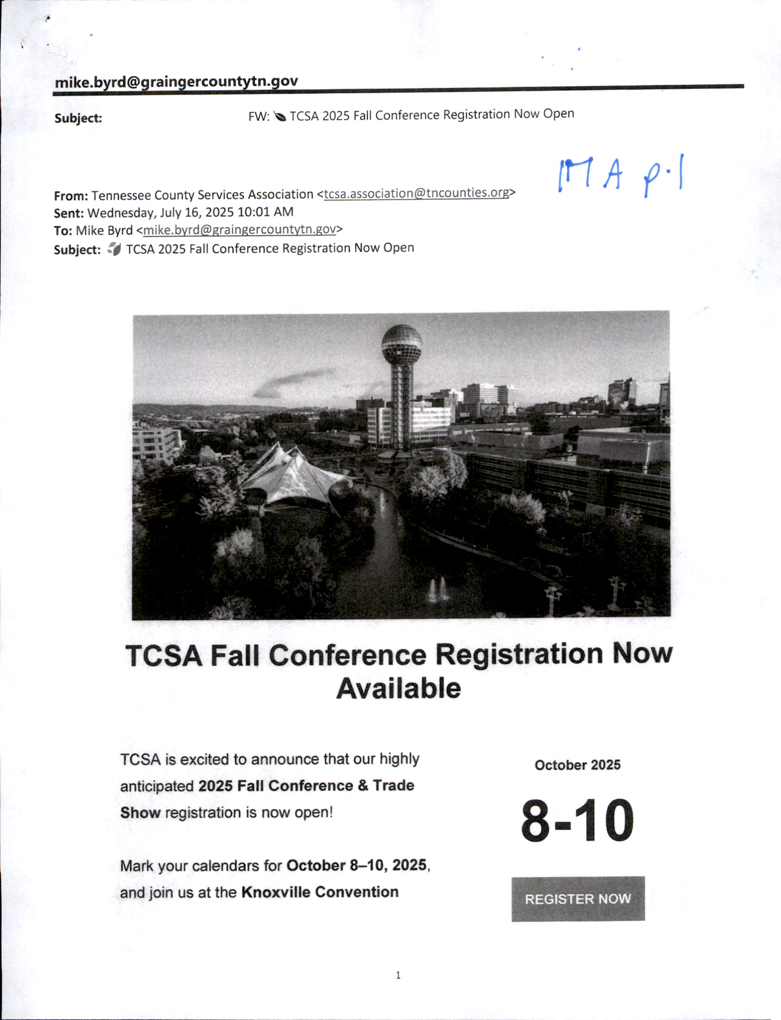

***************



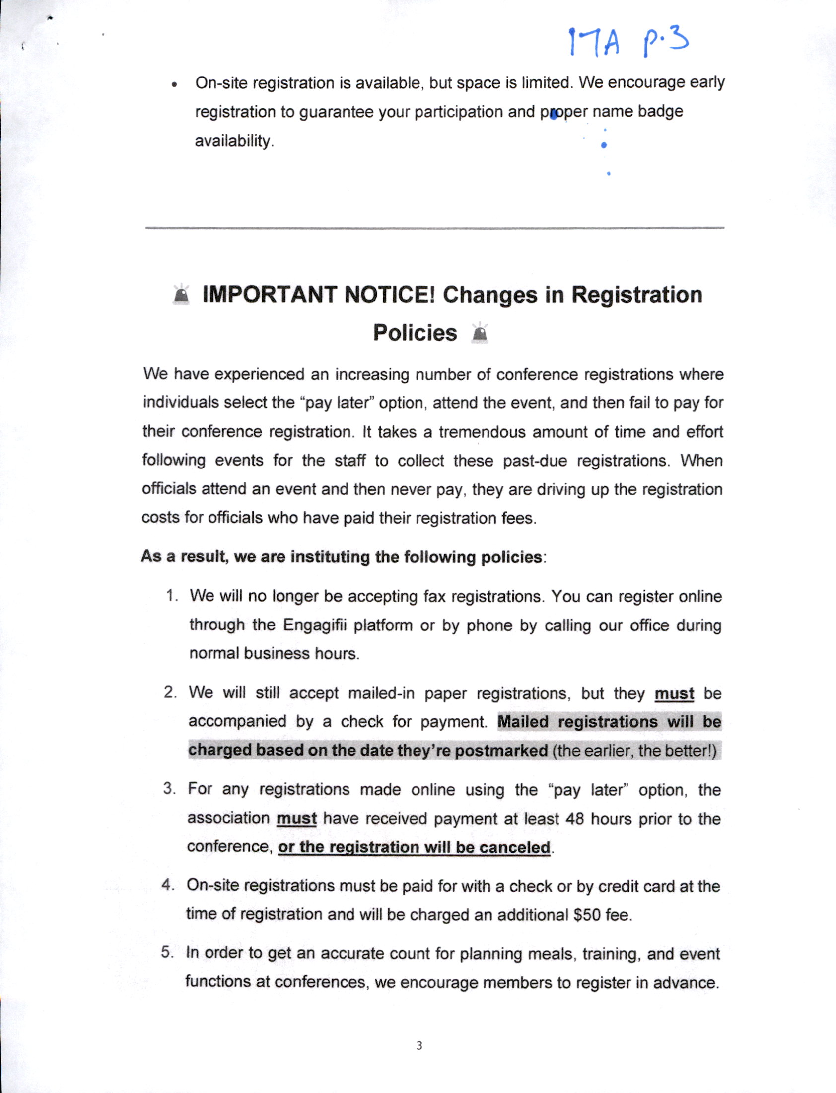

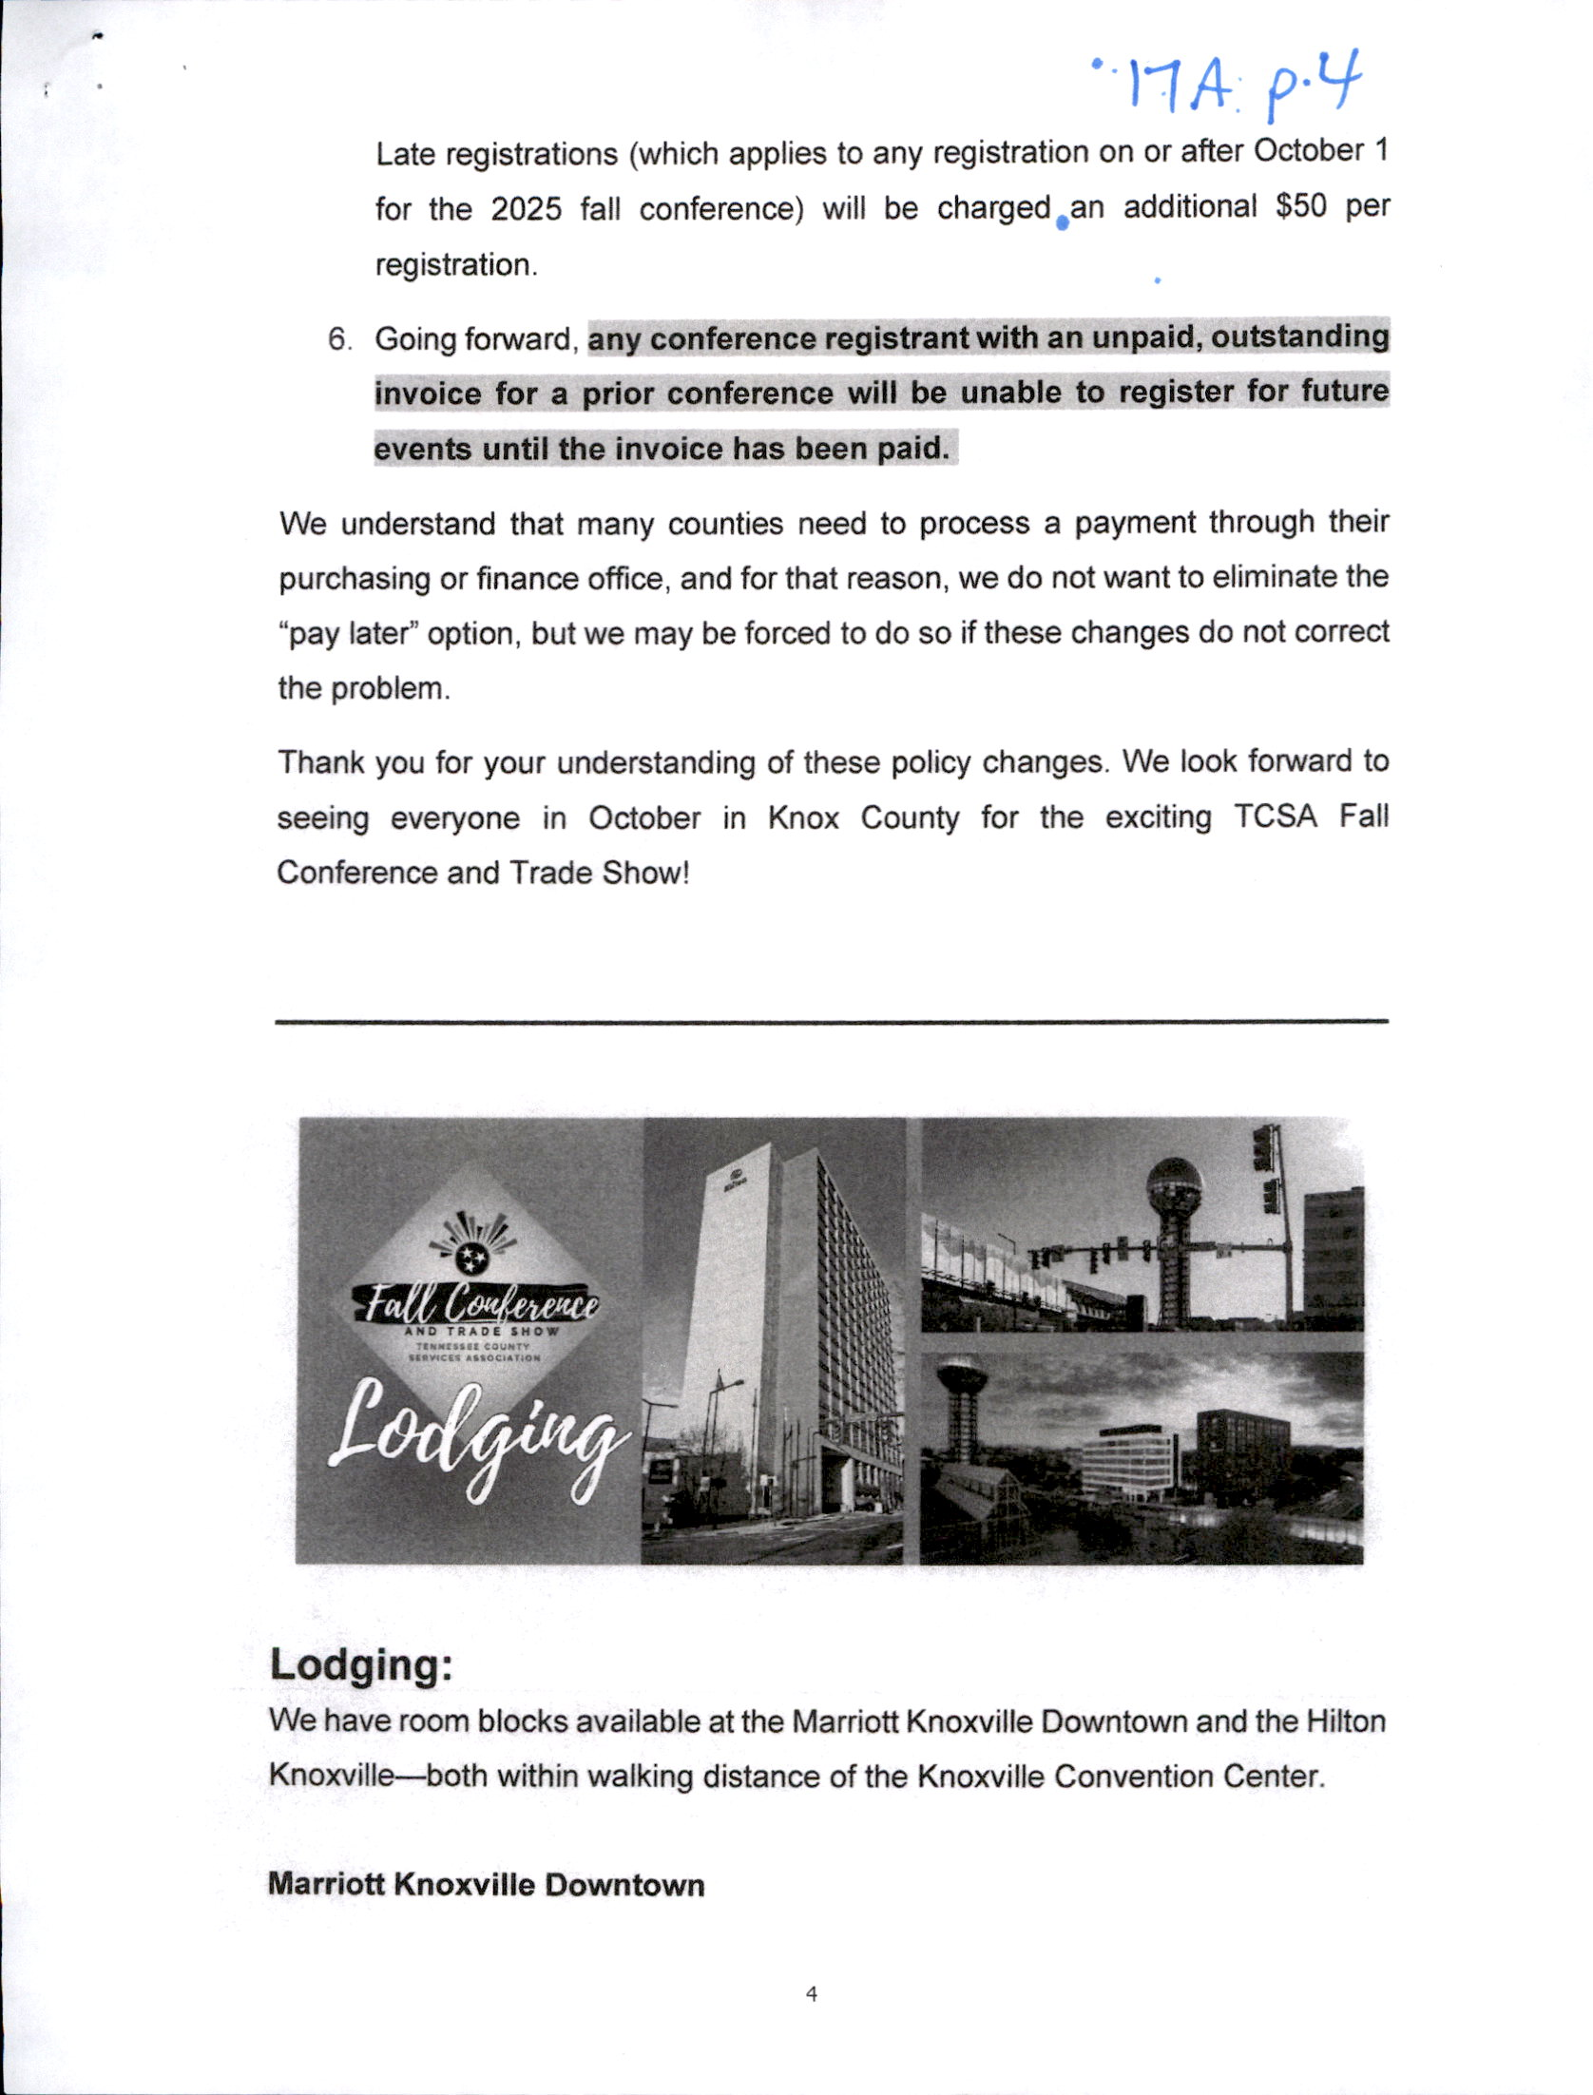

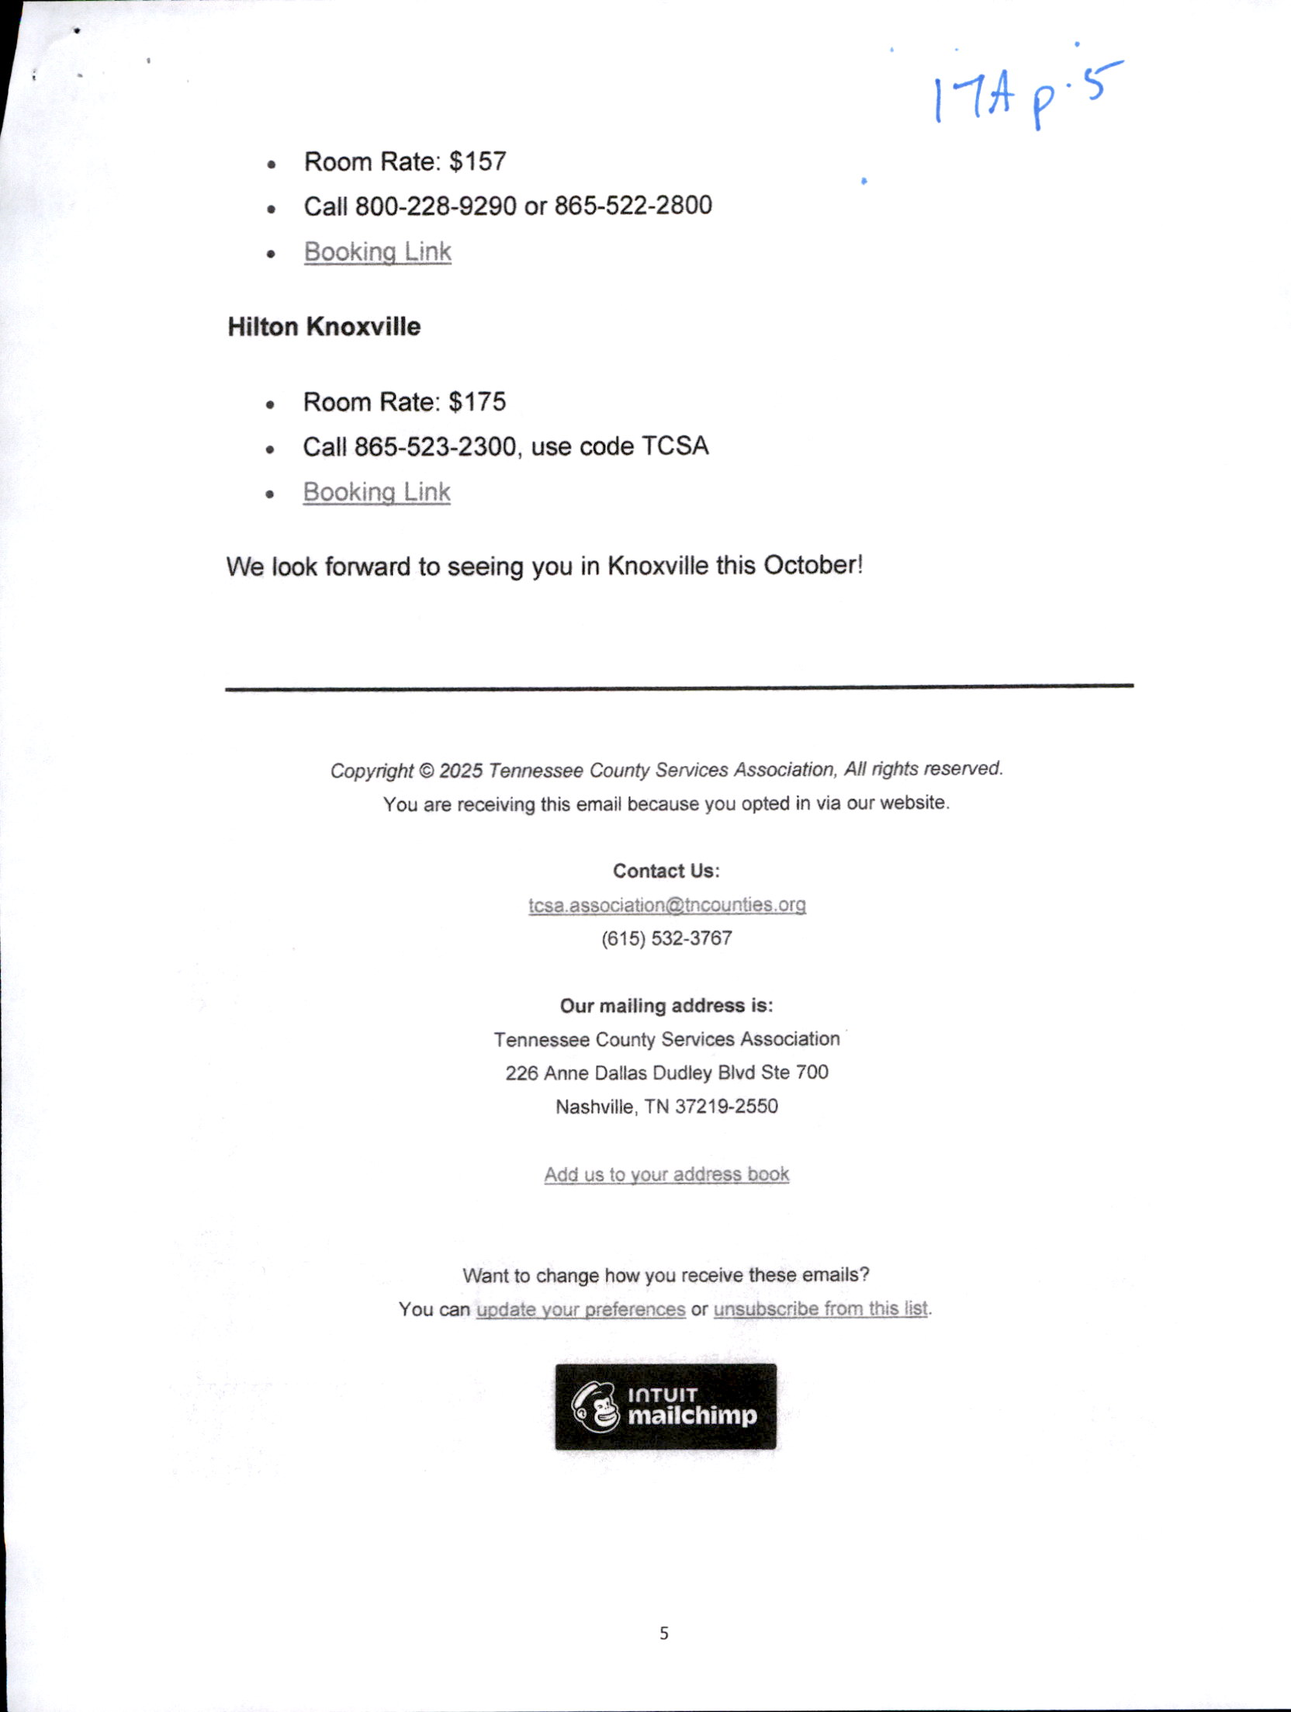

ANNOUNCEMENTS;

NONE

***************

ADJOURN,
UPON MOTION of Commissioner RODNEY OVERBAY, Seconded by Commissioner
LUKE STRATTON, the Commission adjourned until the next regular called meeting on September 8,
2025, at 7:00 p.m. by Voice Vote.

Meeting ended at 8:23 p.m.

__________________________________________________
MIKE HOLT, COUNTY COMMISSION CHAIRMAN

ATTEST:
____________________________________________________
ANGIE J. LAMB, GRAINGER COUNTY CLERK
*************

