`

BOOK 70
PAGE 557

MONDAY, JANUARY 11, 2024 A. D.

STATE OF TENNESSEE)

COUNTY OF GRAINGER)

BE IT REMEMBERED THAT THE BOARD OF COMMISSIONERS
OF GRAINGER COUNTY, TENNESSEE, MET IN REGULAR SESSION ON MONDAY,
DECEMBER 11, 2023 A.D., MIKE HOLT, GRAINGER COUNTY COMMISSION CHAIRMAN, WAS PRESENT AND PRESIDING, AND THE FOLLOWING COUNTY COMMISSIONERS PRESENT TO-WIT:

DARELL STRATTON, SCOTT WYNN, ED MCBEE, RODNEY OVERBAY, LUKE STRATTON, ANDY CAMERON, TINA DAVIS, DARRELL WILLIAMS, JAMES ACUFF, JUSTIN EPPERSON, JENNIFER HOLT, JESSE CLINE AND MIKE HOLT. (13)

COUNTY COMMISSIONER’S ABSENT: WENDY NOE AND ANNA BLANKEN. (2)

OPEN BY: SHERIFF JAMES HARVILLE
PRAYER BY: RODNEY OVERBAY
PLEDGE BY: JAMES ACUFF

MIKE HOLT, COUNTY COMMISSION CHAIRMAN, CALLED THE MEETING OF THE BOARD OF COMMISSION OF GRAINGER COUNTY TO ORDER. ANGIE J. LAMB, GRAINGER COUNTY CLERK, WAS PRESENT AND THE MINUTES OF THE MEETING WERE RECORDED TO WIT:

***************

***************
PUBLIC COMMENTS,

***************

AGENDA, Approval of
UPON MOTION of Commissioner JUSTIN EPPERSON, Seconded by
Commissioner DARRELL WILLIAMS, the Commission approved the agenda with addendums for
the January 8, 2024 meeting by Voice Vote.
*remove 15c & e
*add 15h

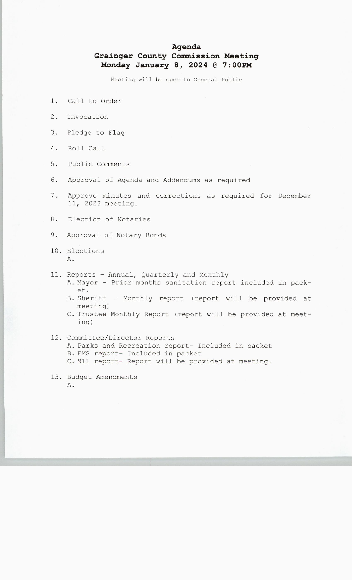

***************

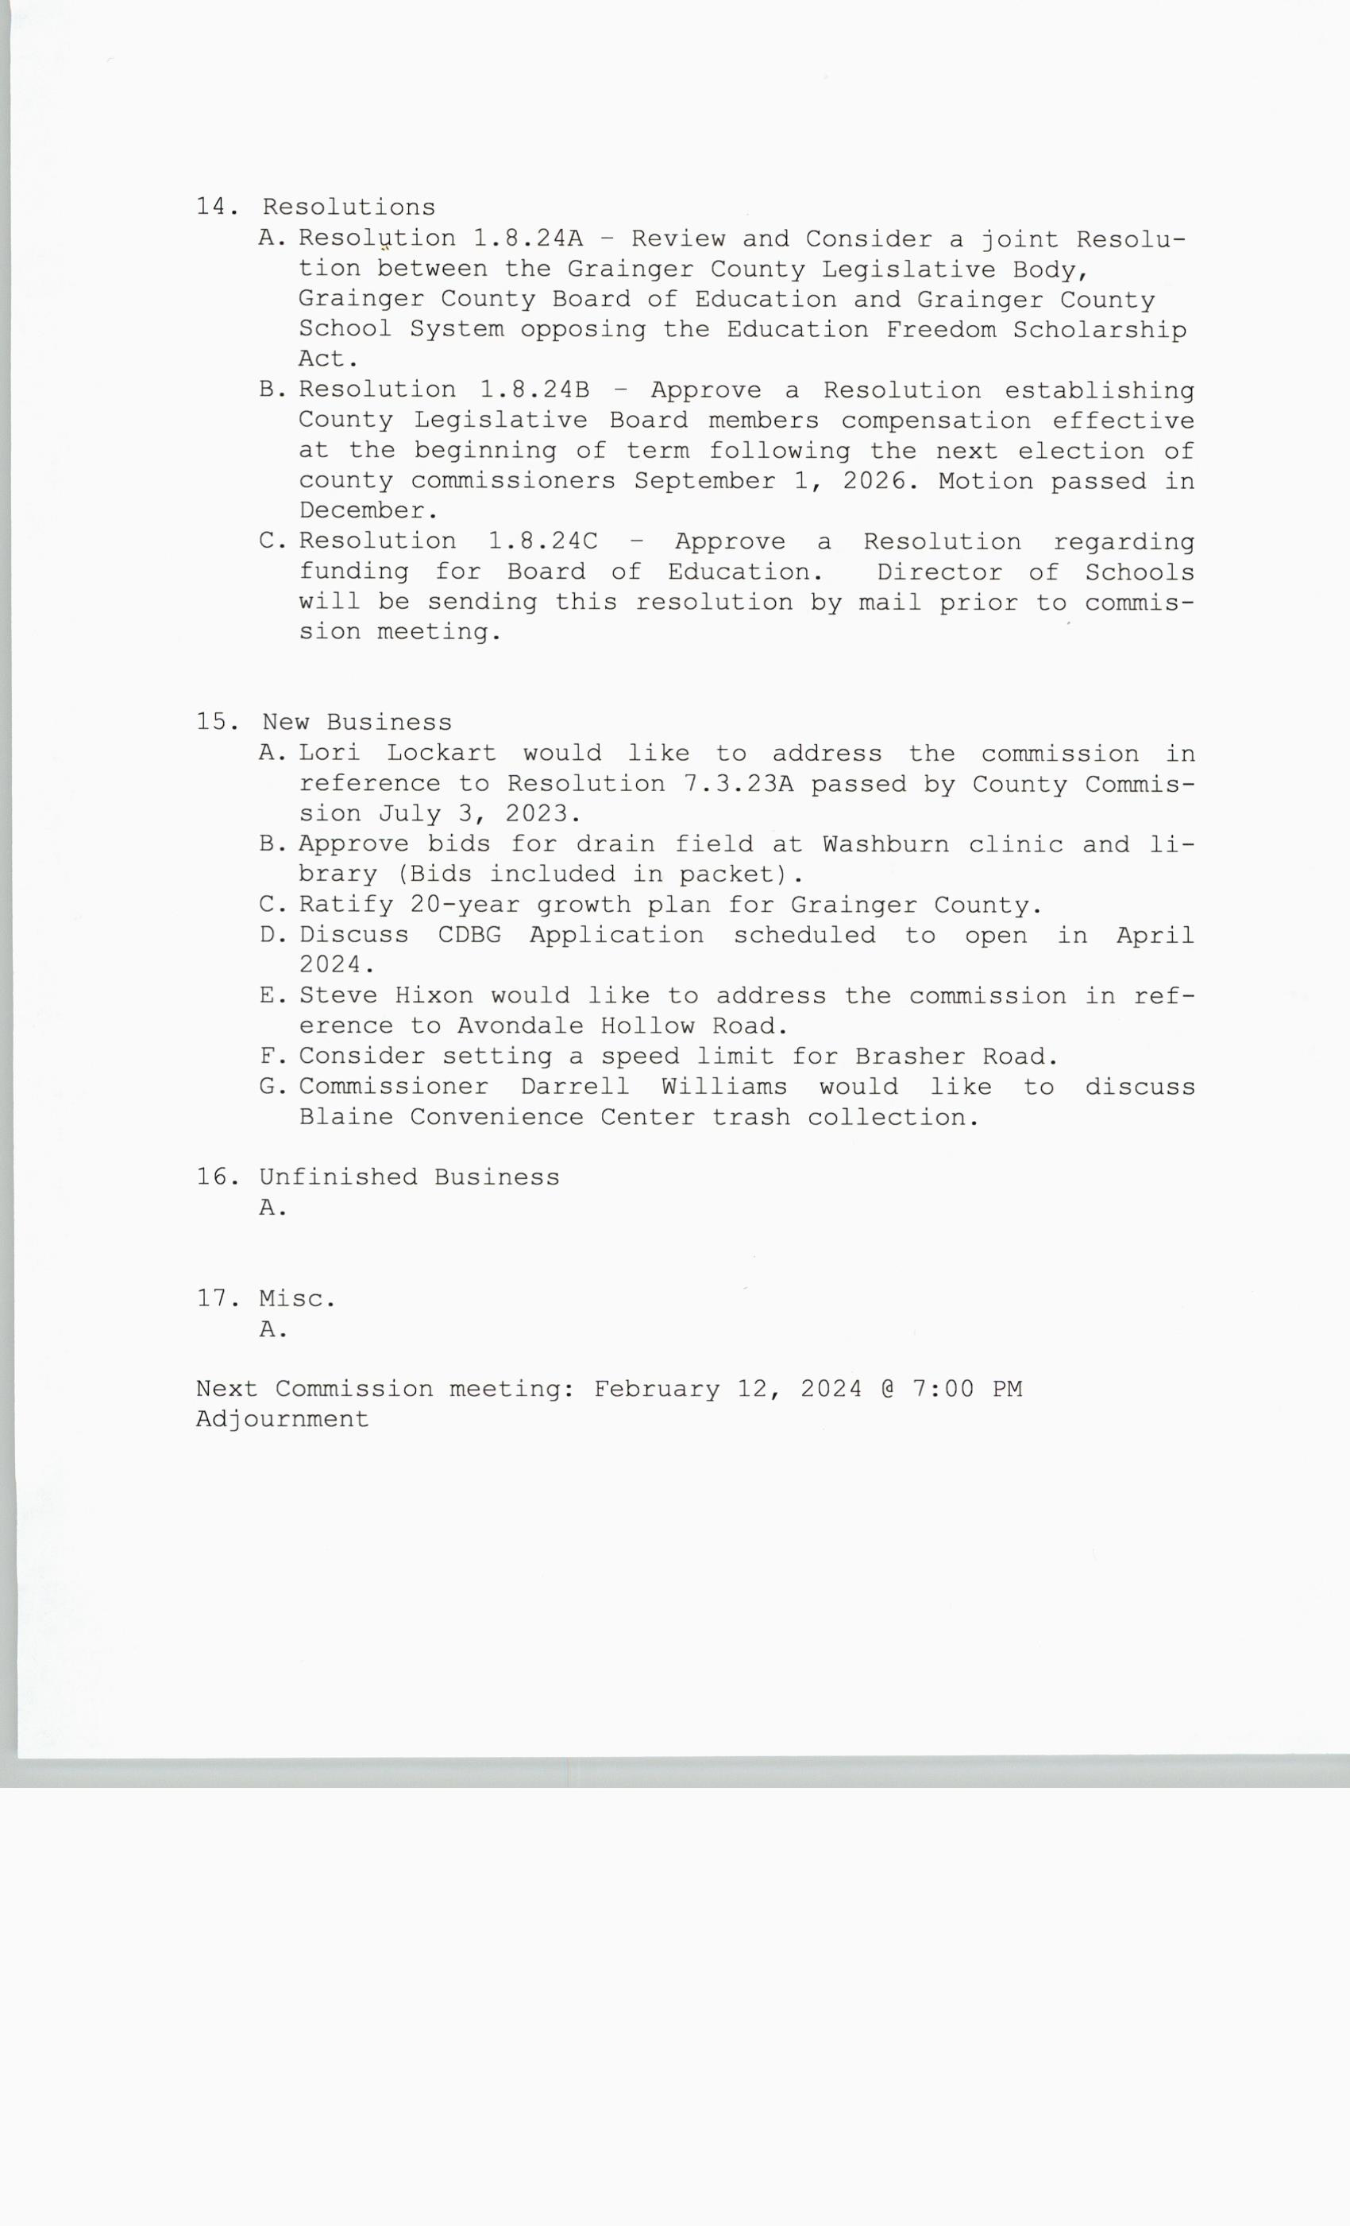

***************

MINUTES, Approval of
UPON MOTION of Commissioner TINA DAVIS, Seconded by
Commissioner ED MCBEE, the Commission approved the minutes for the December 11, 2023
Regular County Meeting by Voice Vote.

***************

ELECTION OF NOTARIES,
NONE

***************

ELECTION OF NOTARY OF BONDS,
NONE

***************

ELECTIONS;
NONE

*****************

*****************

REPORTS, MONTHLY, QUARTERLY & ANNUALLY, Mayor/Sanitation Reports
NO MOTIONS

Sanitation Reports:

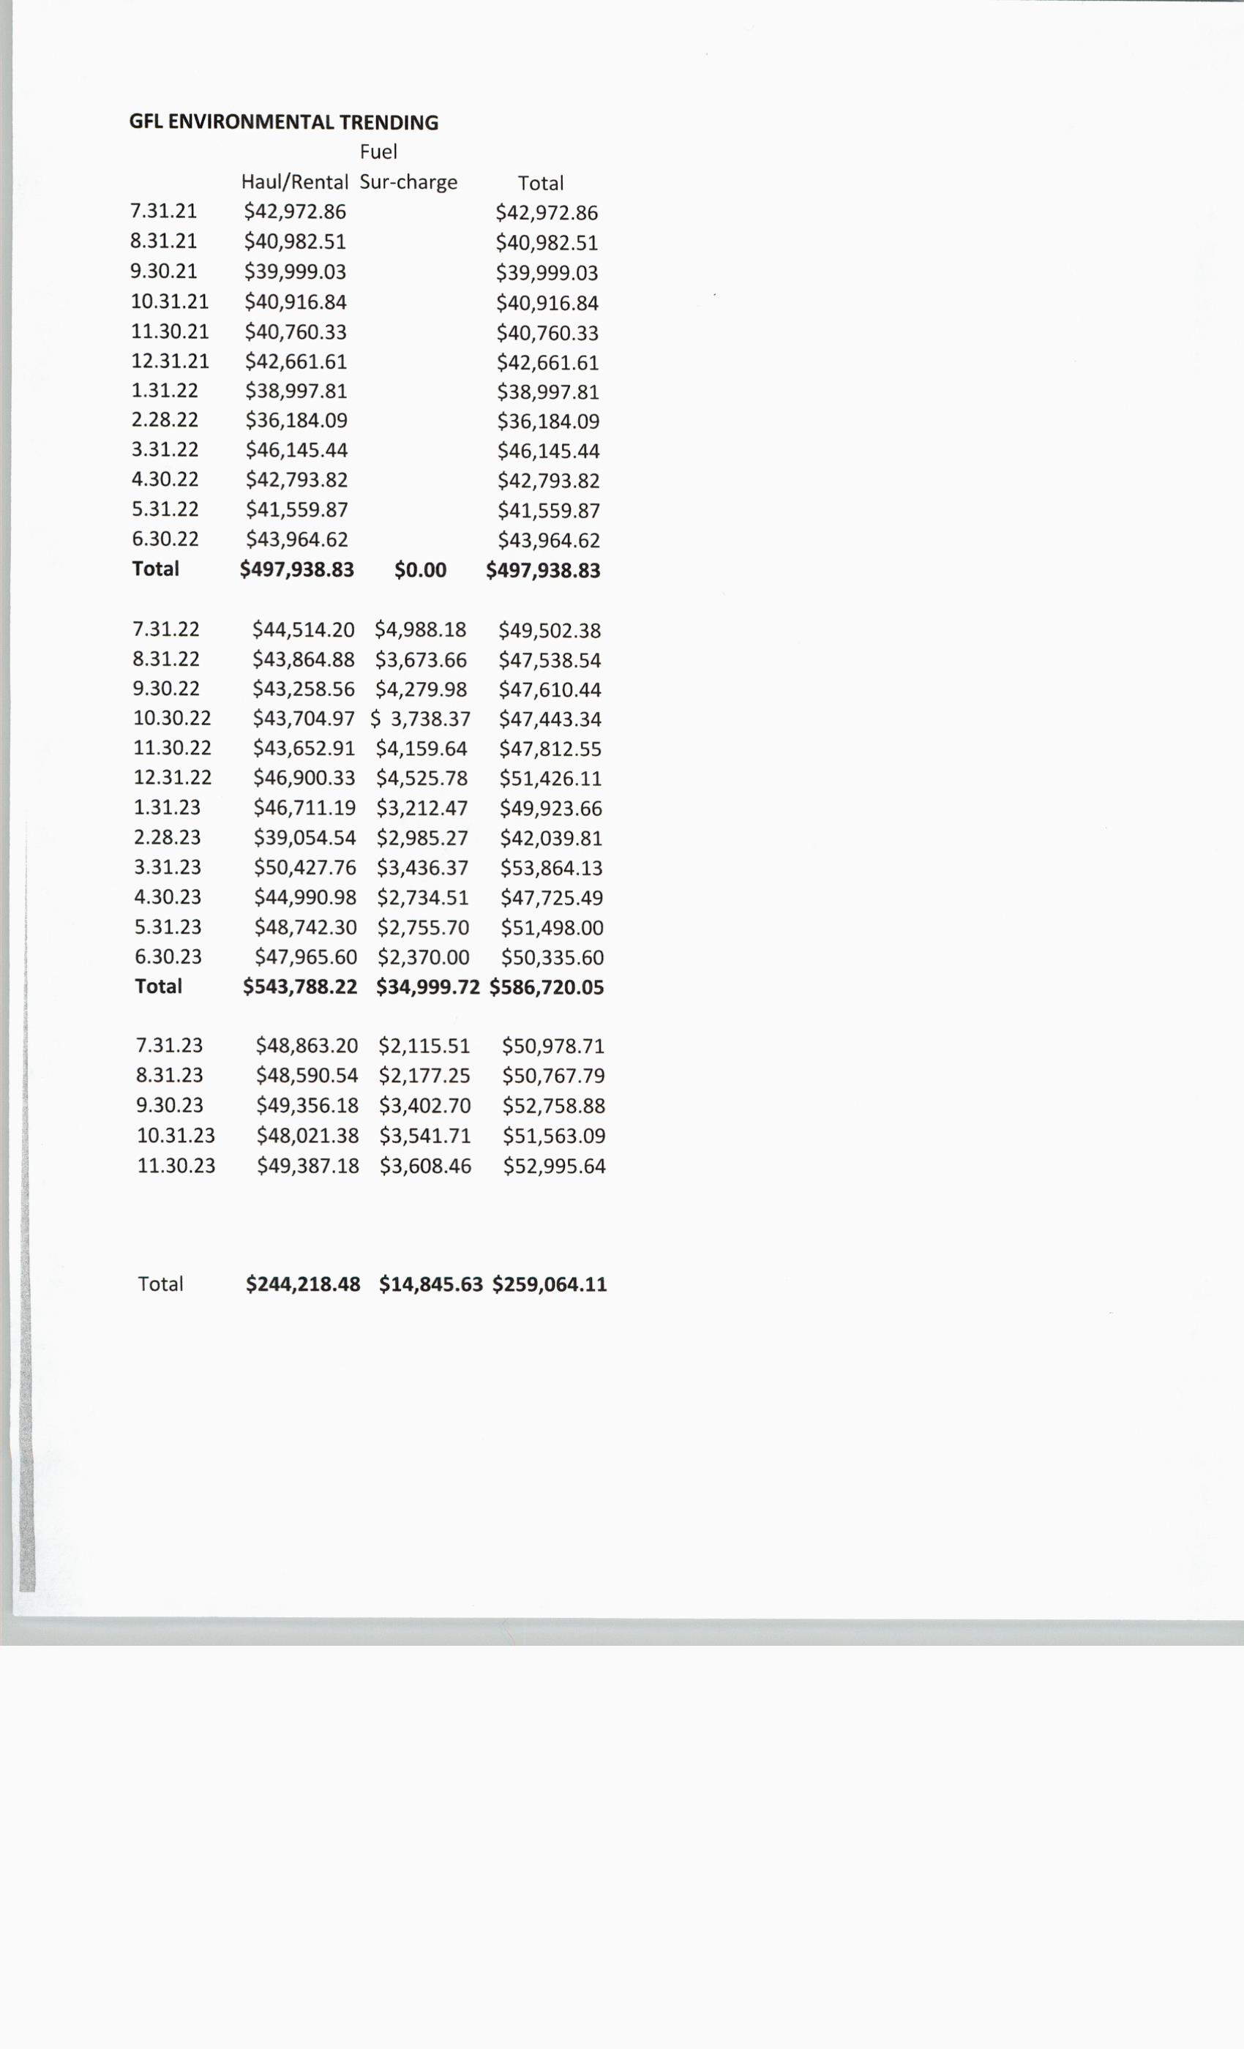

*************

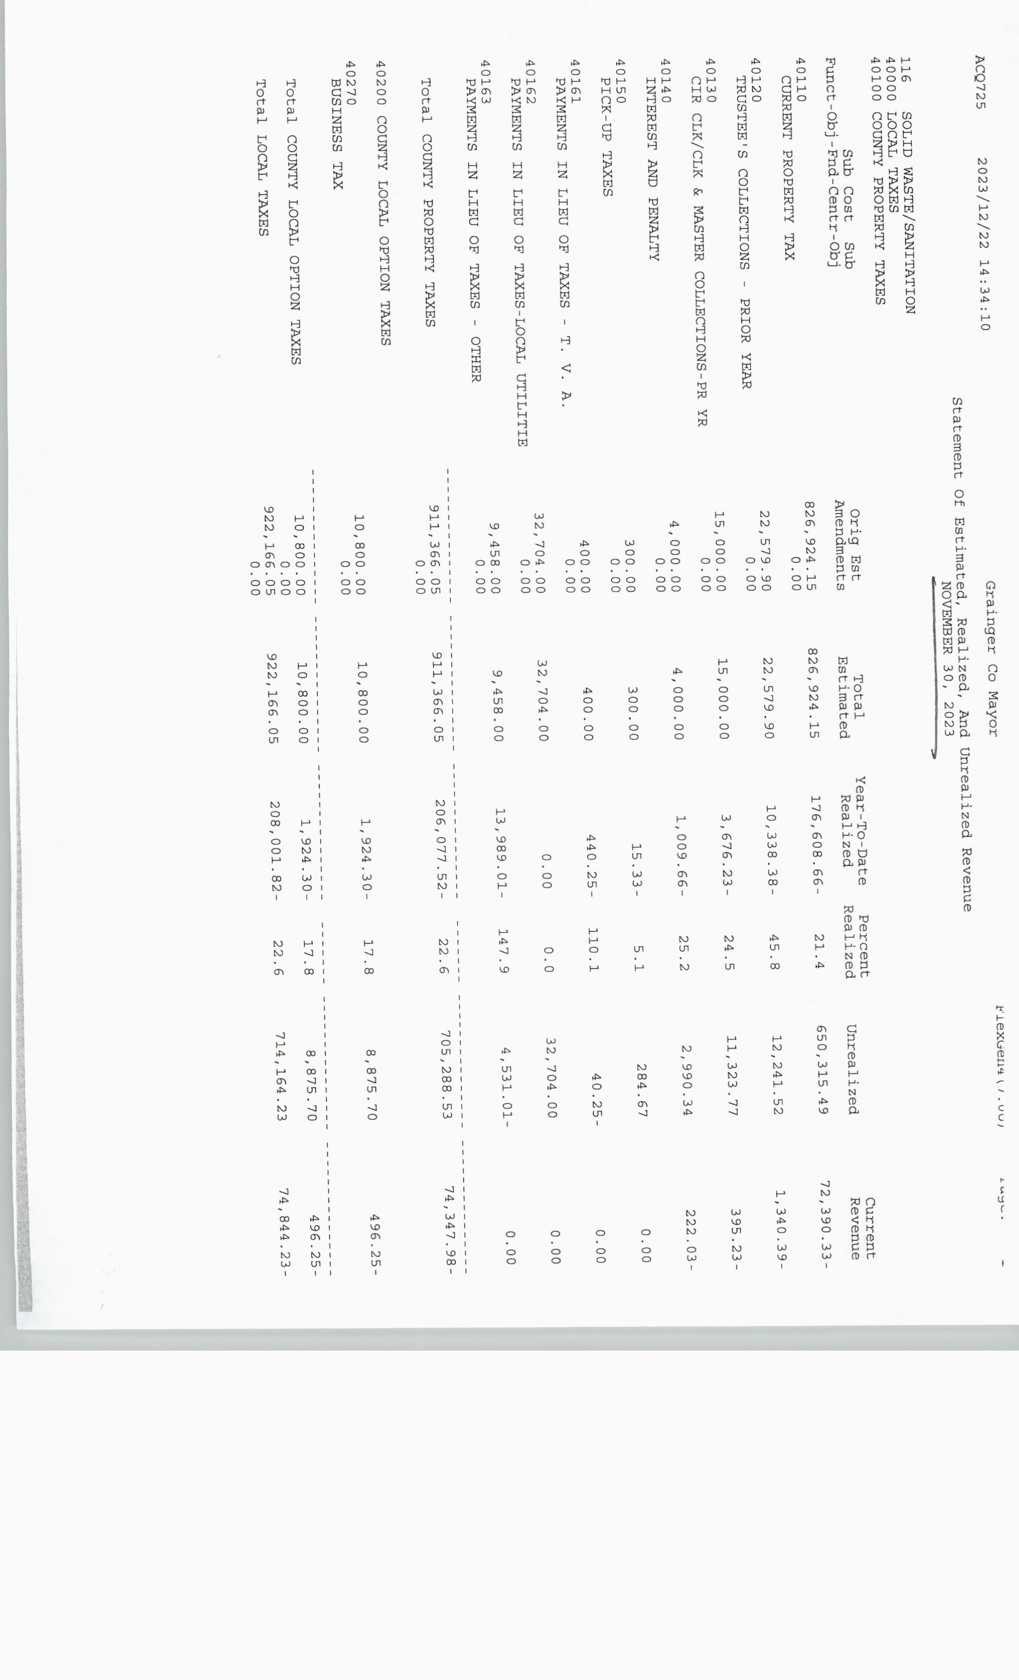

*************

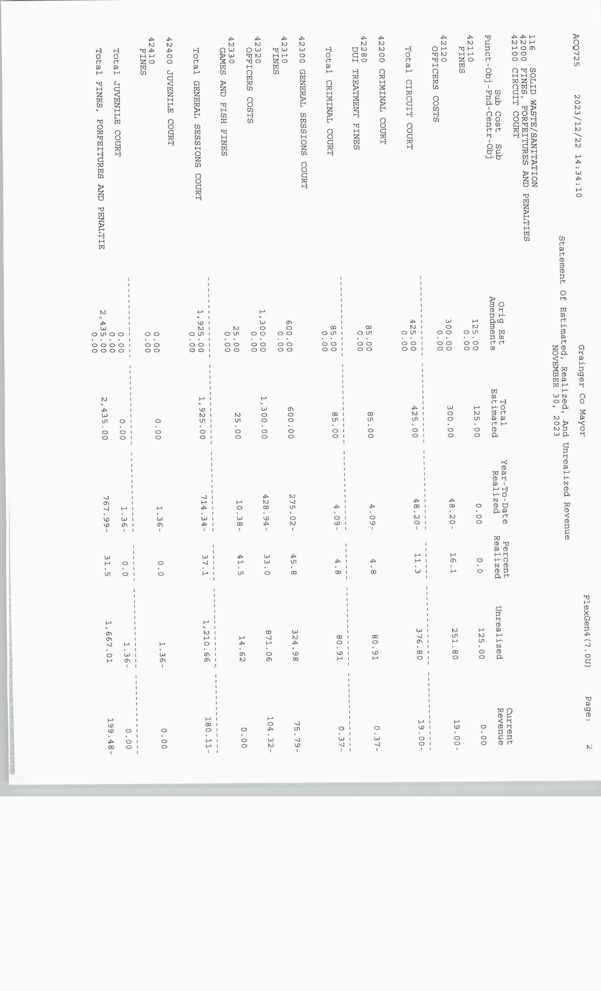
*************

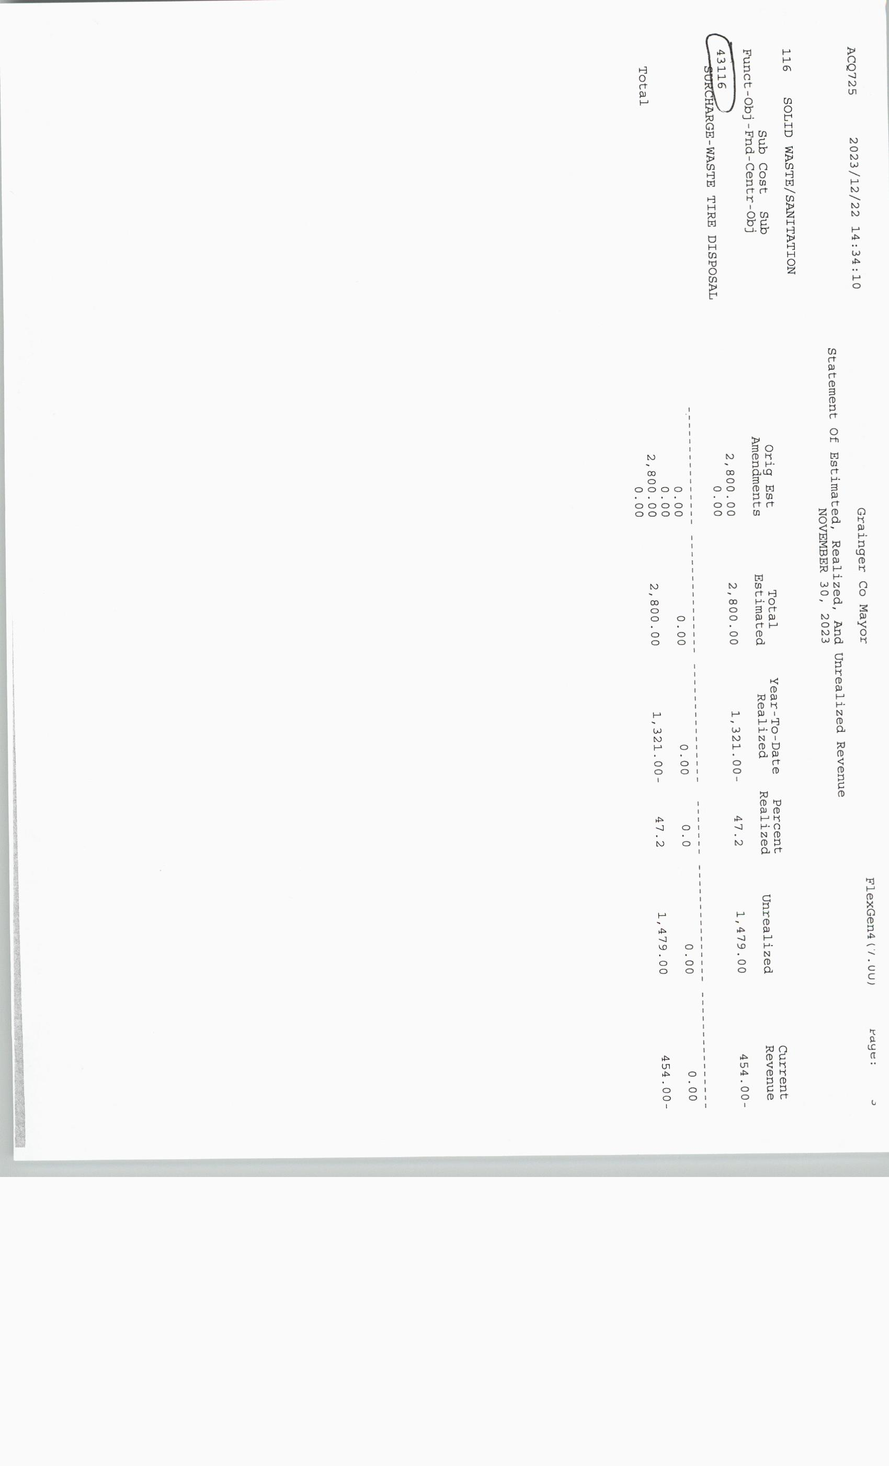

*************
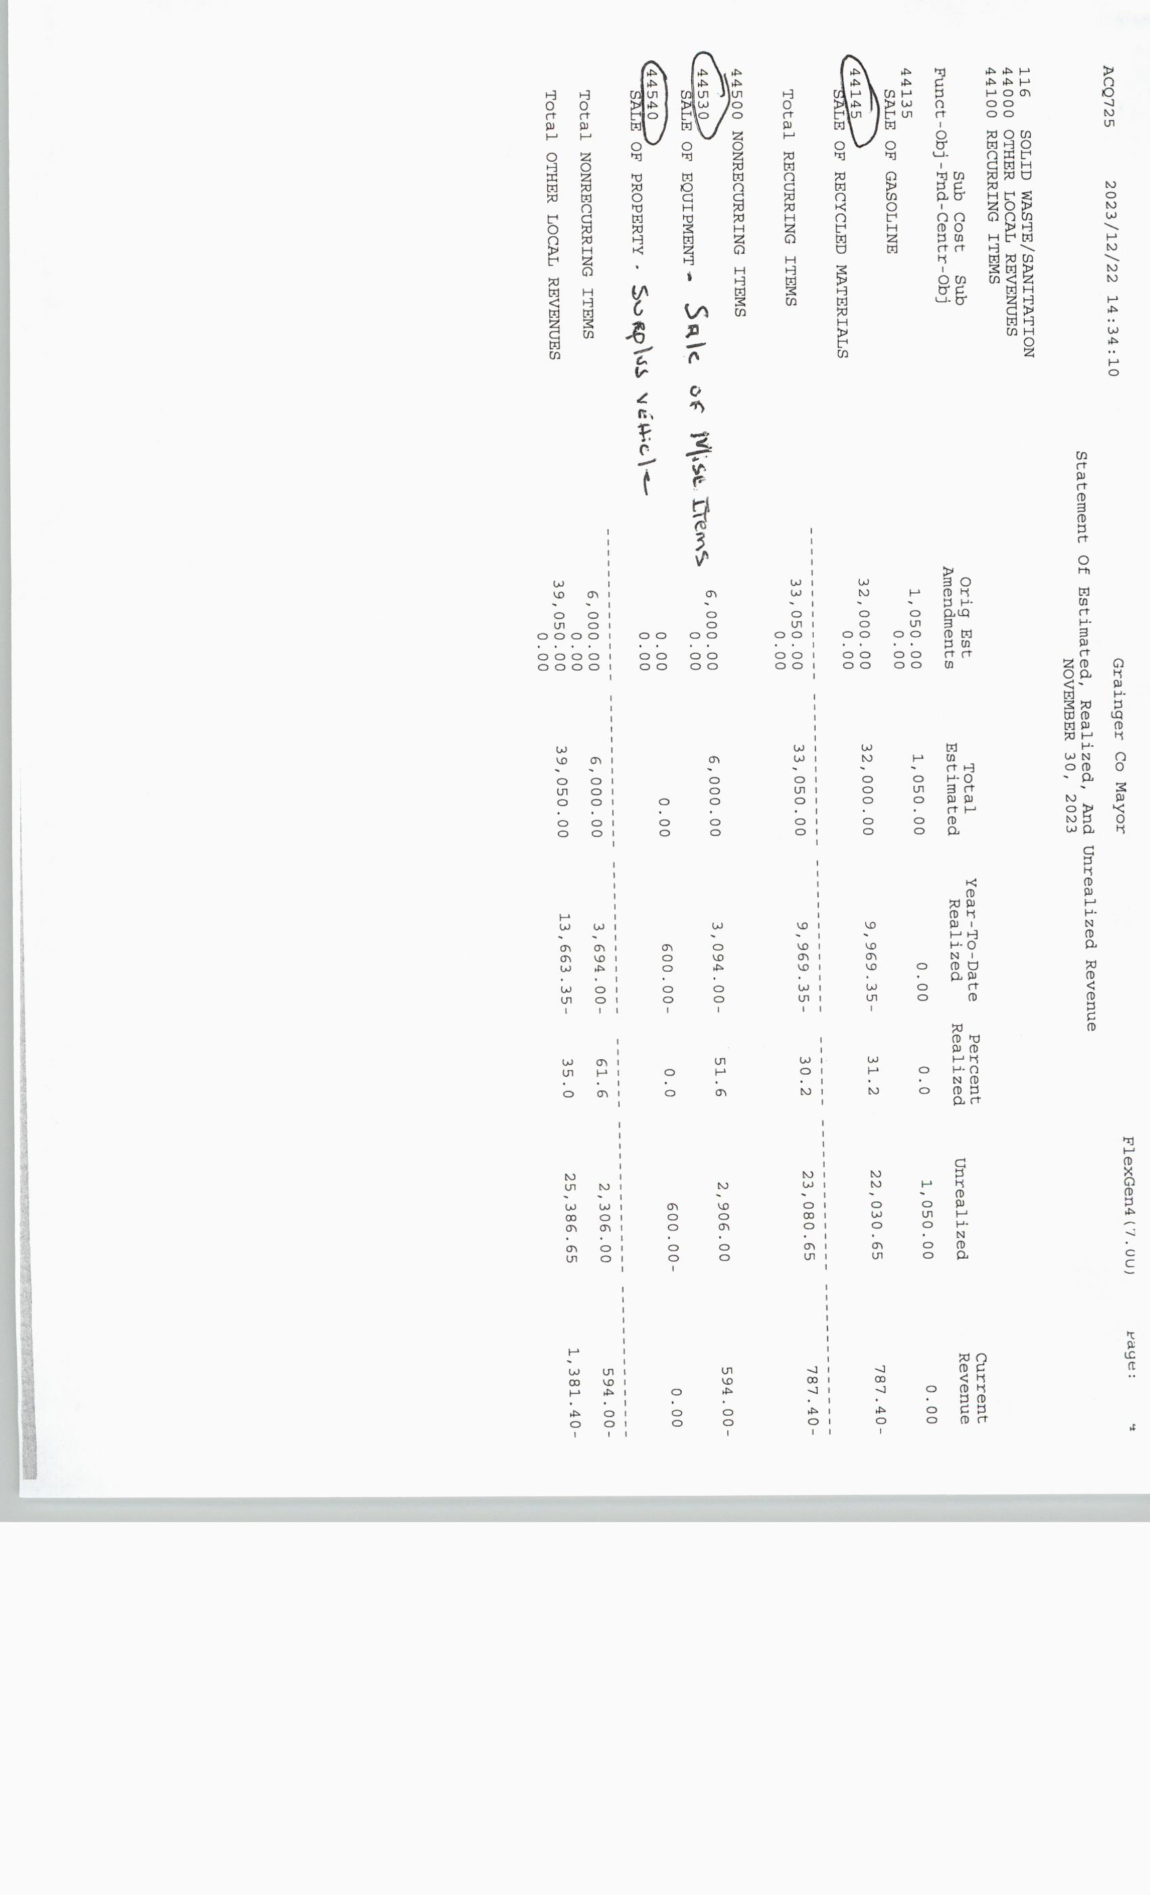

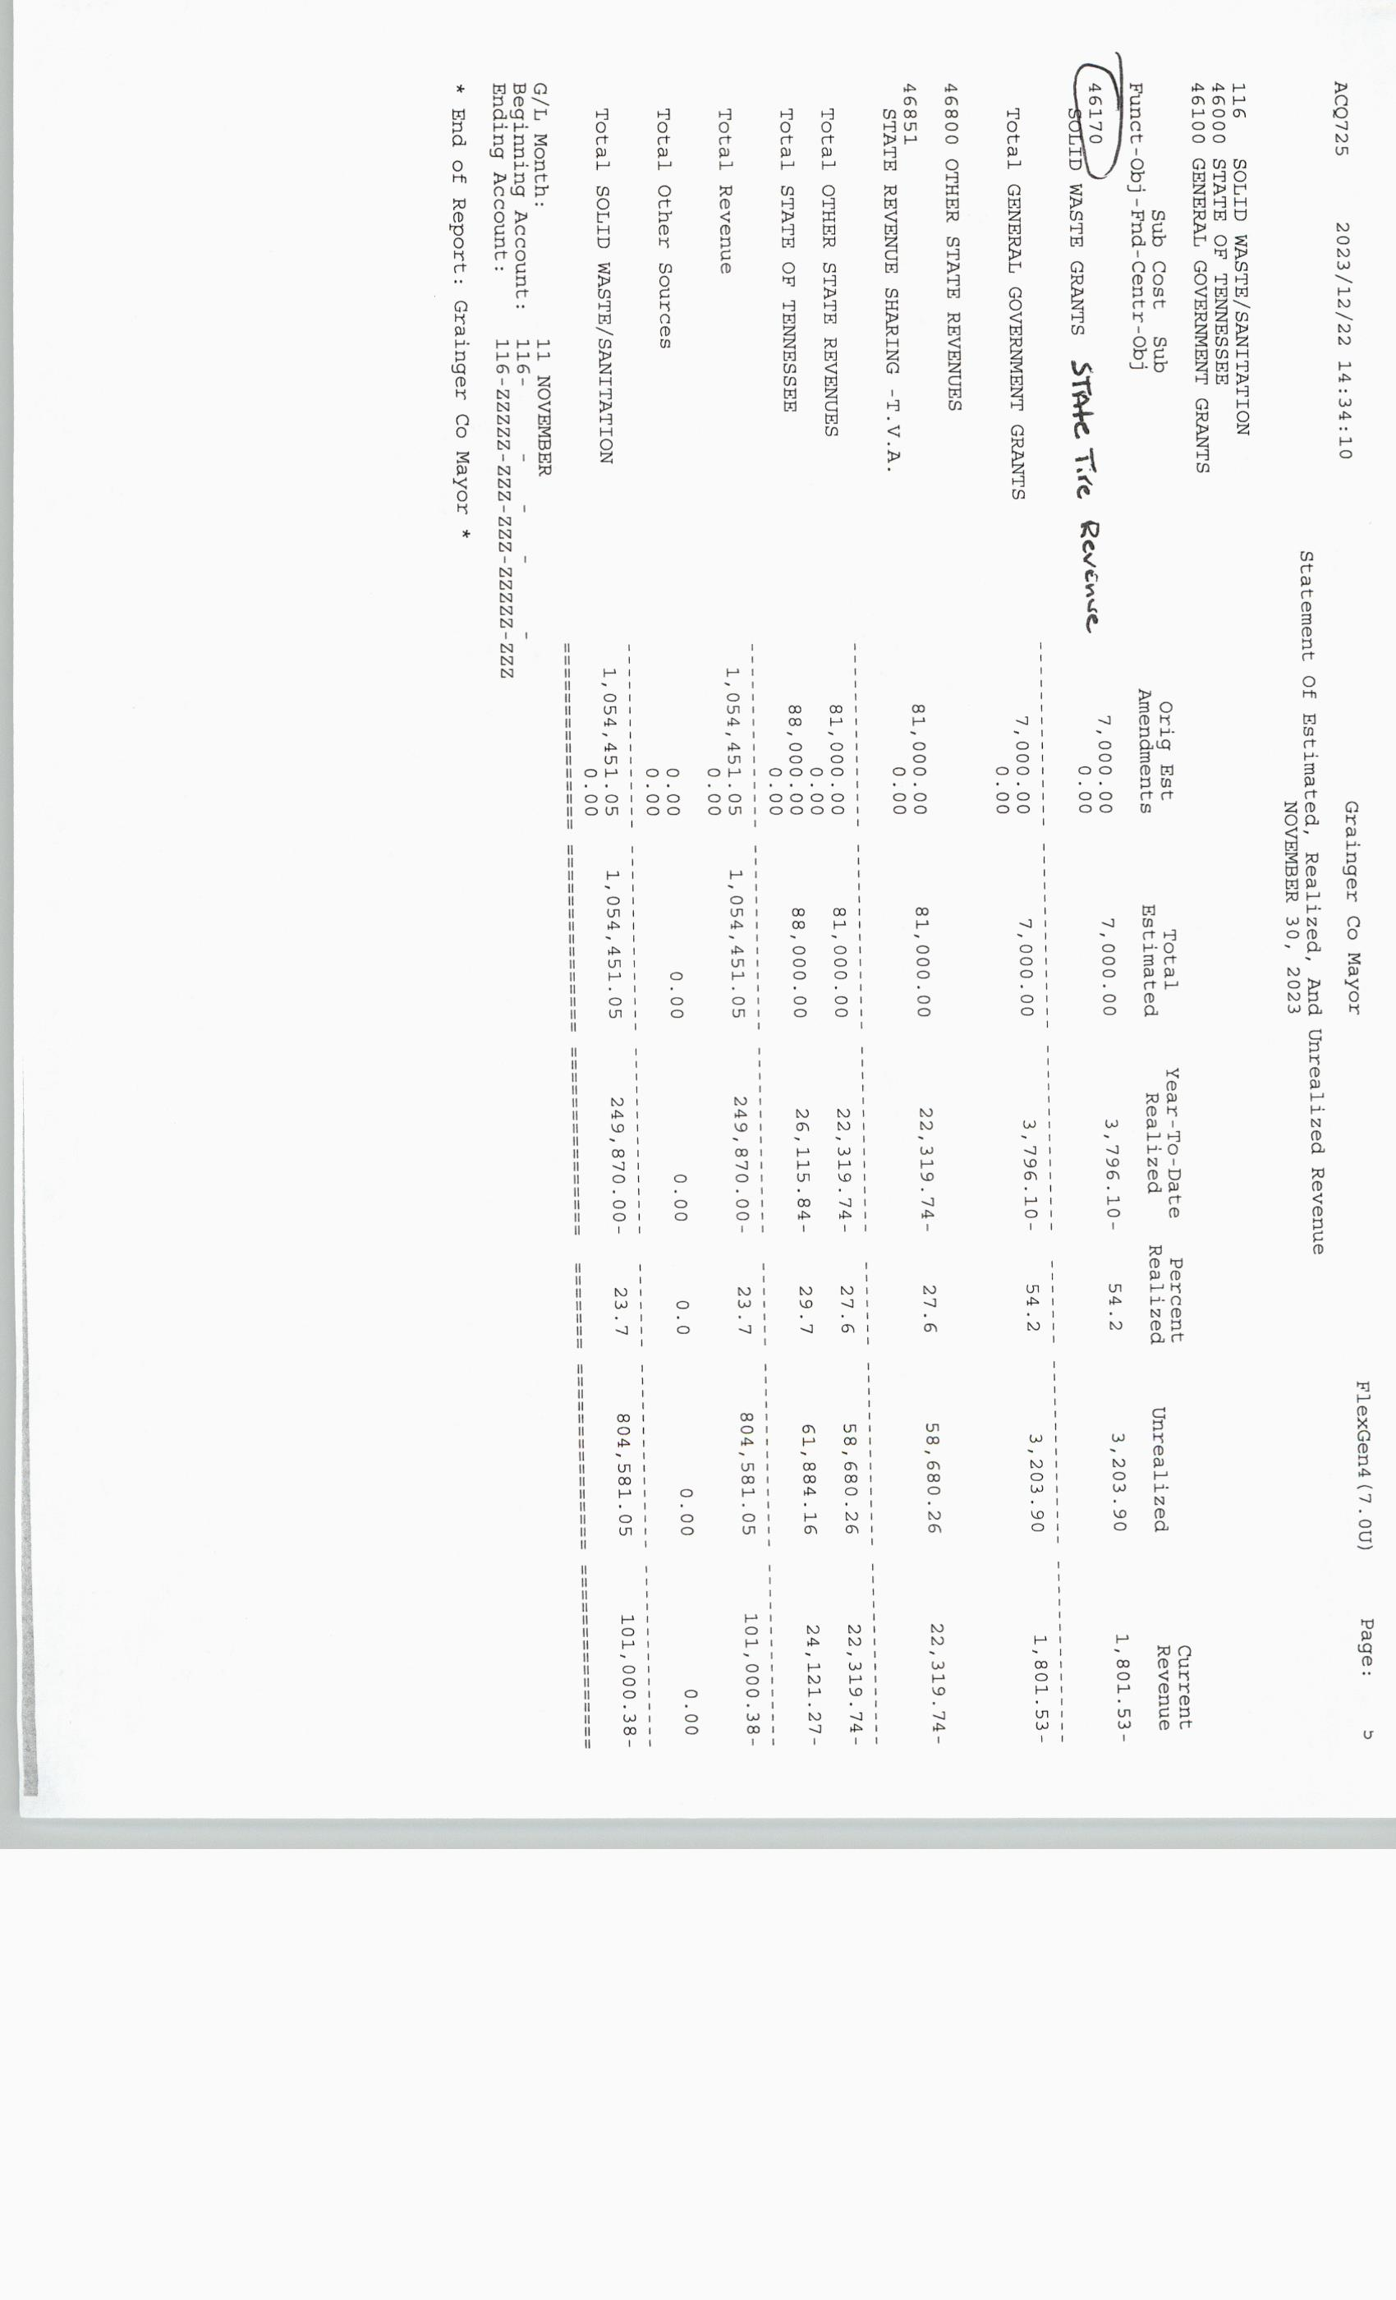

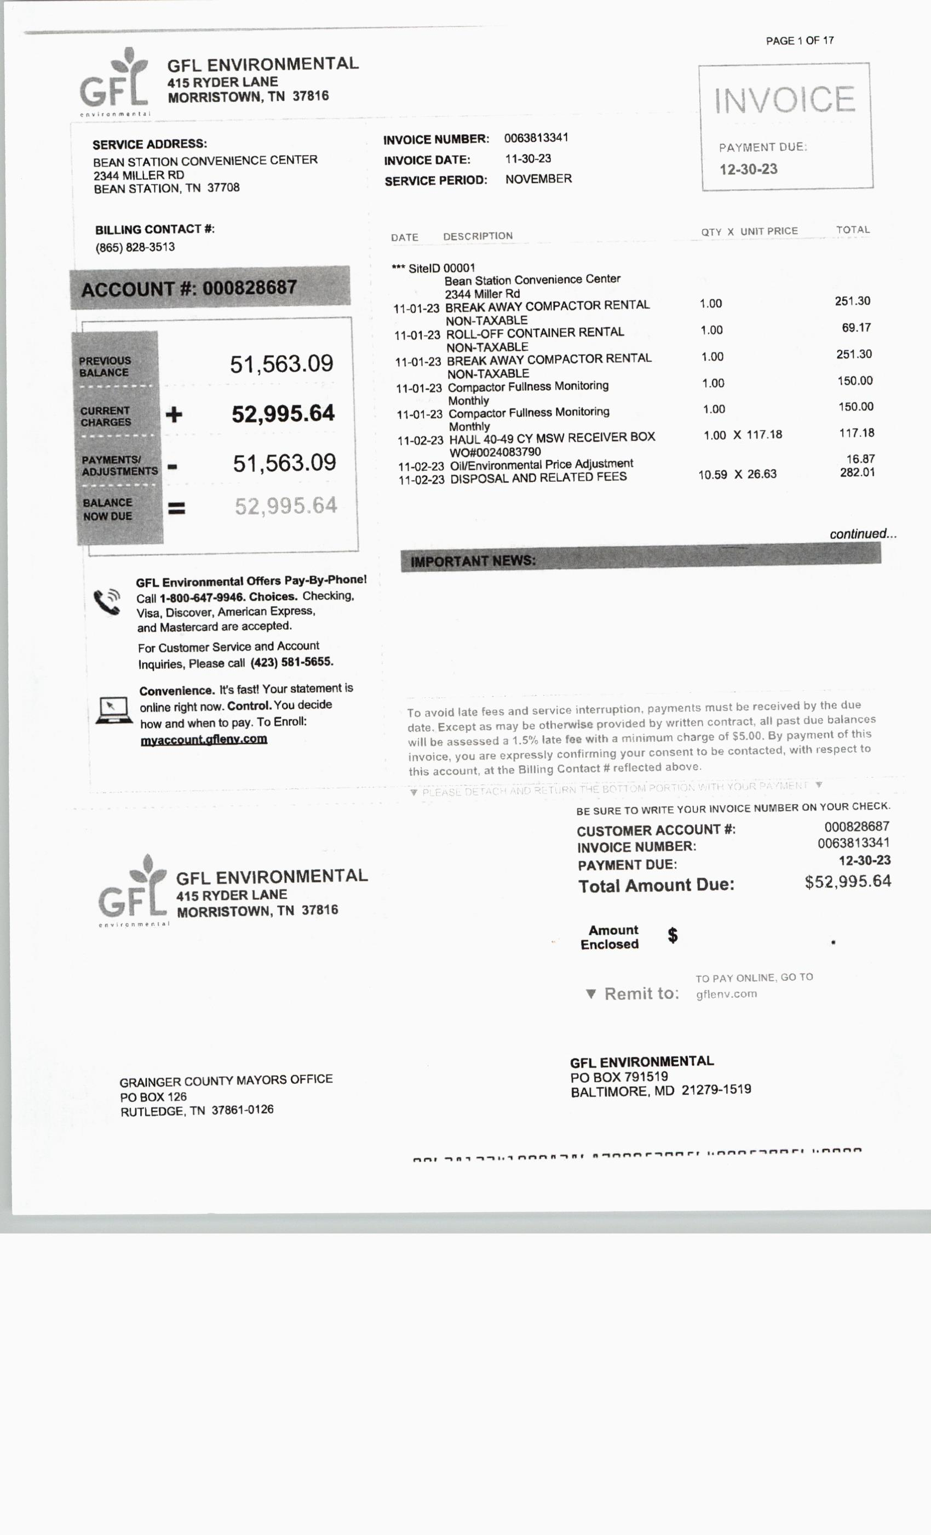

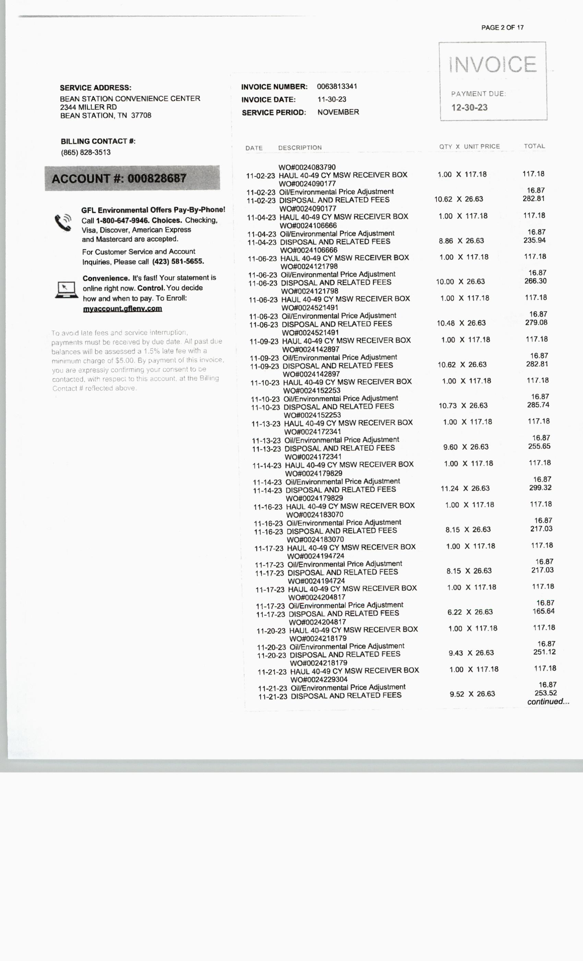

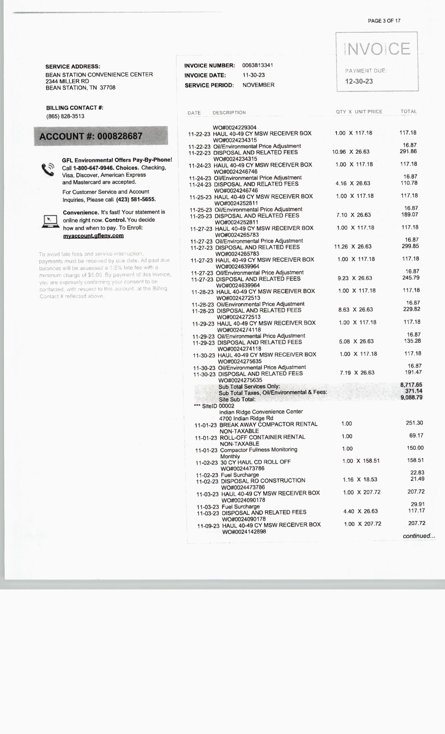

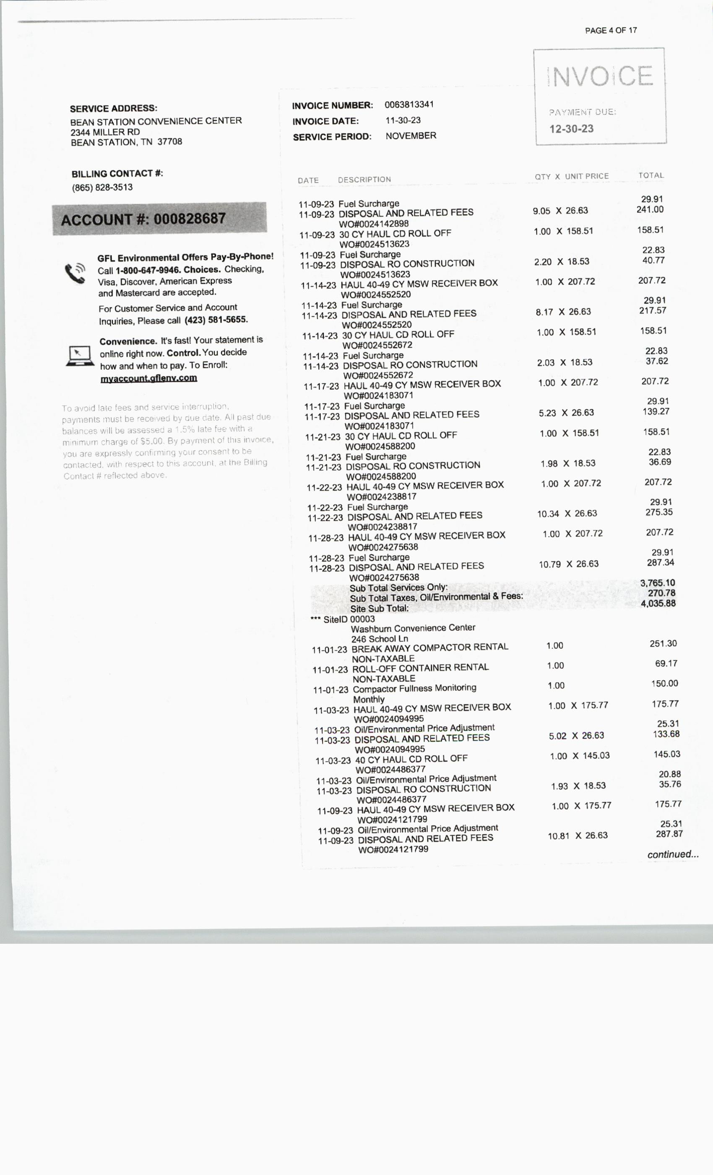

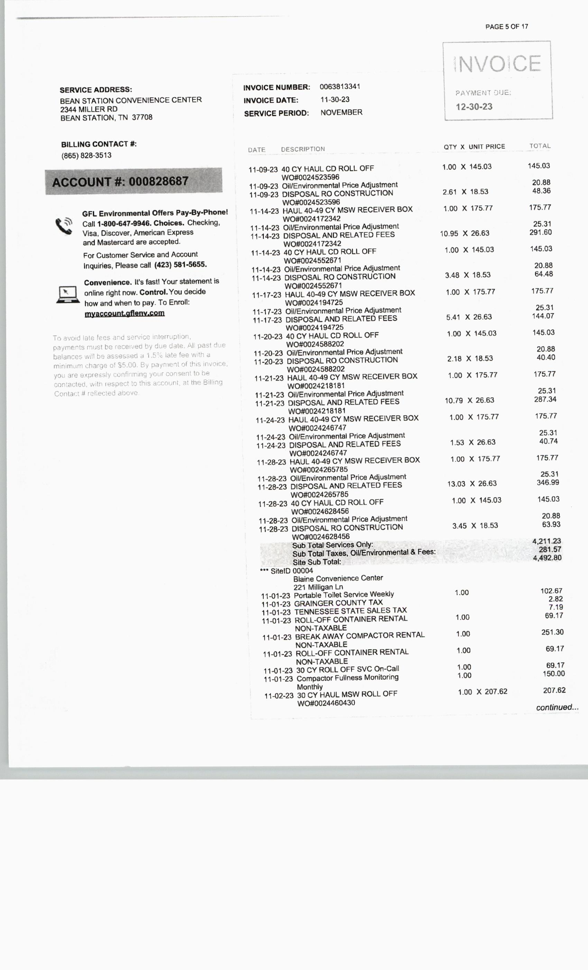

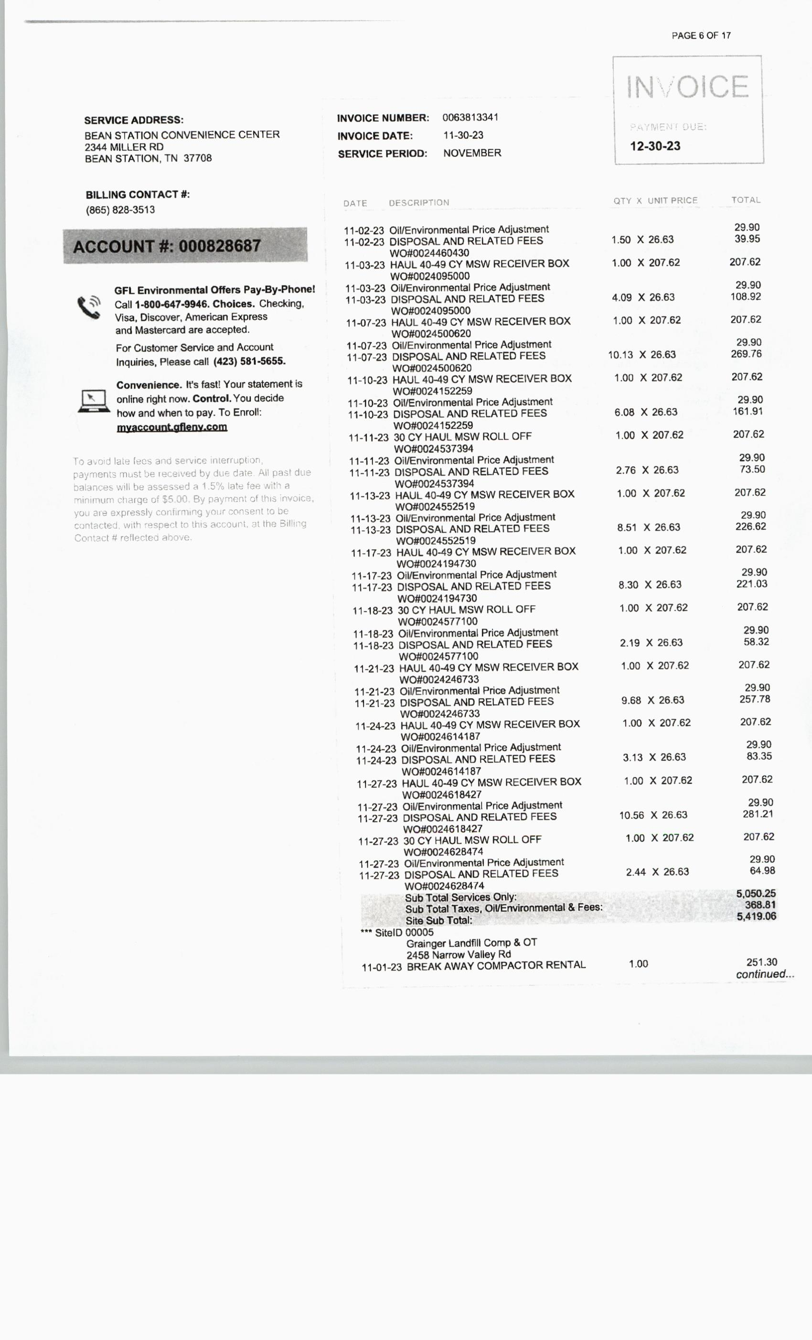
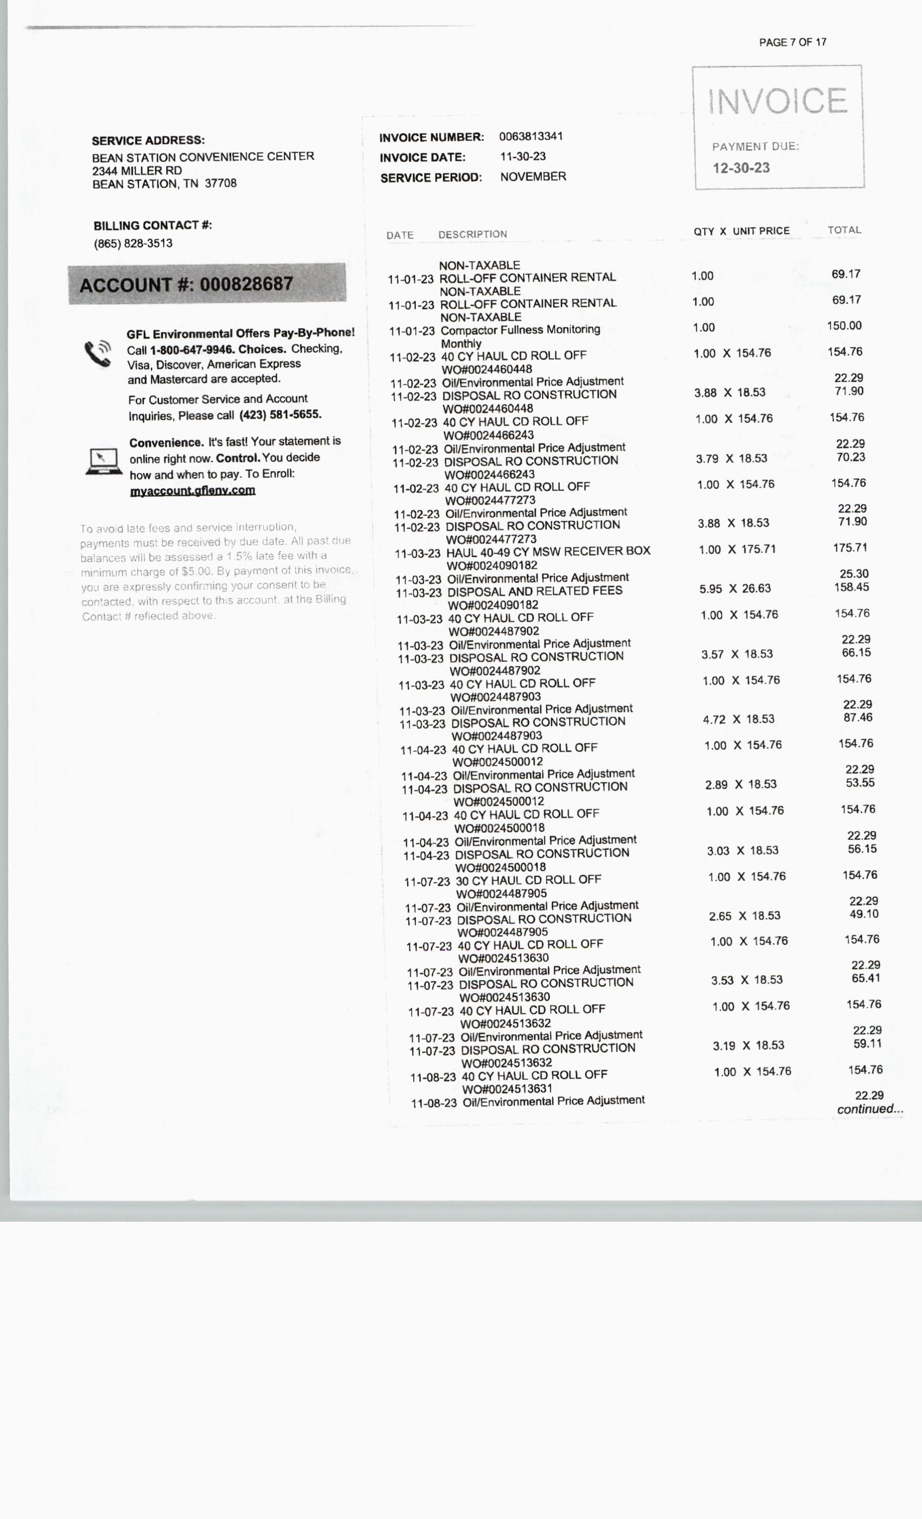

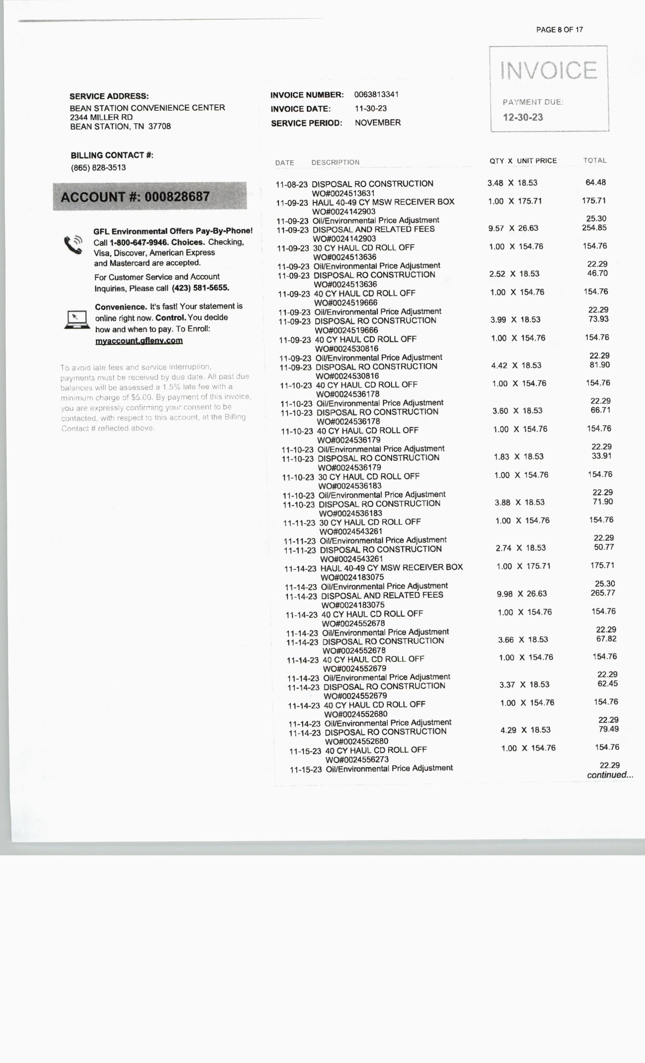

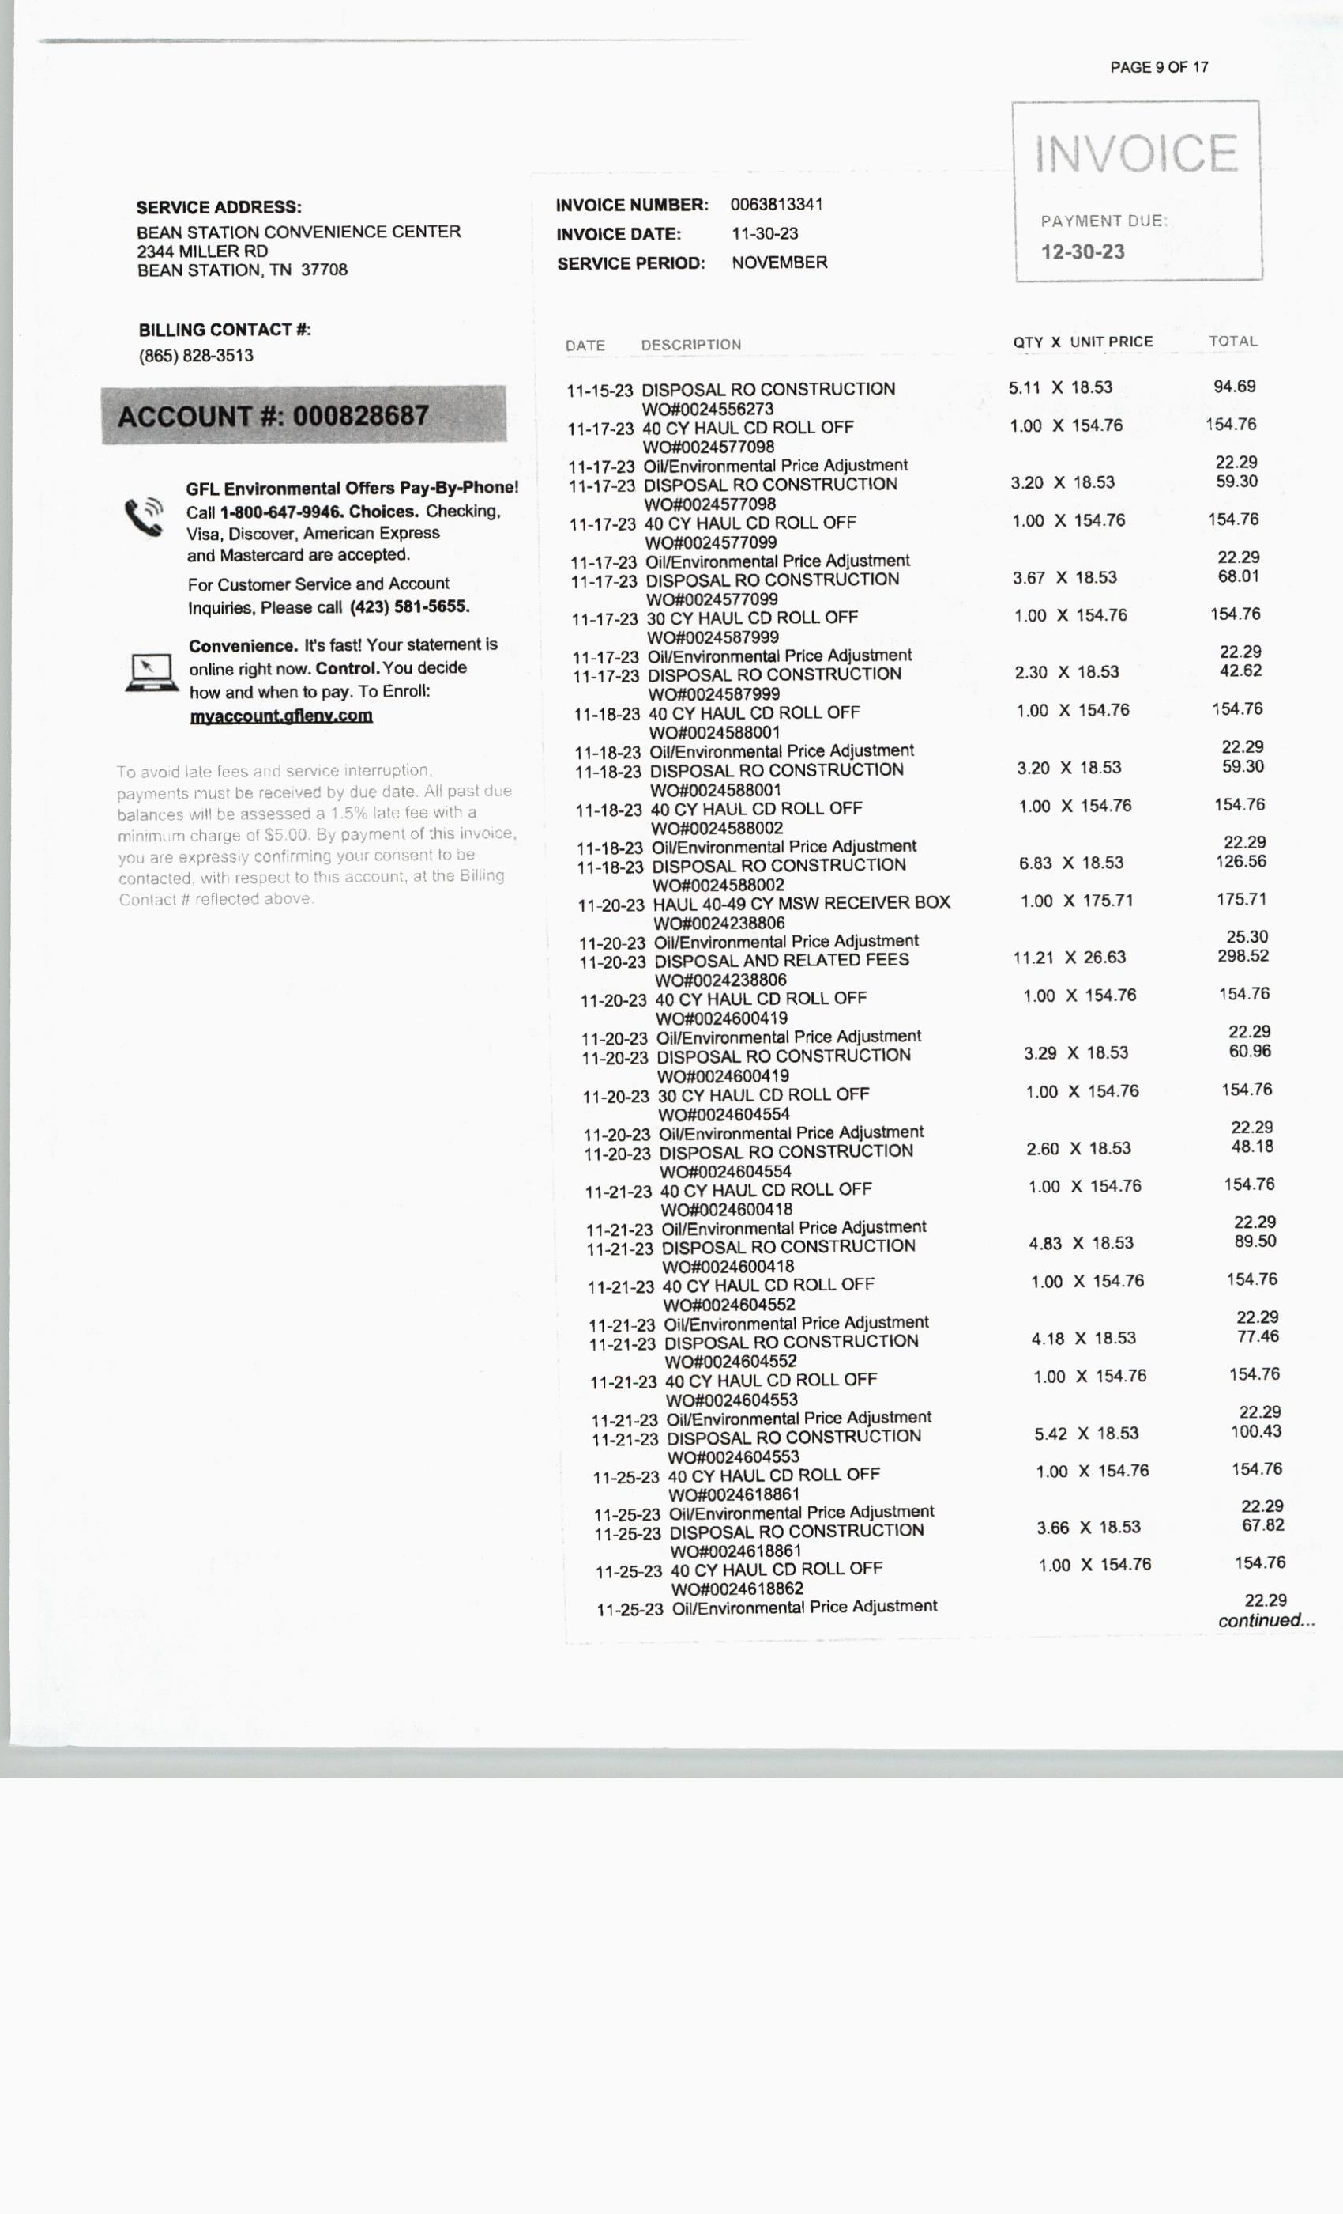
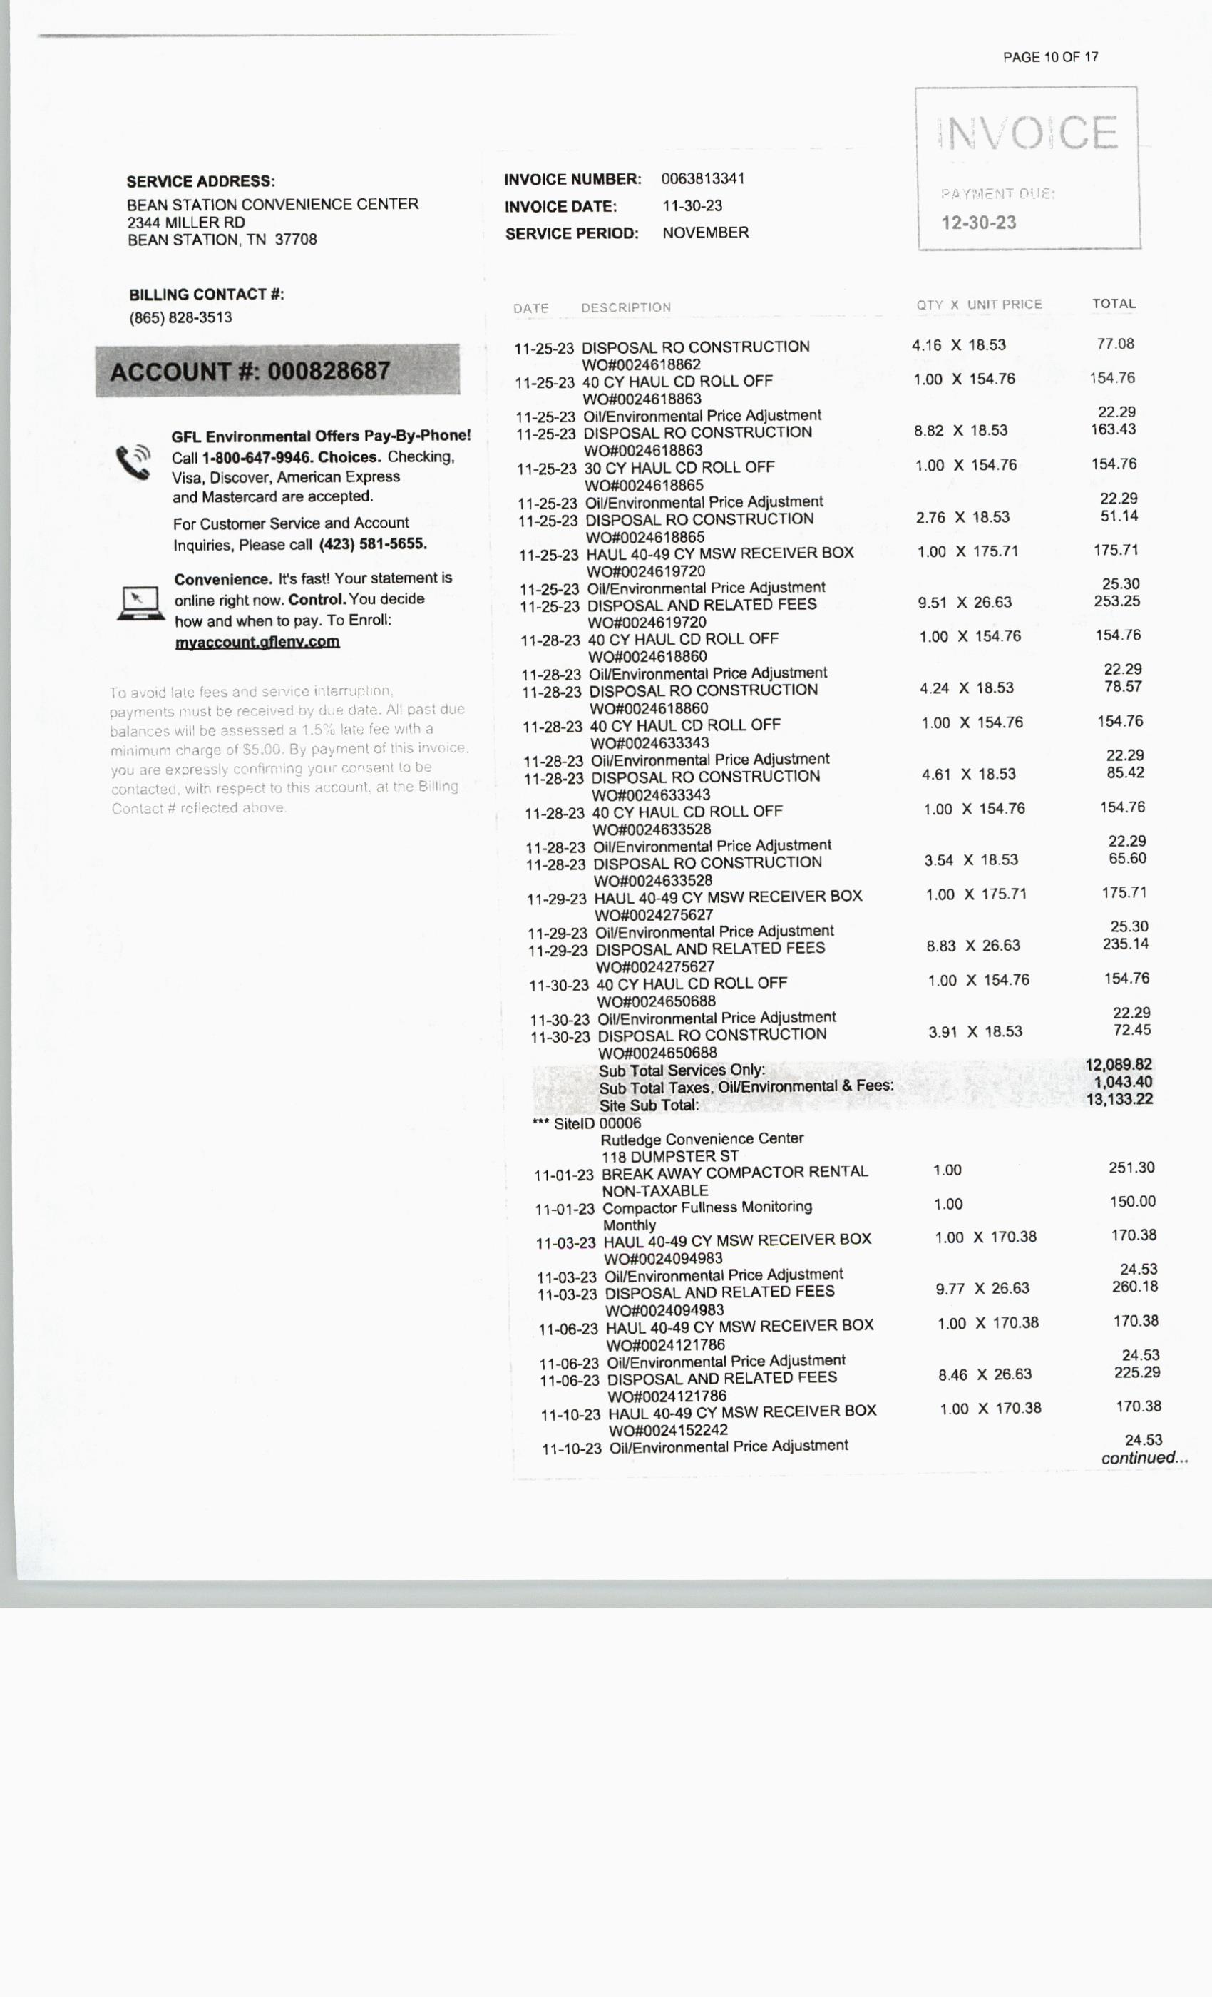

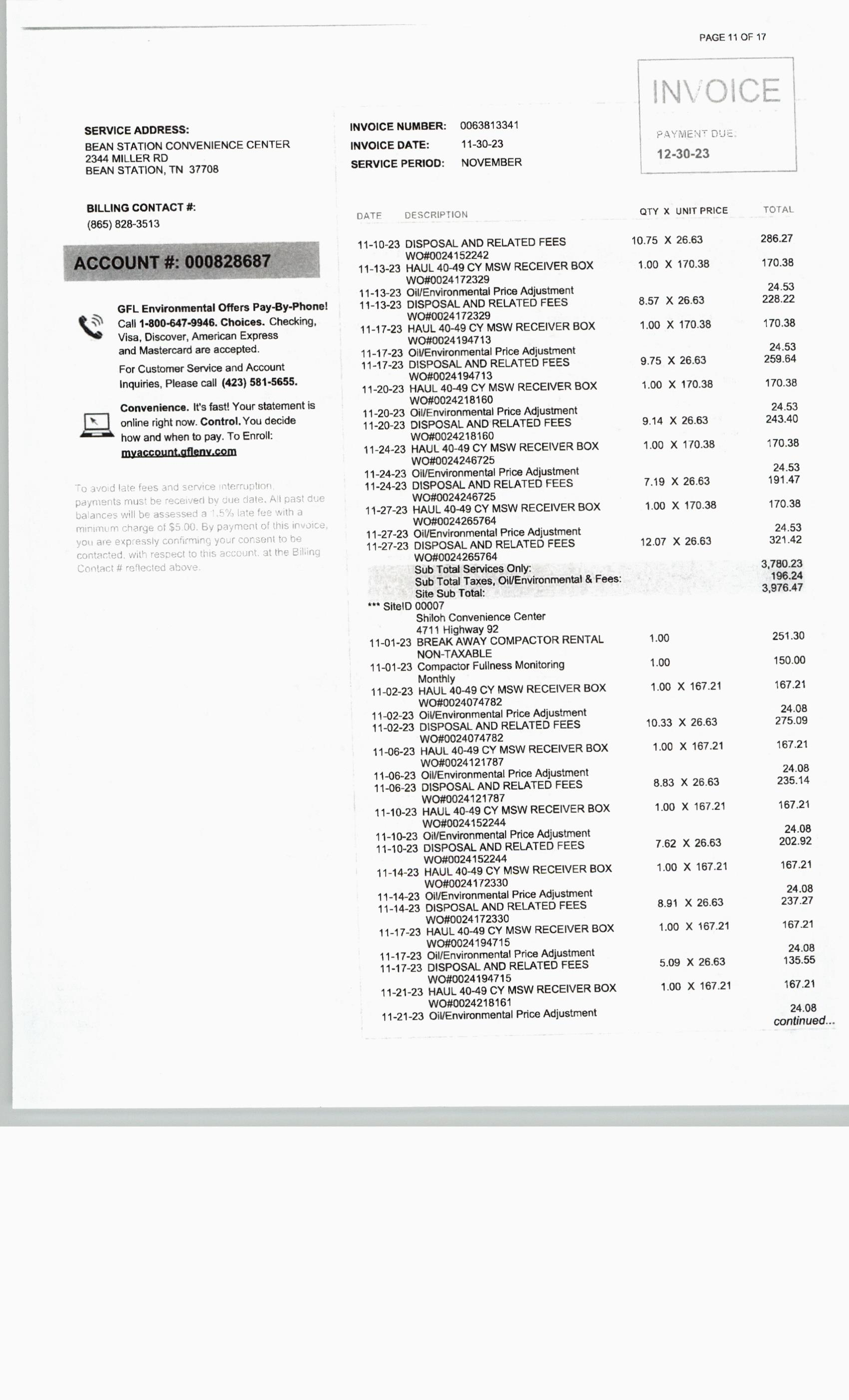

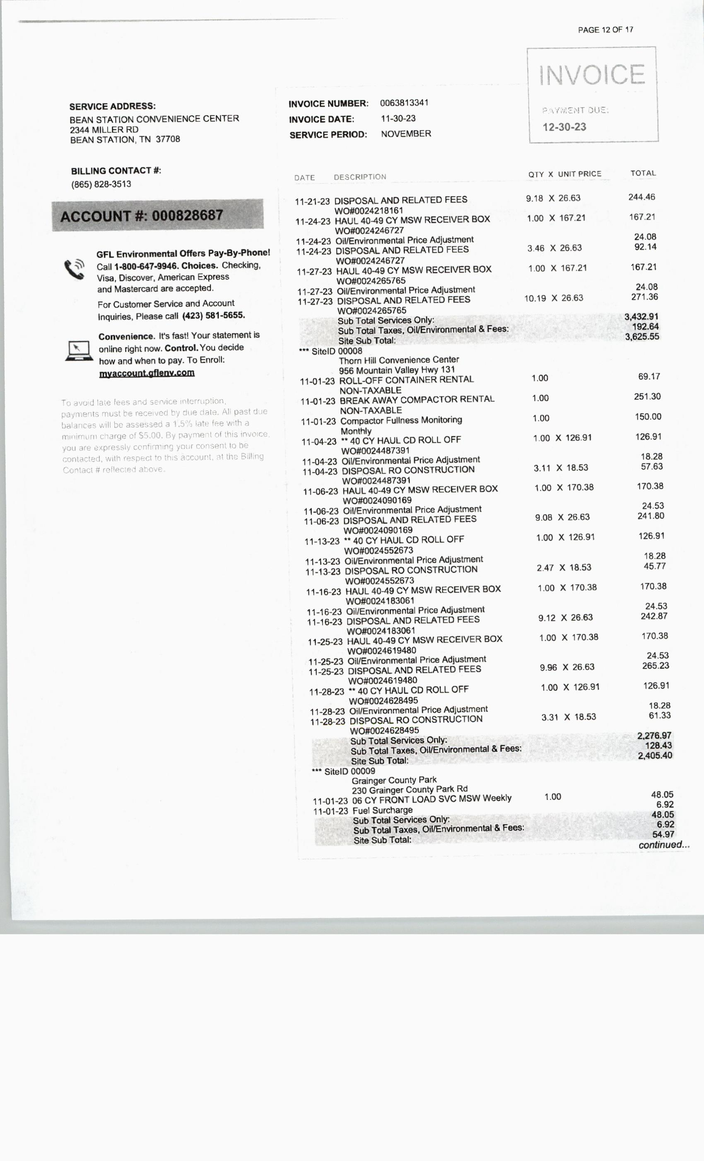

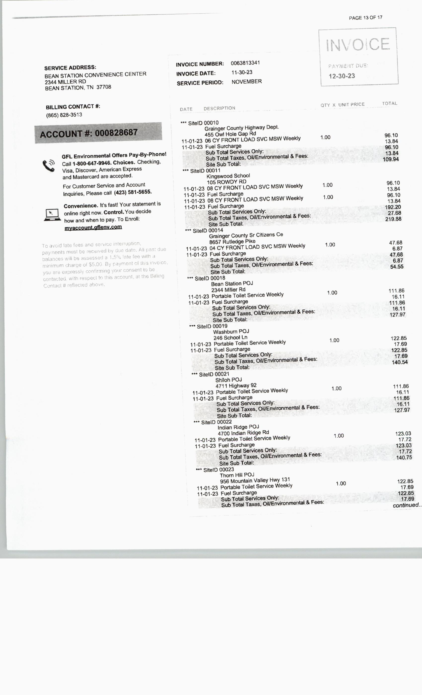

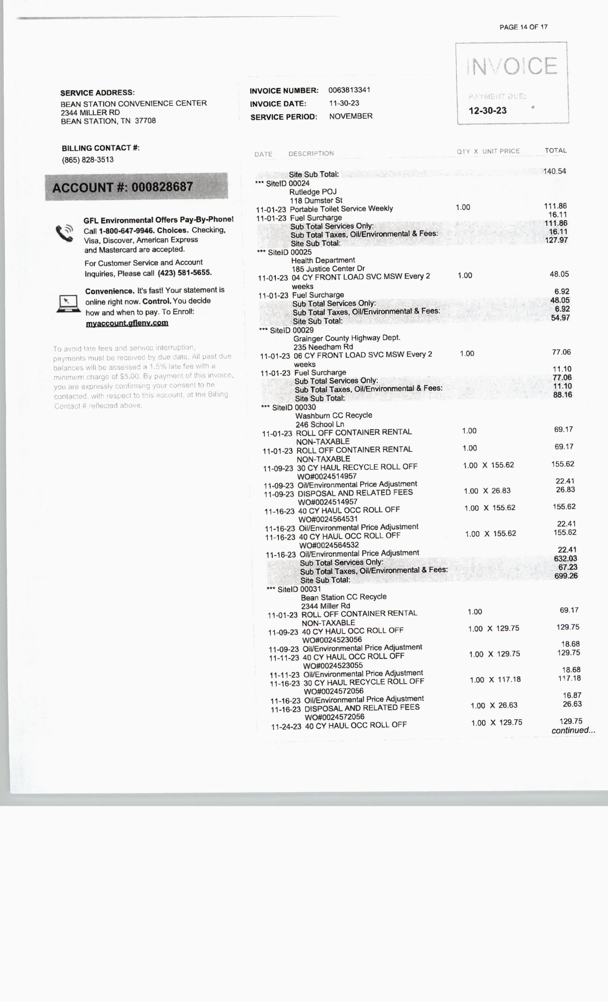

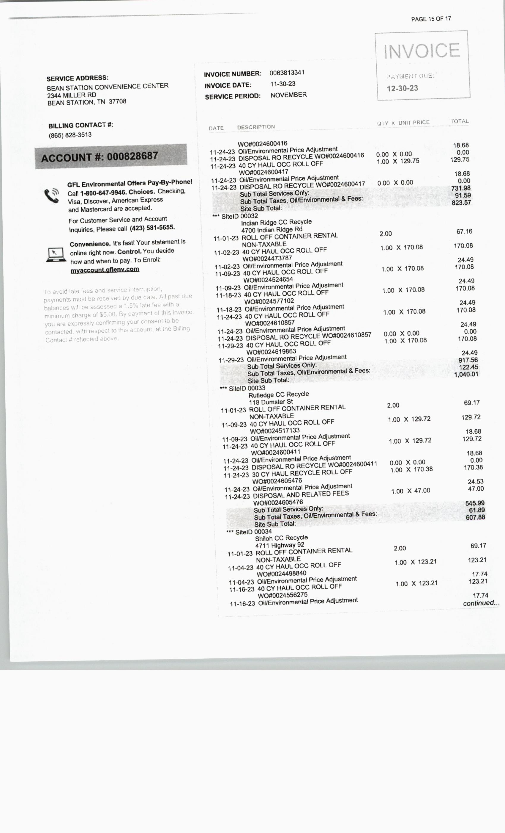

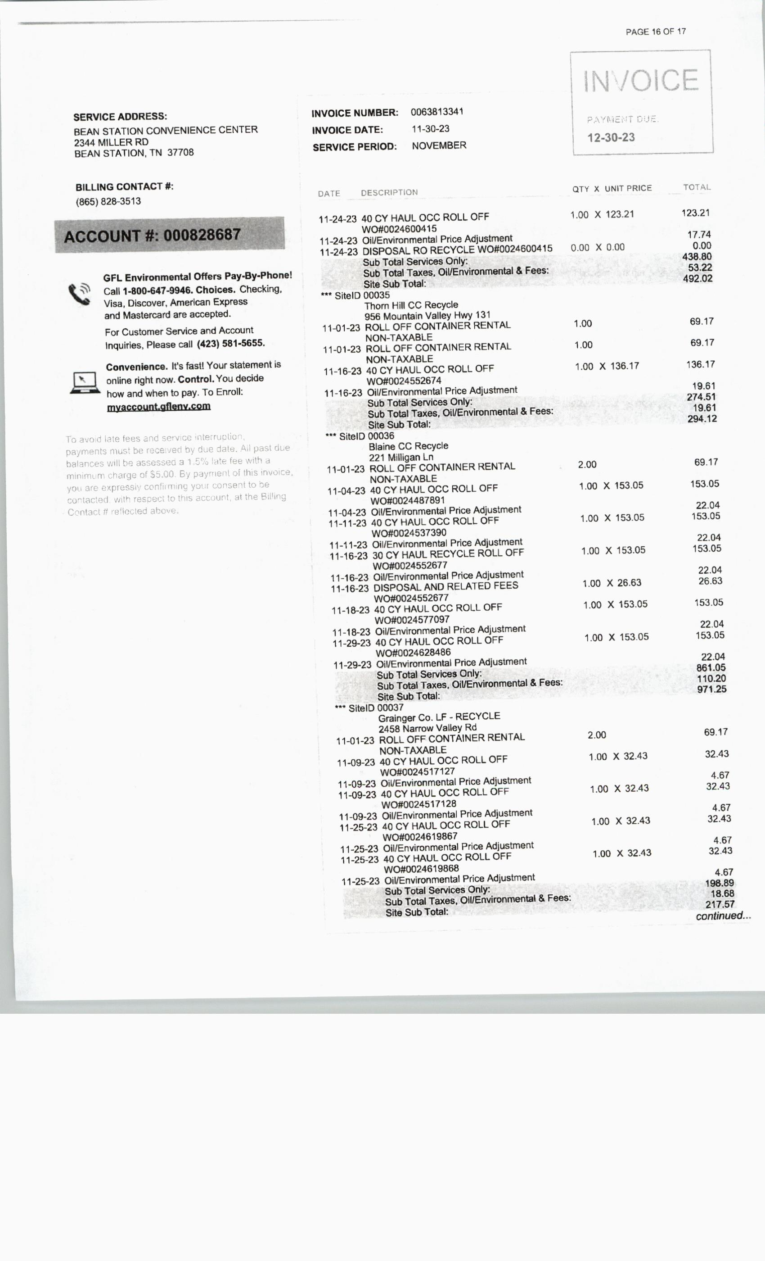

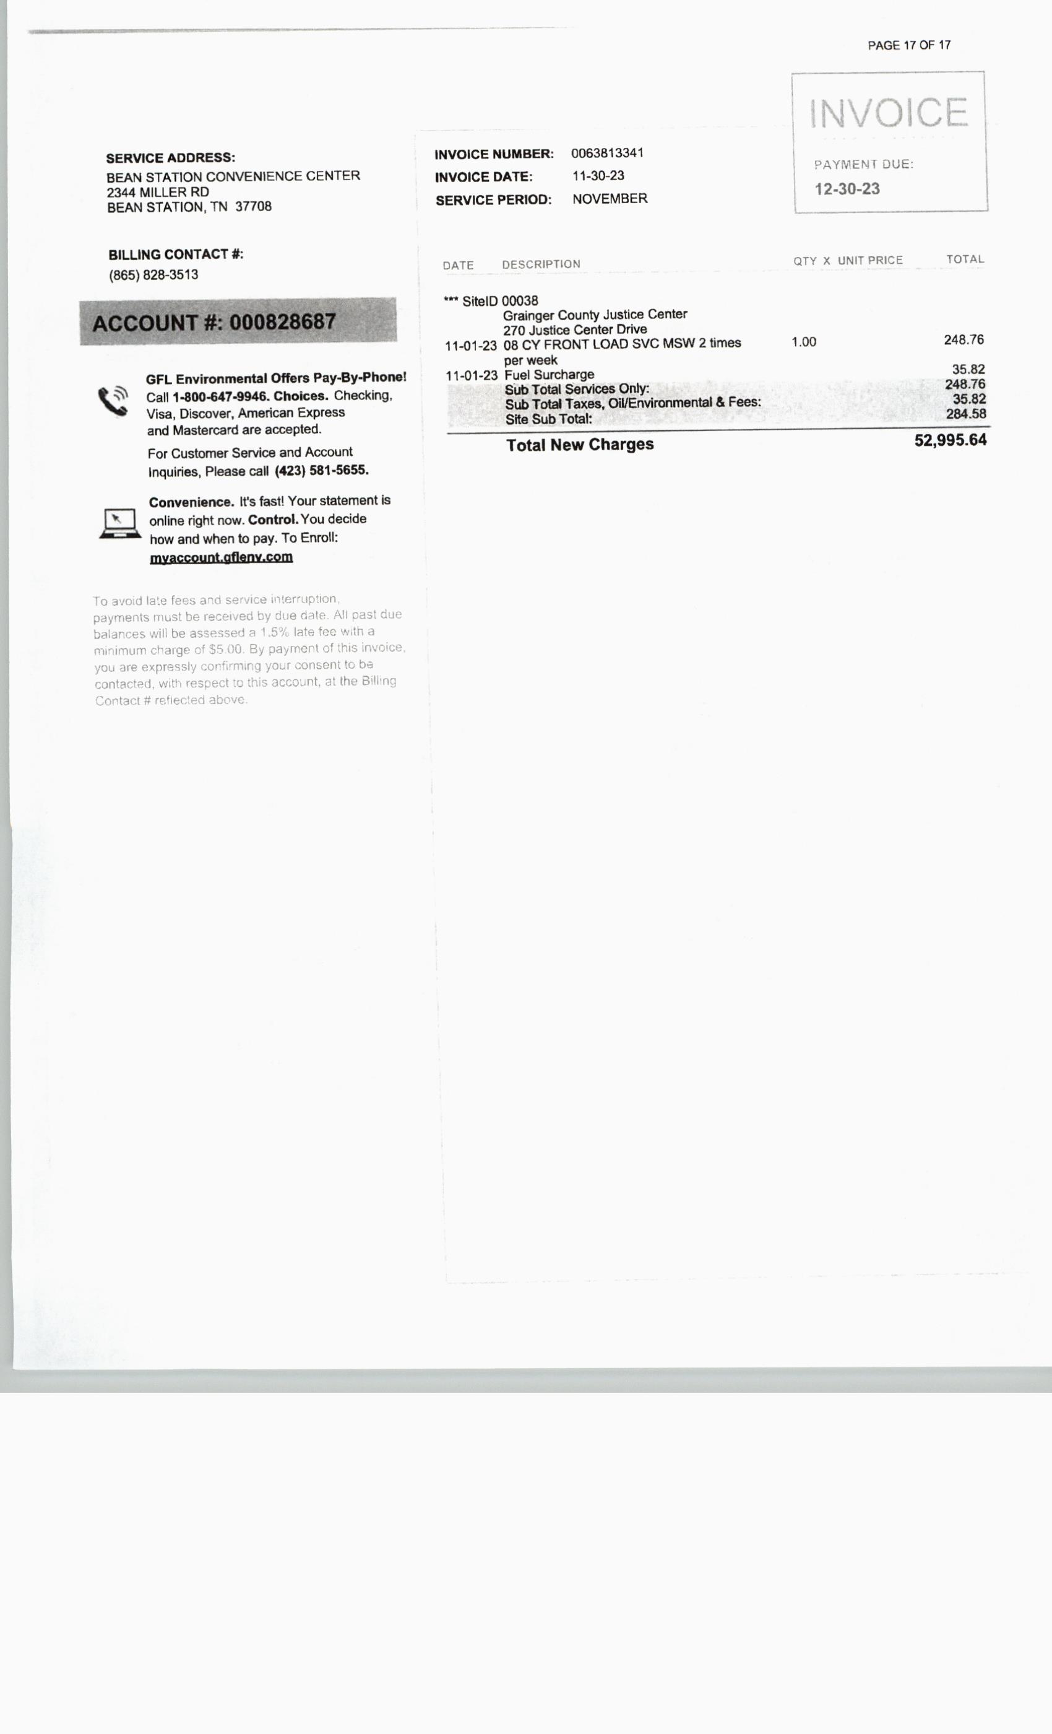

REPORTS, MONTHLY, QUARTERLY & ANNUALLY, Sheriff
NO MOTIONS

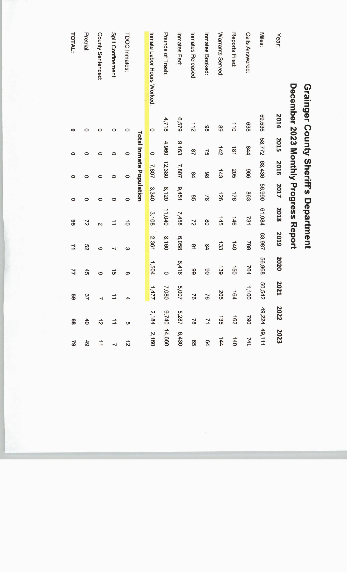
***************

REPORTS, MONTHLY, QUARTERLY & ANNUALLY, Trustee
NO MOTIONS
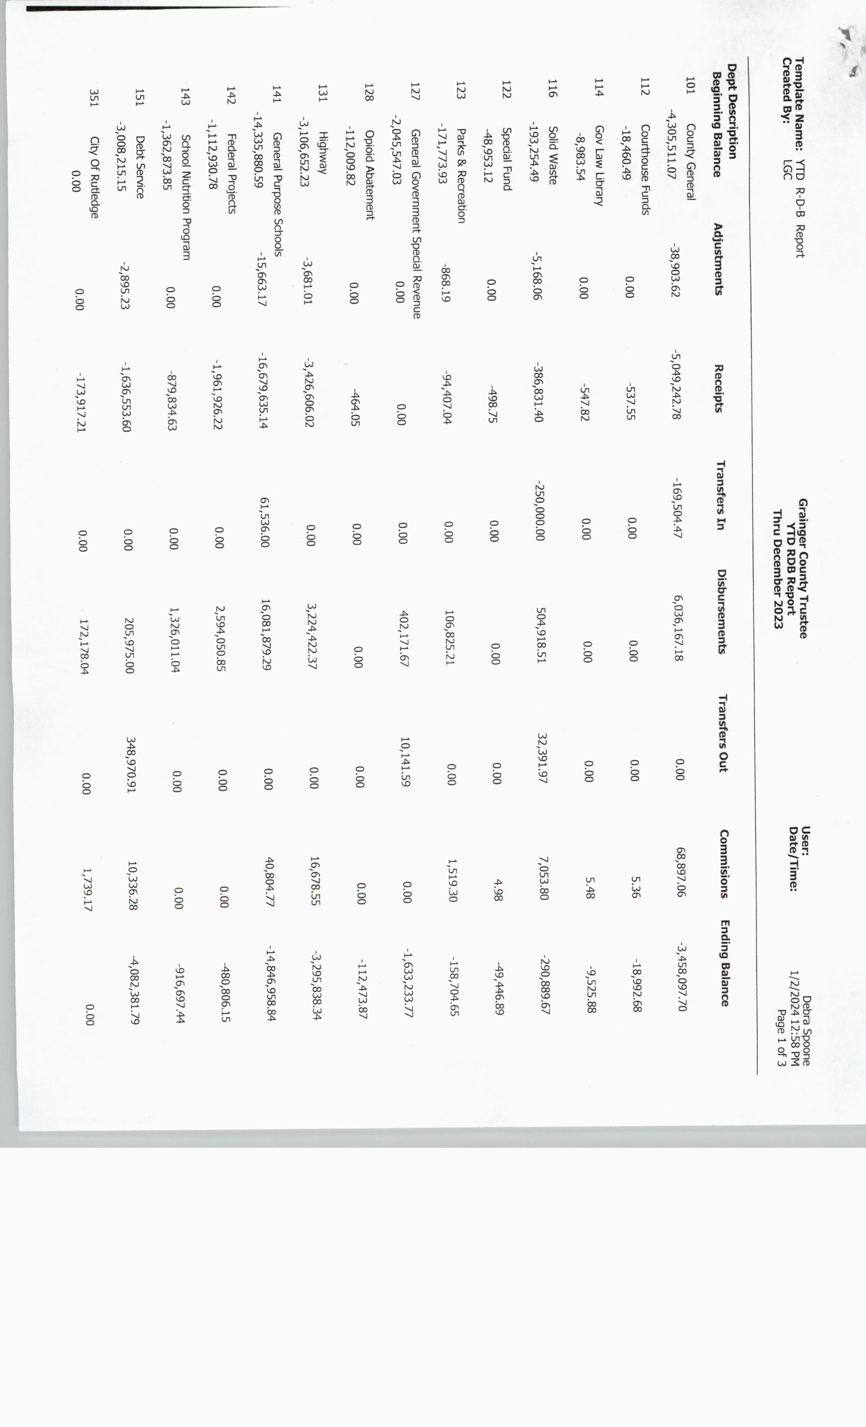

***************

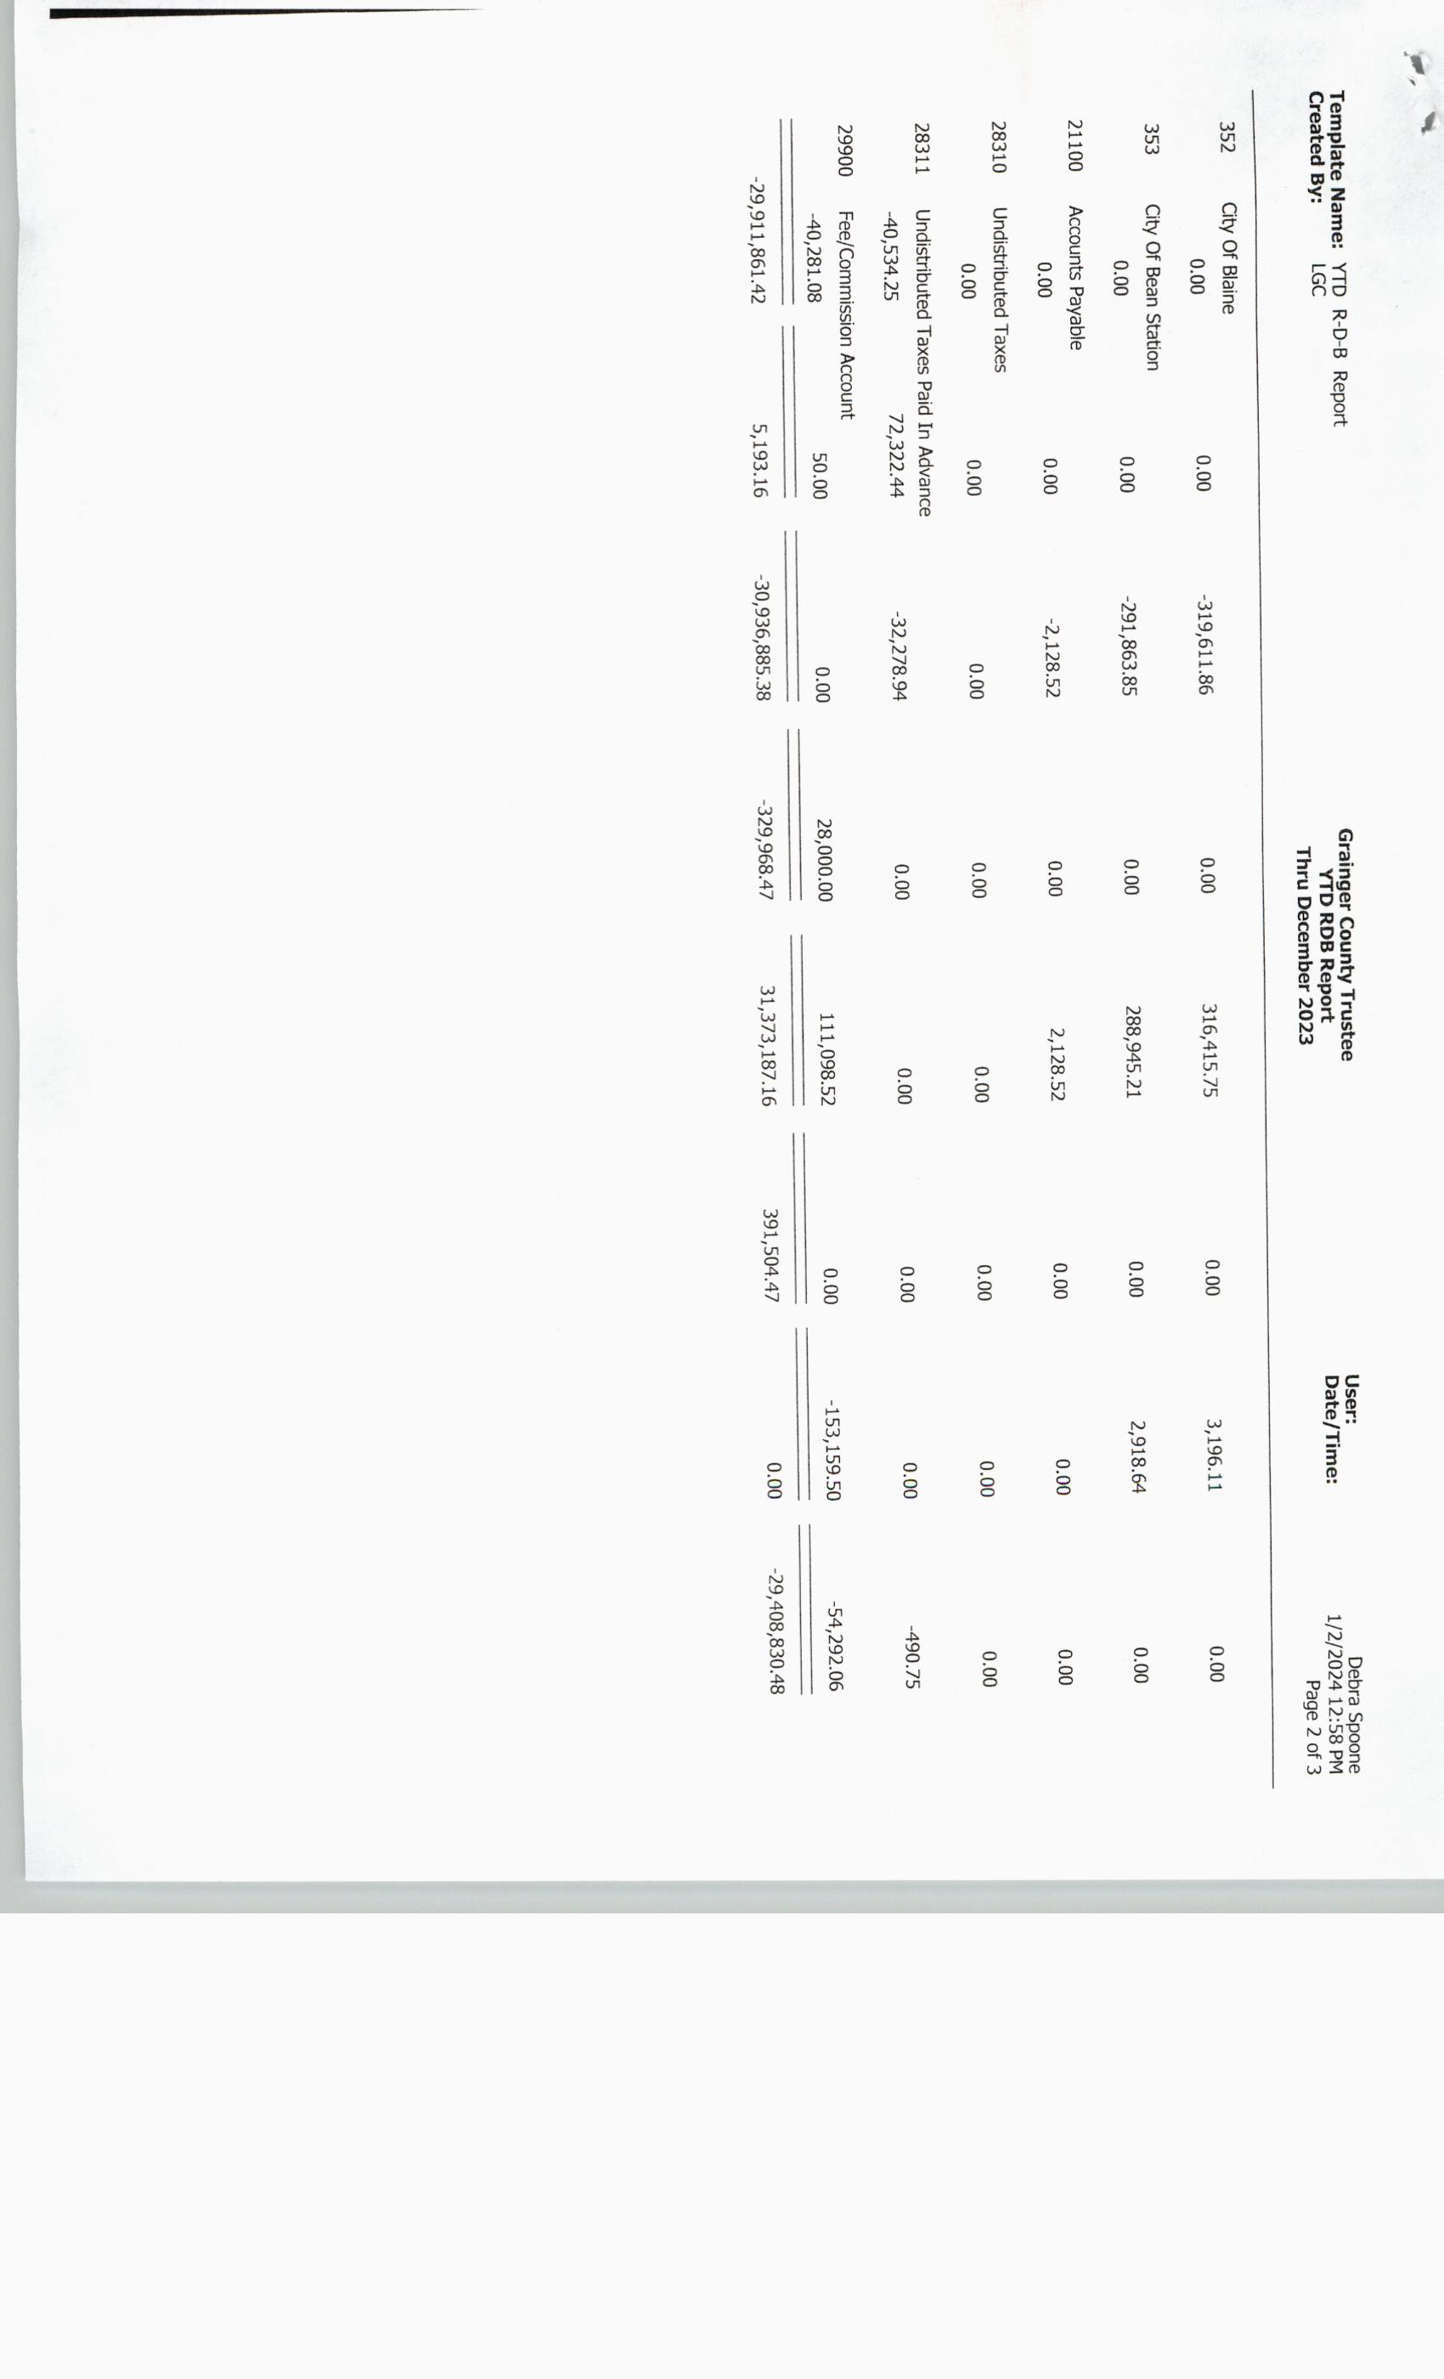

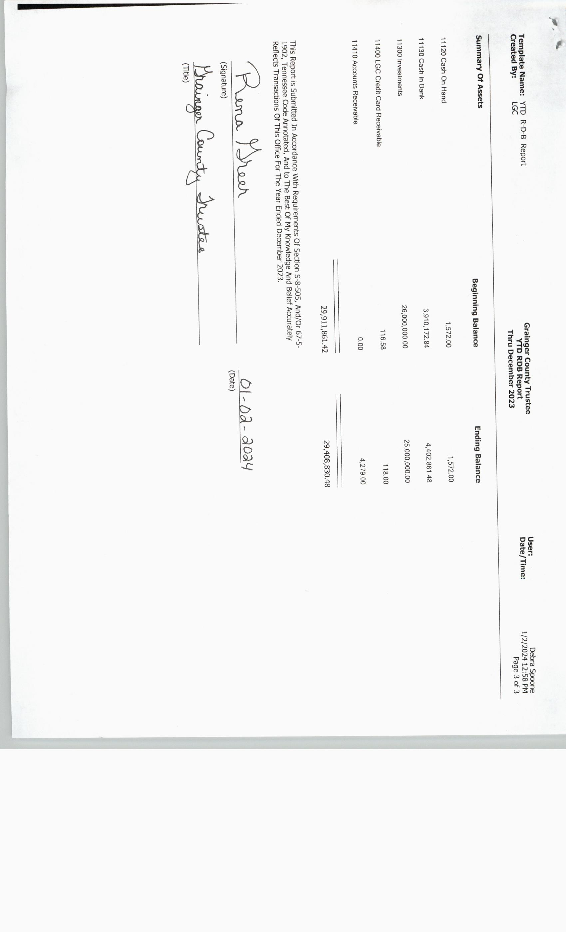

COMMITTEE/DIRECTOR REPORTS, Parks and Recreation
Report/No Motions

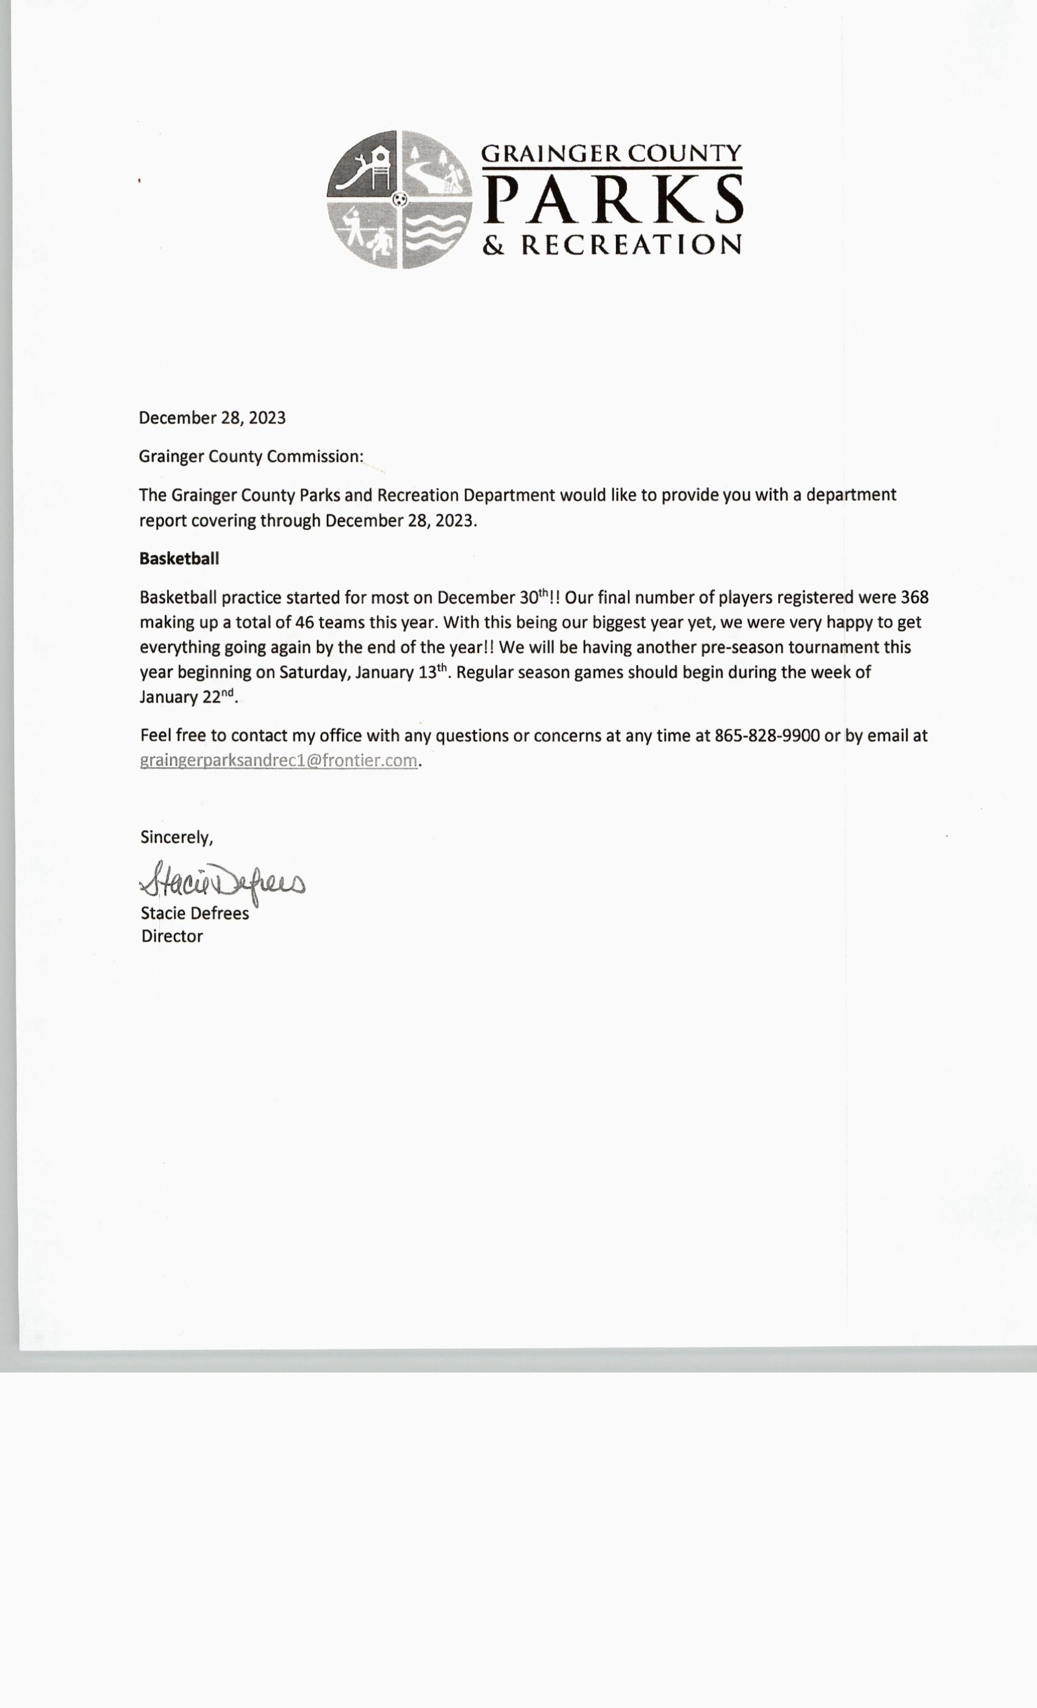

***************
COMMITTEE/DIRECTOR REPORTS, EMS
Report/No Motions

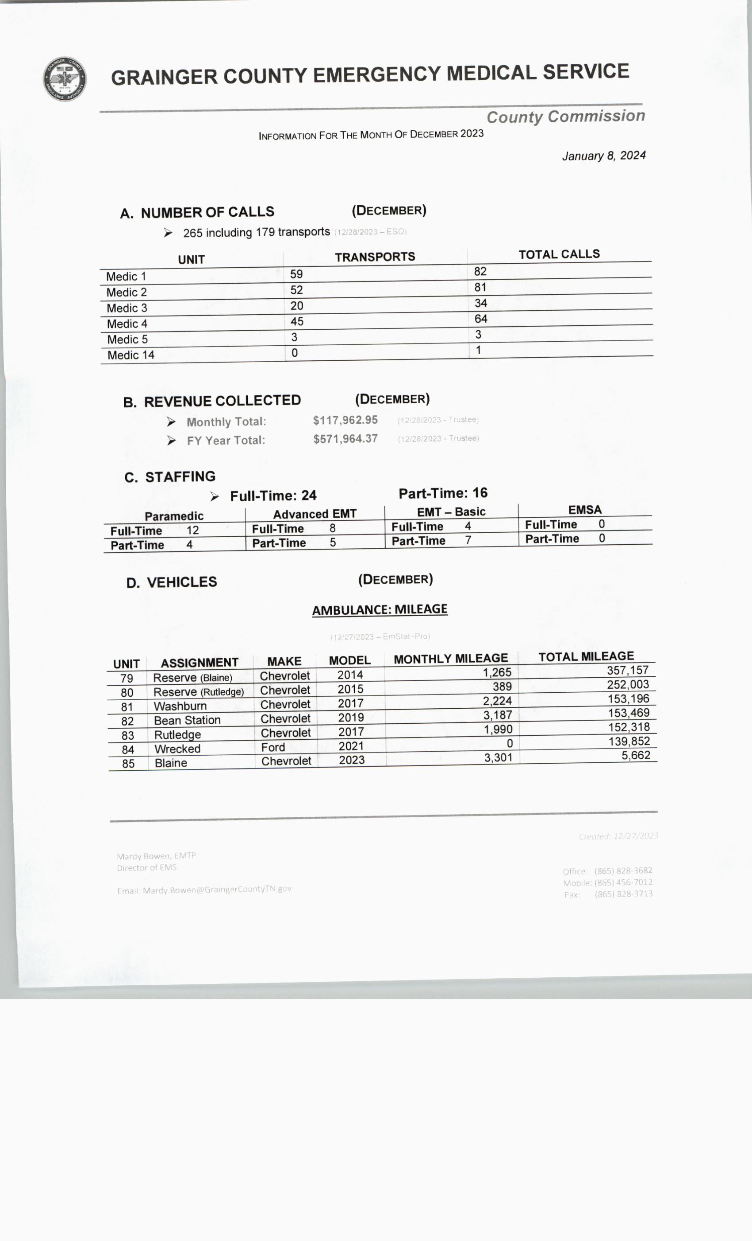

COMMITTEE/DIRECTOR REPORTS; E-911
No Motions

BUDGET AMENDMENTS;
NONE

**************

RESOLUTIONS; 1.8.2024A; Joint Resolution between Grainger County Legislative Body and Grainger County Board of Education and Grainger County School System opposing the Education Freedom Scholarship Act
UPON MOTION of Commissioner JAMES ACUFF, Seconded by Commissioner JENNIFER HOLT, the Commission approved Resolution 1.8.2024A, a joint resolution between Grainger County Legislative Body and Grainger County Board of Education and Grainger County School System opposing the Education Freedom Scholarship Act by Voice Vote.

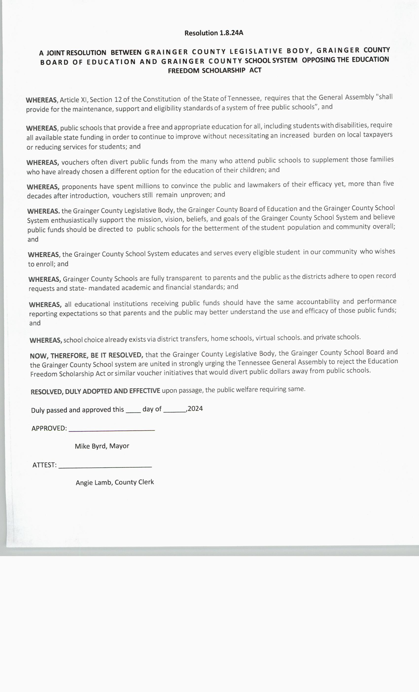

**************

RESOLUTIONS; 1.8.2024B; Resolution Establishing Board Member Compensation
UPON MOTION of Commissioner JAMES ACUFF, Seconded by Commissioner TINA DAVIS, the Commission approved Resolution 1.8.2024B, a resolution establishing County Legislative Board Members compensation effective at the beginning of the term following the next election of County Commissioners, September 1, 2026 (Motion passed in December) by *Voice Vote.
*Commissioner Justin Epperson voiced Nay to the Voice Vote.
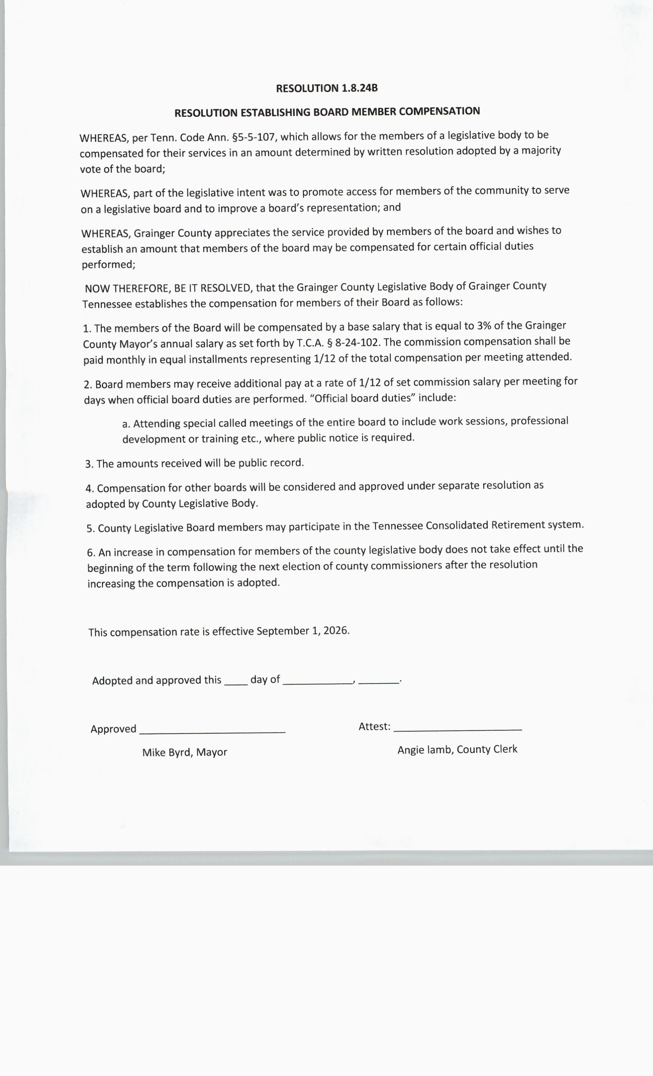
***************

RESOLUTIONS; 1.8.2024C; Resolution/Board of Education
UPON MOTION of Commissioner LUKE STRATTON, Seconded by Commissioner ANDY CAMERON, the Commission approved Resolution 1.8.2024C, a resolution regarding funding for the Board of Education to transfer funds from general purpose school fund to federal programs fund for the fiscal year ending June 30, 2024 by Roll Call Vote as Follows:
*This Resolution will be presented to the Grainger County School Board on January 16, 2024.

AYE: DARRELL STRATTON, SCOTT WYNN, ED MCBEE, RODNEY OVERBAY, LUKE STRATTON, ANDY CAMERON, TINA DAVIS, DARRELL WILLIAMS, JAMES ACUFF, JUSTIN EPPERSON, JENNIFER HOLT, JESSE CLINE AND MIKE HOLT. (13)

NAY: (0)

ABSENT: WENDY NOE AND ANNA BLANKEN. (2)
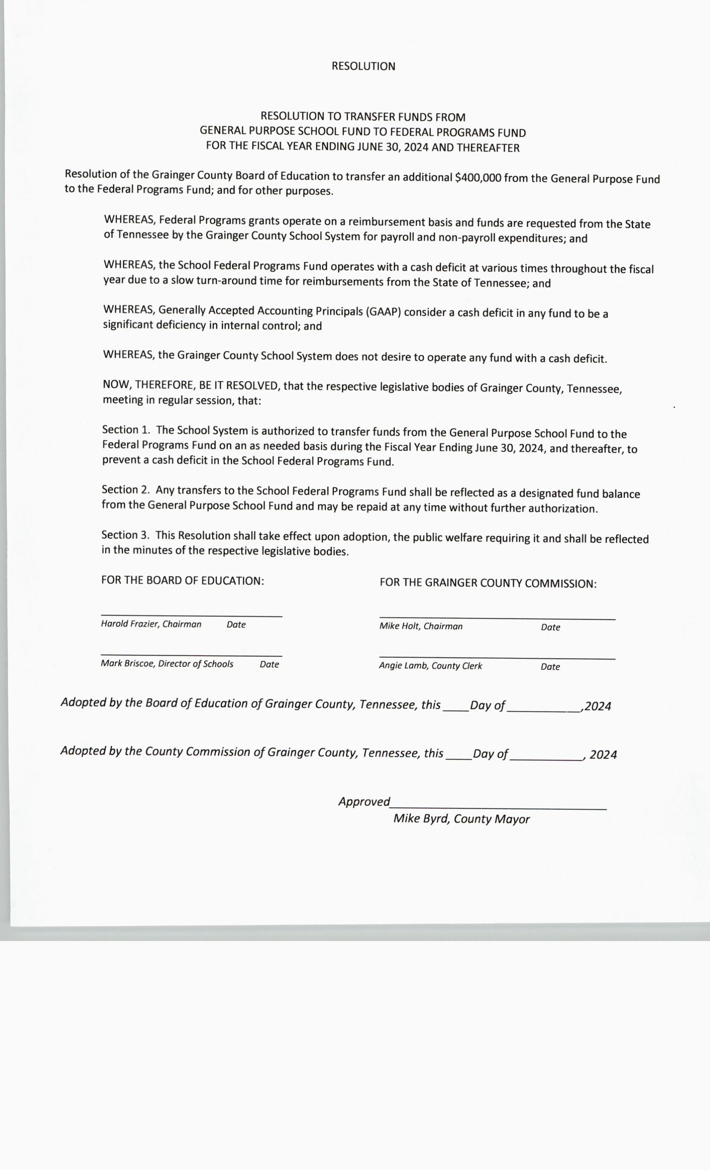

***************

NEW BUSINESS, Regarding Resolution 7.3.23A
NO MOTIONS/Lori Lockhart spoke for 30 minutes.

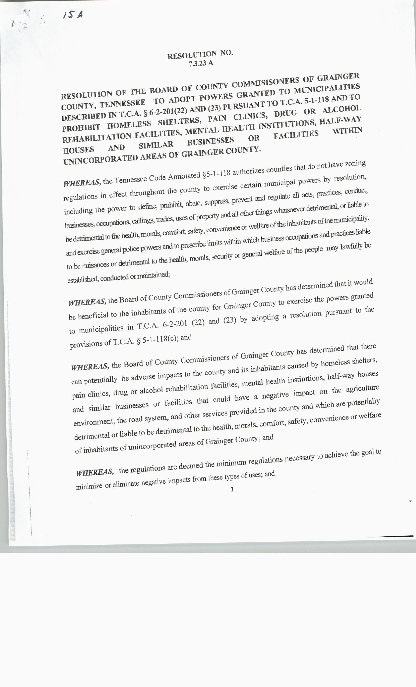

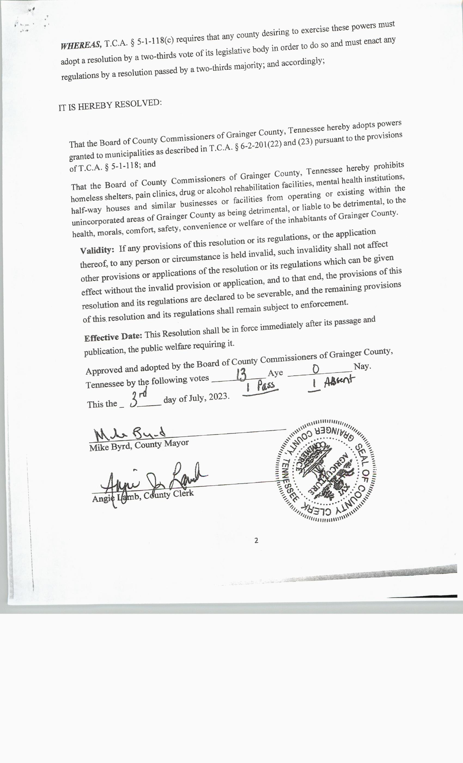

NEW BUSINESS, Washburn Clinic and Library Drain Field
UPON MOTION of Commissioner ED MCBEE, Seconded by Commissioner RODNEY OVERBAY, the Commission approved a bid from Collins and Dalton for $22,850.00 for Washburn Clinic and Library drain field by Roll Call Vote as Follows:

AYE: DARRELL STRATTON, SCOTT WYNN, ED MCBEE, RODNEY OVERBAY, LUKE STRATTON, ANDY CAMERON, TINA DAVIS, DARRELL WILLIAMS, JAMES ACUFF, JUSTIN EPPERSON, JENNIFER HOLT, JESSE CLINE AND MIKE HOLT. (13)

NAY: (0)

ABSENT: WENDY NOE AND ANNA BLANKEN. (2)

Collins/Dalton Bid Approved:

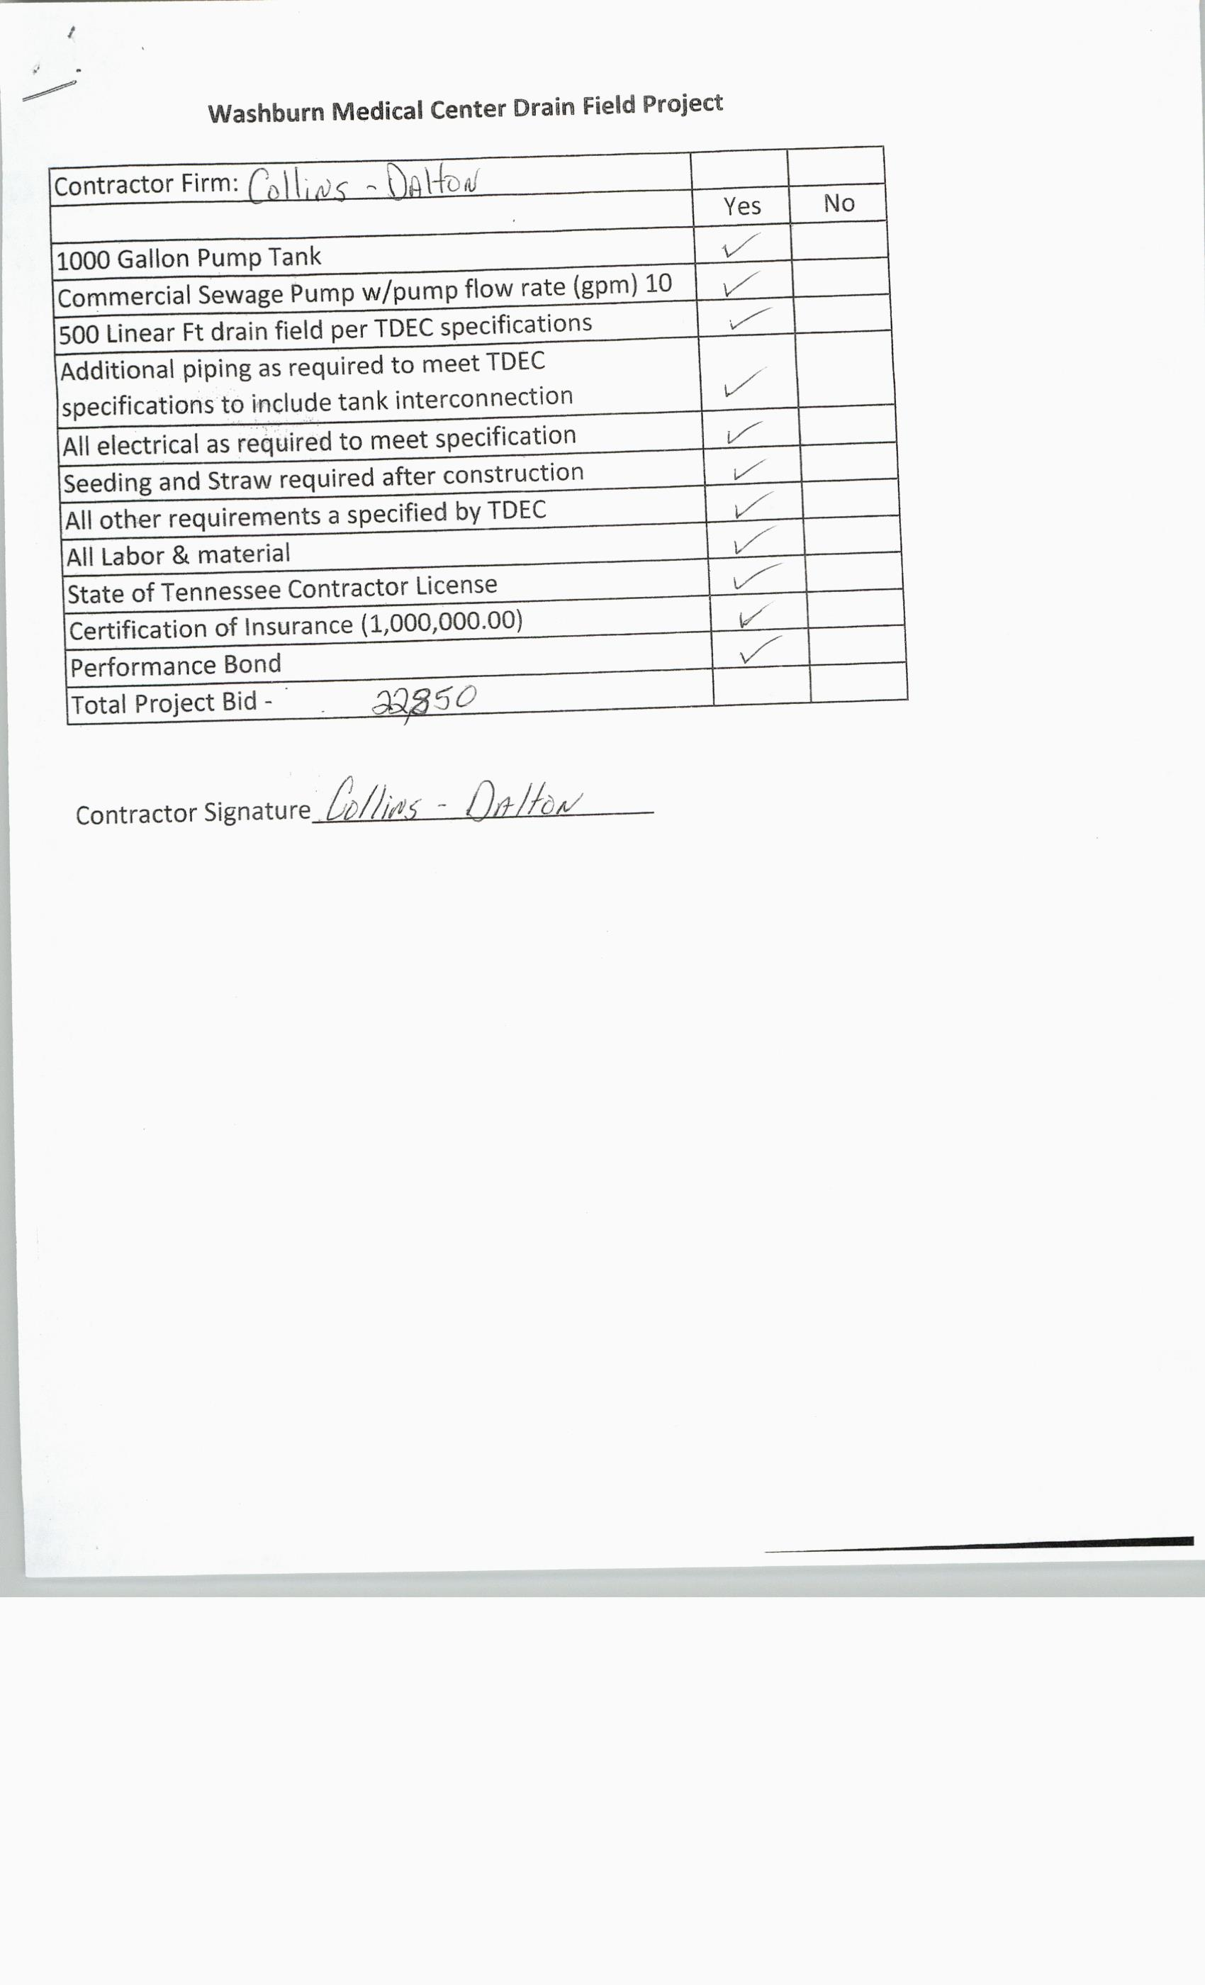

****************

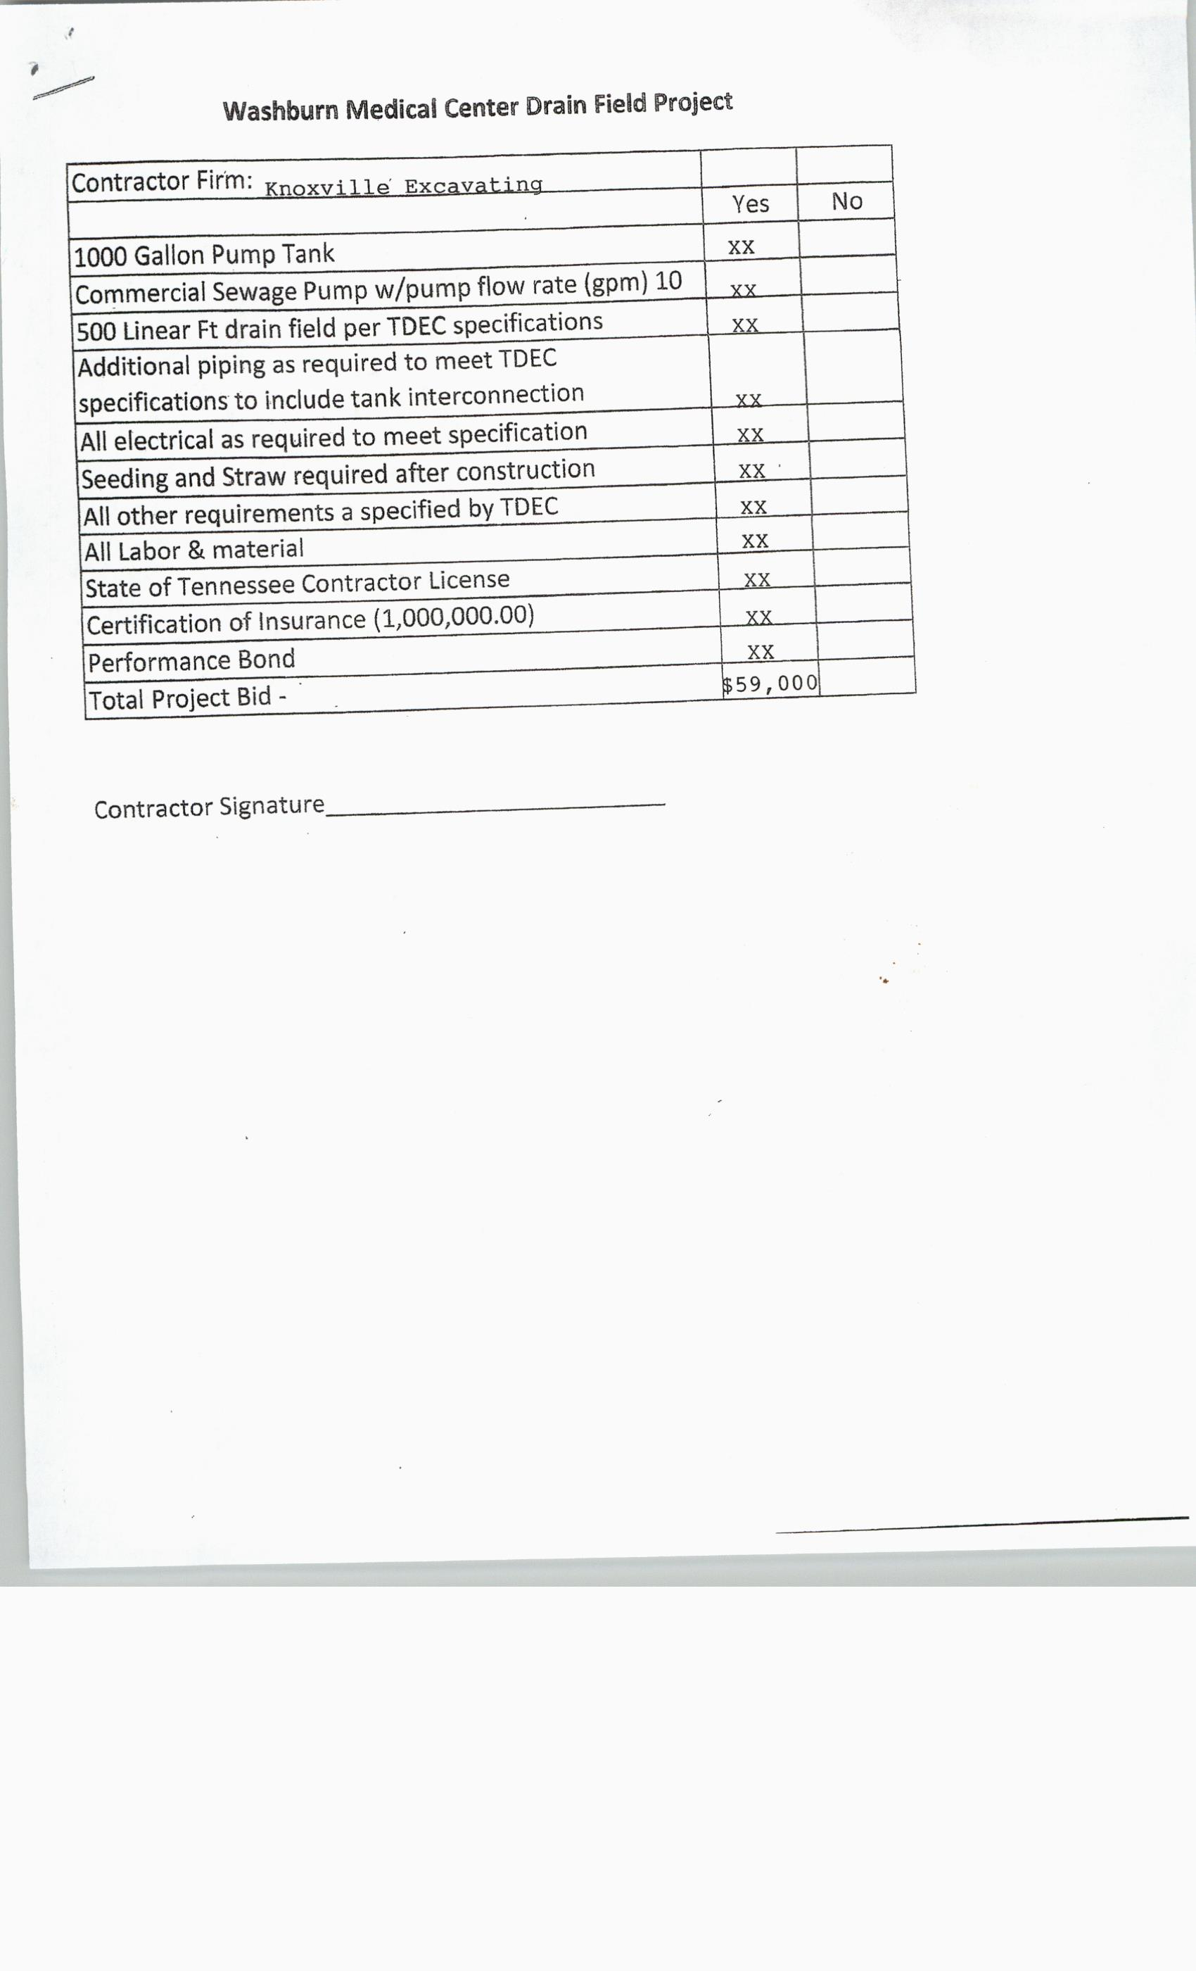

NEW BUSINESS; CDBG Application
NO MOTIONS

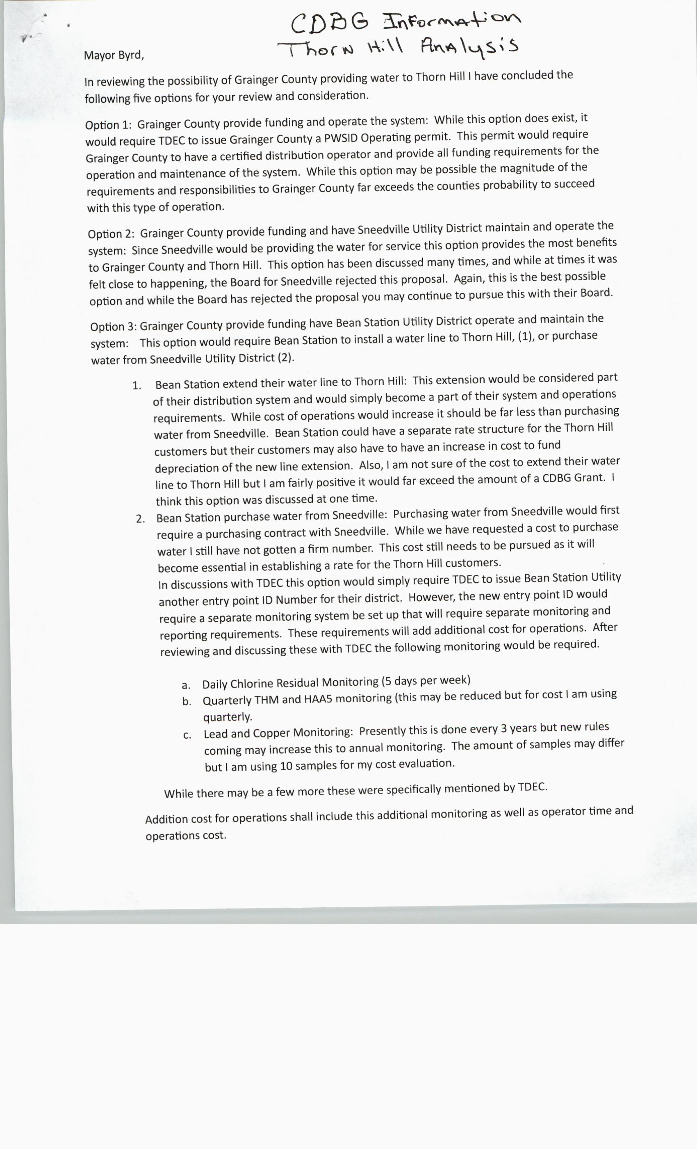
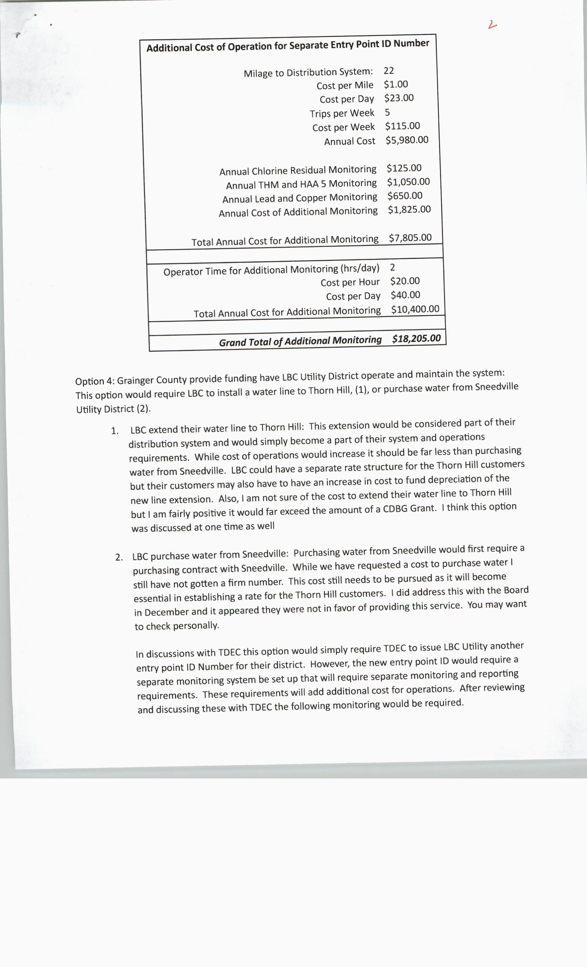
****************

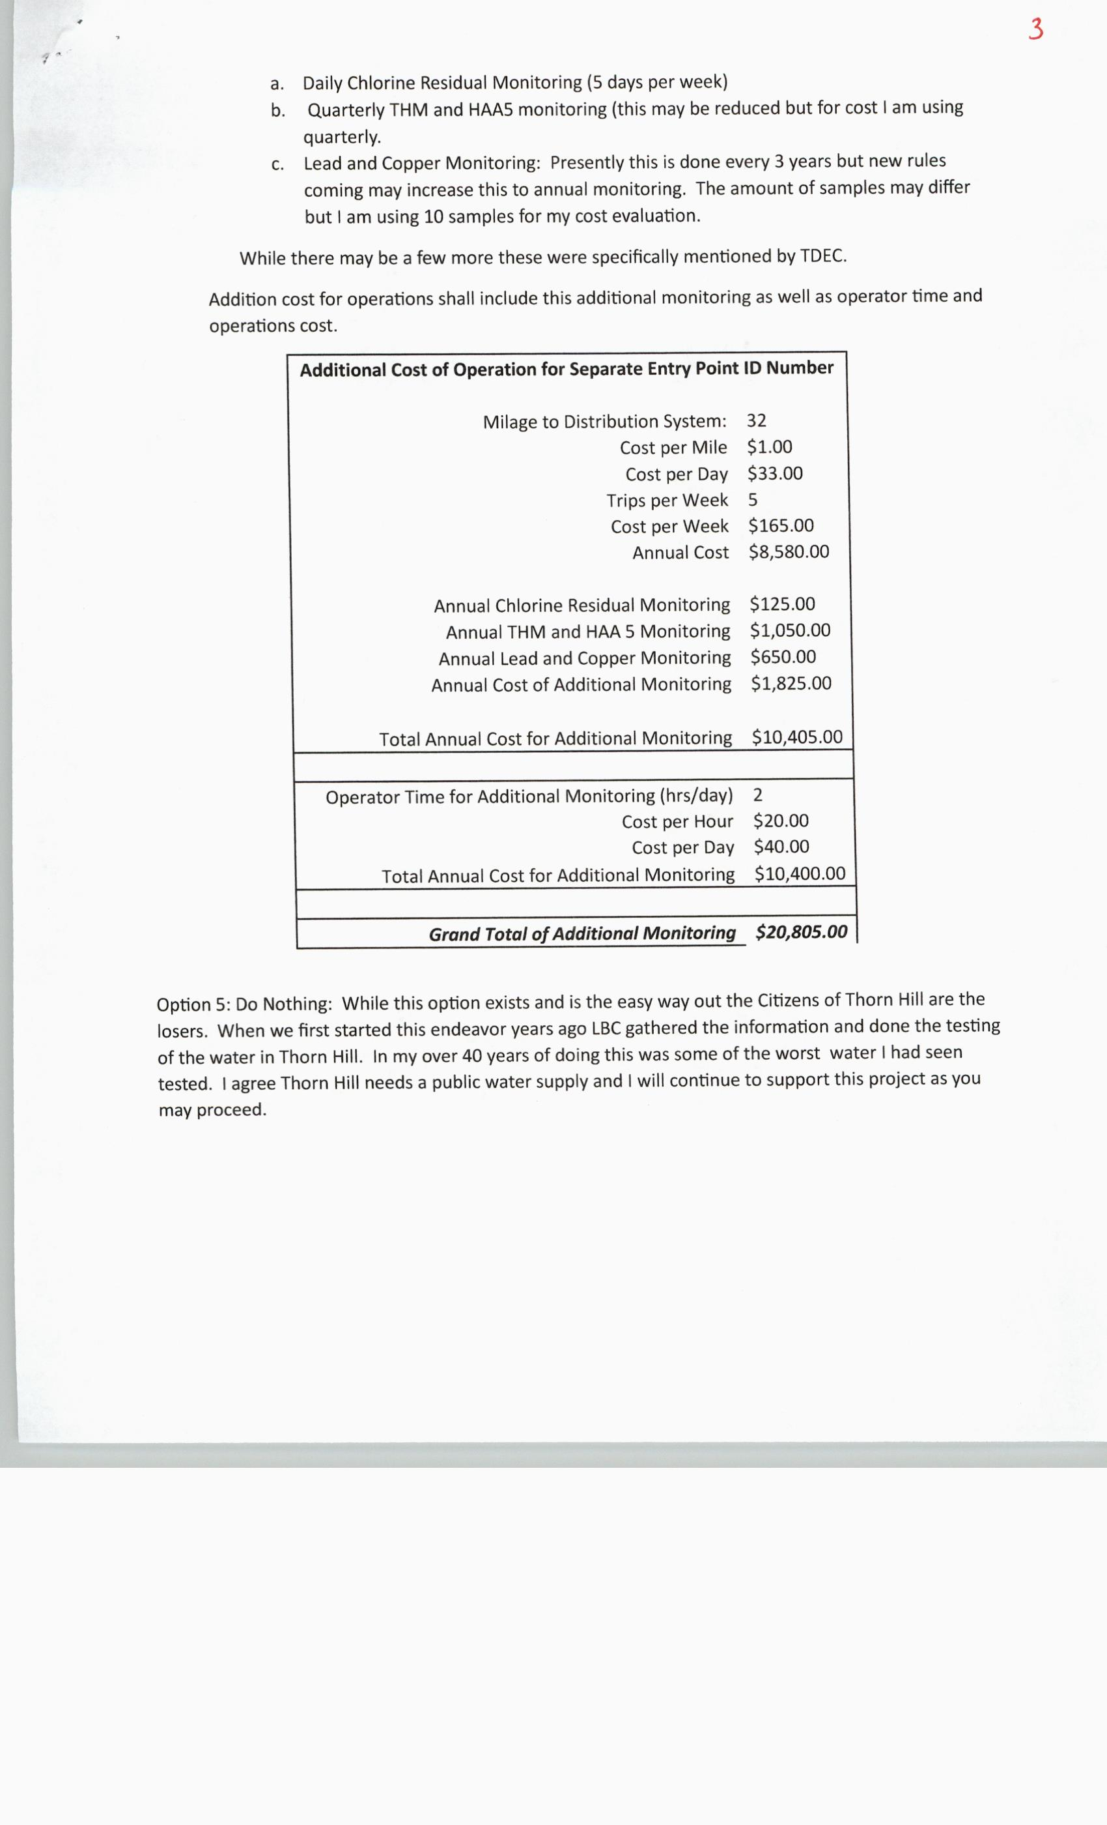

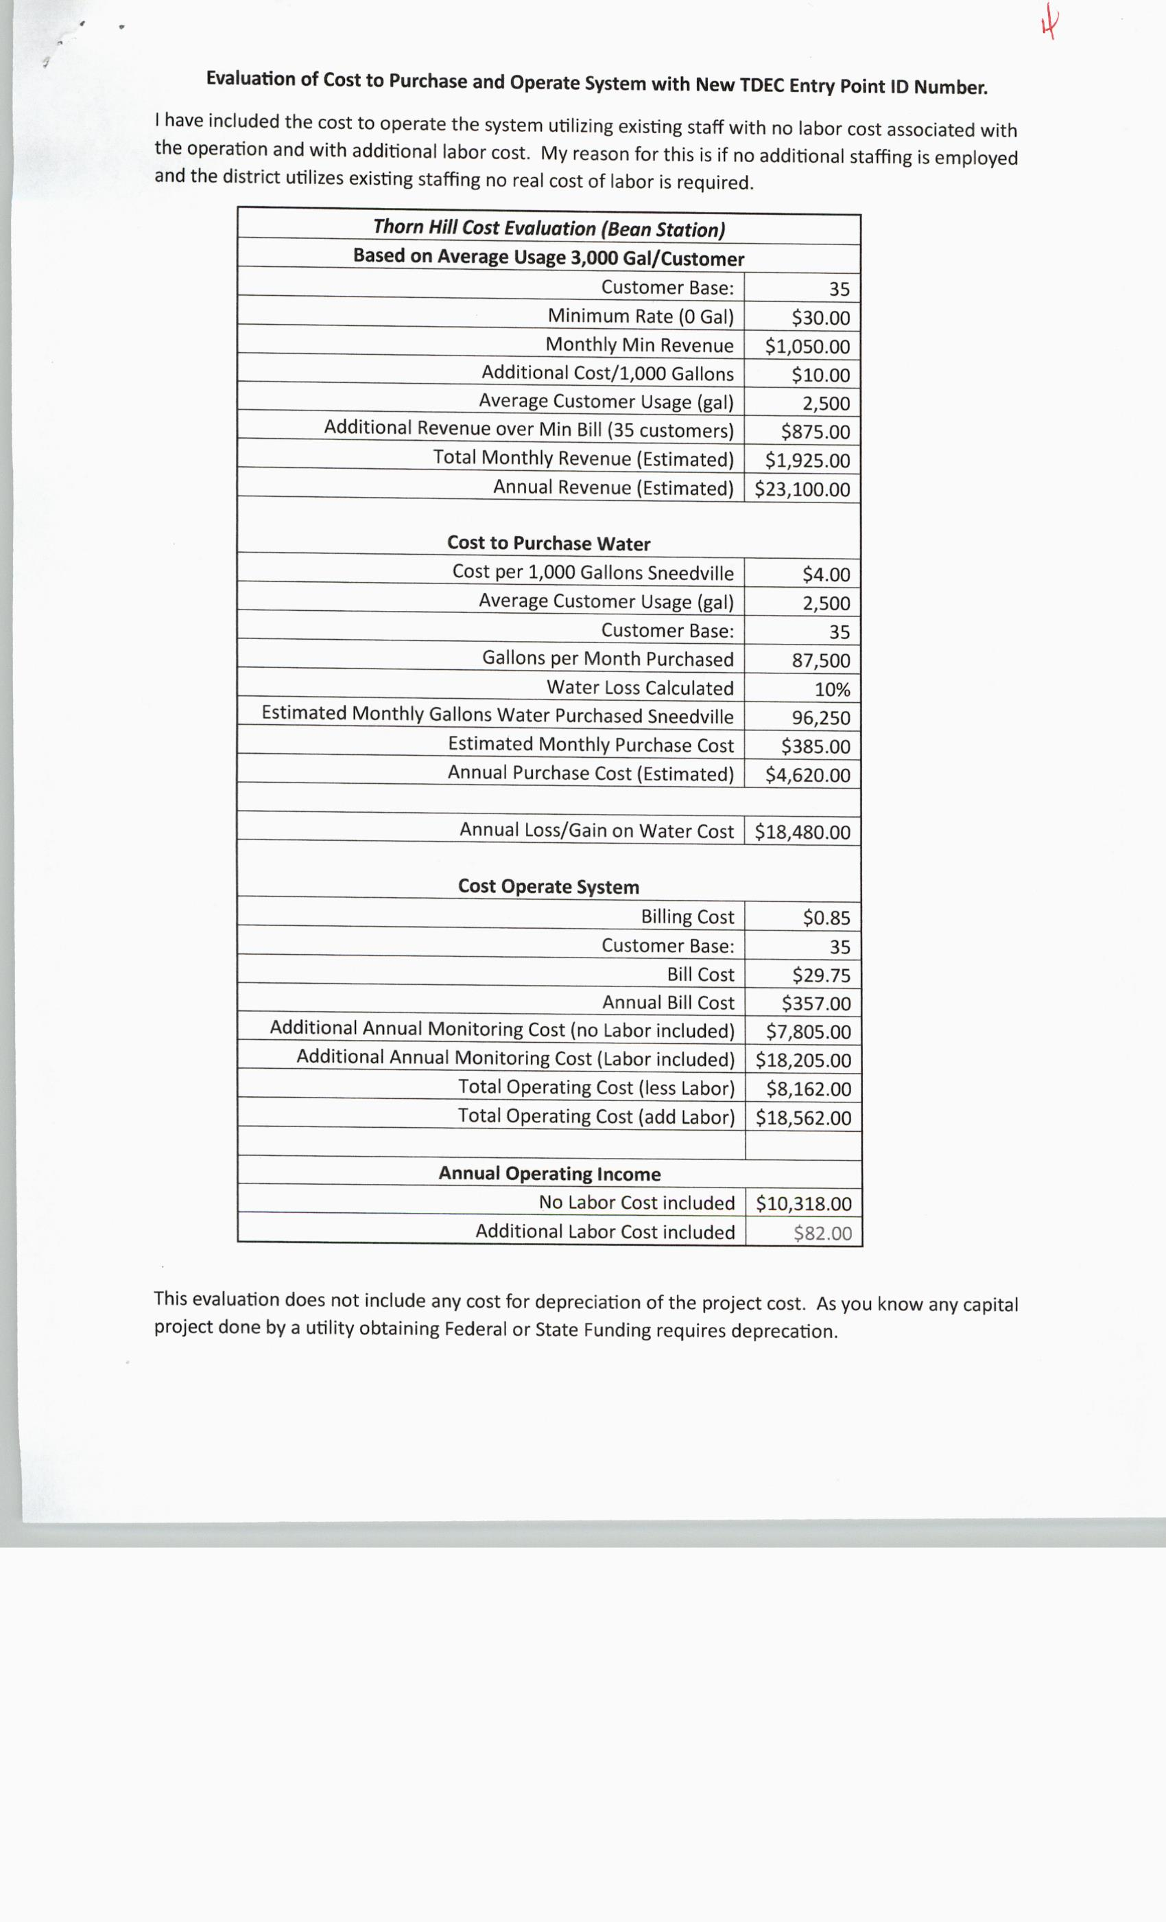

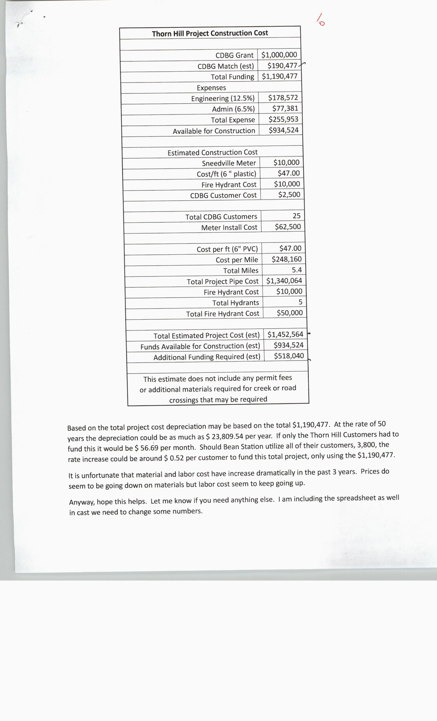

NEW BUSINESS, Brasher Road Speed Limit
UPON MOTION of Commissioner JESSE CLINE, Seconded by Commissioner
TINA DAVIS, the Commission approved to change the speed limit on Brasher Road to 20 mph by Voice
Vote.

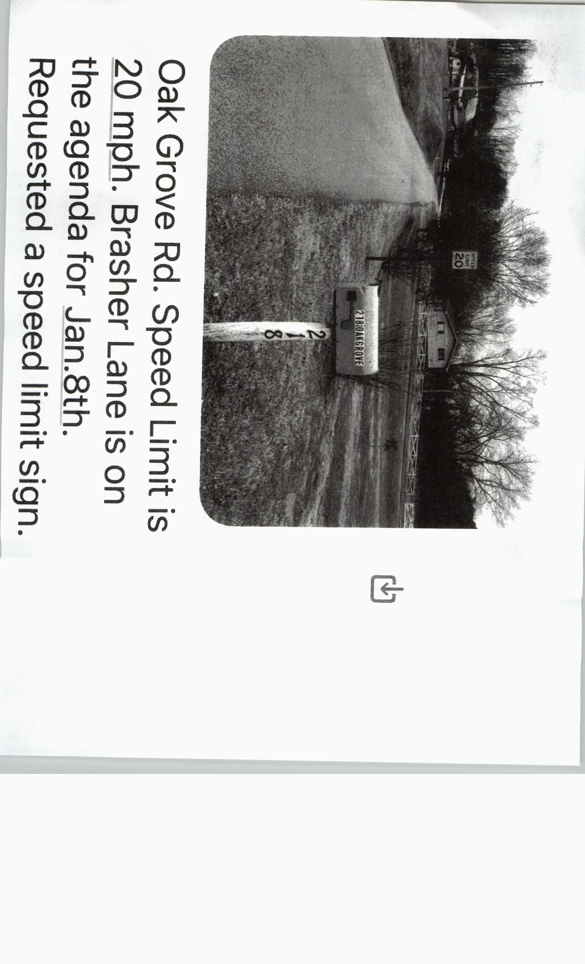
***************

NEW BUSINESS, Out of County Trash
UPON MOTION of Commissioner SCOTT WYNN, Seconded by Commissioner DARRELL WILLIAMS, the Commission approved to contact Hawkins and Jefferson Counties to find out their policies on out of county residents taking trash to their convenience centers by Voice Vote.

***************

NEW BUSINESS, Blaine Convenience Center Trash Collection Hours
UPON MOTION of Commissioner DARRELL WILLIAMS, Seconded by Commissioner ANDY CAMERON, the Commission approved to make Blaine and Indian Ridge Convenience Centers 40 hours a week instead of 32 hours a week which will be an additional $5,000.00 cost by Roll Call Vote as Follows:

AYE: DARELL STRATTON, SCOTT WYNN, LUKE STRATTON, ANDY CAMERON, TINA DAVIS, DARRELL WILLIAMS, JAMES ACUFF, JENNIFER HOLT, JESSE CLINE AND MIKE HOLT. (11)

NAY: RODNEY OVERBAY. (1)

ABSTAIN: ED MCBEE. (1)

ABSENT: WENDY NOE AND ANNA BLANKEN. (2)

***************

NEW BUSINESS, Review and approve Emergency Purchase and Replacement of Leonard Water Mixing Valve #TM-1520B-LF-DT for the Justice Center
UPON MOTION of Commissioner ANDY CAMERON, Seconded by Commissioner JAMES ACUFF, the Commission approved an emergency purchase and replacement of Leonard Water Mixing Valve #TM-1520B-LF-DT for the Justice Center for $12,576.00 by Roll Call Vote as Follows:

AYE: DARRELL STRATTON, SCOTT WYNN, ED MCBEE, RODNEY OVERBAY, LUKE STRATTON, ANDY CAMERON, TINA DAVIS, DARRELL WILLIAMS, JAMES ACUFF, JUSTIN EPPERSON, JENNIFER HOLT, JESSE CLINE AND MIKE HOLT. (13)

NAY: (0)

ABSENT: WENDY NOE AND ANNA BLANKEN. (2)

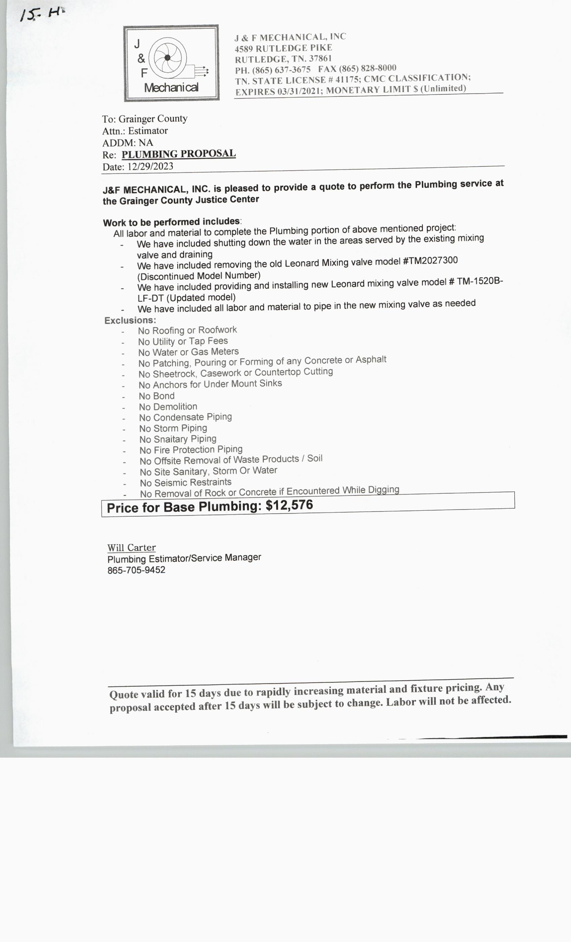

UNFINISHED BUSINESS, Road List
Highway Superintendent Charlie McAnally gave the Commissioners the Road List to look over before the February 2024 Meeting.

*****************

MISC,
NONE

*****************

ADJOURN,
UPON MOTION of Commissioner RODNEY OVERBAY, Seconded by Commissioner
LUKE STRATTON, the Commission adjourned until the next regular called meeting on February 12,
2024, at 7:00 p.m. by Voice Vote.

Meeting ended at 8:40 p.m.

__________________________________________________
MIKE HOLT, COUNTY COMMISSION CHAIRMAN

ATTEST:
____________________________________________________
ANGIE J. LAMB, GRAINGER COUNTY CLERK

